FOREST KINDERGARTEN

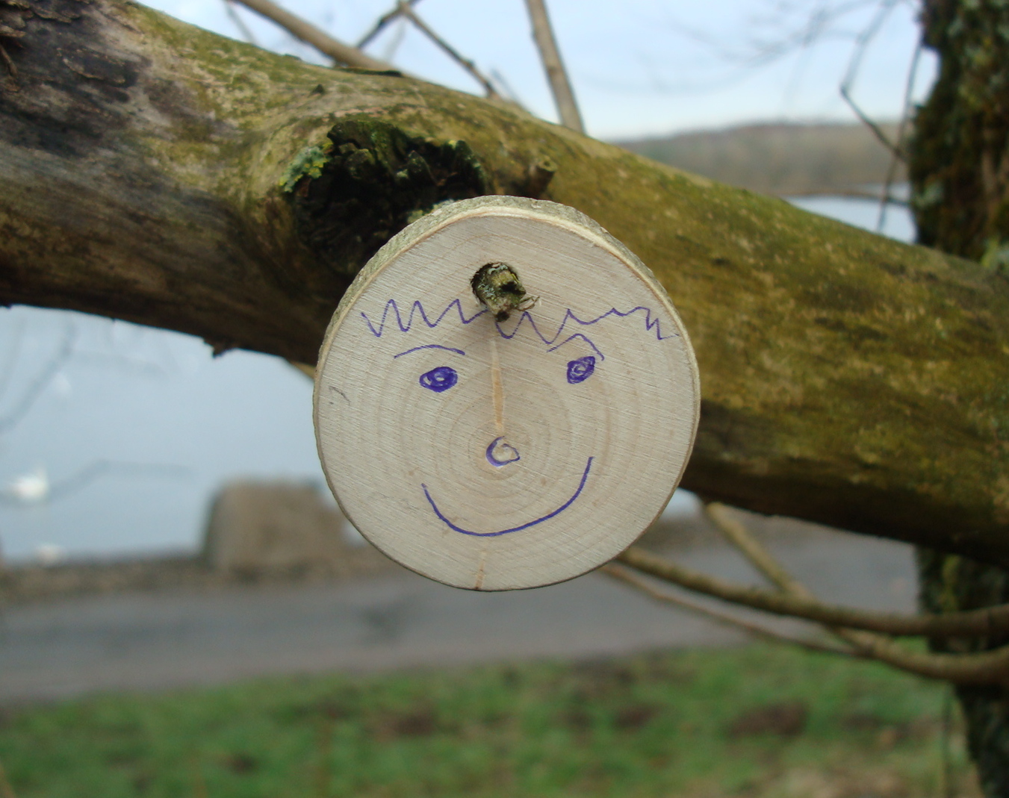

Participant Training Notes

Index

P3 Acknowledgements
P4 Course aims
P7 Overview of Forest Kindergarten
P8 Background history
P9 Key things to know
P10 Useful book list and websites
P11 National documents about outdoor learning and play

P12 PLACE
P13 Key considerations: PLACE

P14 1.1a Defining woodland activity
P16 UN Convention on the Rights of the Child

P17 1.1b The benefits of woodland visits (including research snippets)
P26 What’s unique about woodland and greenspace

P28 1.1c Scottish outdoor access code: rights and responsibilities
P31 Embedding ‘The Code’ into Woodland Visits Summary

P32 Outcomes 1.2 1.3 Site appraisal, audit and survey

P36 Outcome 1.4 Landowner’s permission
P38 Liaising with landowners and managers: site information checklist
P40 Example communications to a landowner
P41 Insurance
P42 Leave Less Trace Principles

P44 Outcome 1.5 Developing risk benefit assessments (RBAs)

P46 Outcome 1.6 Dynamic risk assessments
P47 Developmental considerations for practitioners
P50 Daily site check form
P52 Daily off-site register
P53 Health and safety outdoors
P55 Health and safety websites and useful books

Forest Kindergarten
The Essential Guide
Bonnie Maggio
bonnie.maggio@forestry.gov.scot

www.forestry.gov.scot
www.owlscotland.org

Acknowledgements:

Many thanks to:

- The participants of all the Forest Kindergarten courses run to-date for their feedback and suggestions.
- The children and staff from many early years and childcare centres who welcome the participants to their Forest Kindergarten sessions and for their use of their documentation.
- Juliet Robertson, Creative STAR Learning Ltd., for permission to use her course handouts, blog, photos and website materials to compile this handbook.
- Marian Cairns, former Early Years Quality Development Officer, North Lanarkshire Council, for her support with this course. After retiring, Marian continued to work with the Scottish Forestry on further development and training of the Forest Kindergarten model.
- Jane Mason, Fife Early Years co-ordinator and her early year’s team for allowing us to adapt the `Out on Forest Kindergarten: Helpers Leaflet’ used within this handbook.
- Chris Miles, MBE, Fife Early Years co-ordinator in the early 2000’s, who developed the original course this is based on.
- Karen Boyd, the Central Scotland Education Officer from 2009 – 2014 whose energy and determination ensured this course was created and the dream realised.
- Sarah Archer, Hugh McNeish, Sally York and Bonnie Maggio for their work with the SQA and other partners to enable the Forest Kindergarten course to become a national qualification.

Scottish Forestry accepts no responsibility for the quality of the goods or services provided by the companies or websites listed in this document. We do not endorse other organisations.

COURSE AIMS

Many settings already make good use of access to the outdoors, not only through their immediate outdoor space but also through ensuring access to their local woodlands, glens, parks and green spaces. This regular contact with nature can engender an appreciation and respect for biodiversity. It can also connect them to their local community and sense of place, helping them to develop as responsible citizens committed to sustainability. Realising the Ambition, p55.

The aim of the course is to enable early years practitioners to organise, safely set up and facilitate forest kindergarten sessions. These sessions will be frequent, regular and routine off-site visits to a local woodland or nearby greenspace for children in their childcare establishment. The course is designed to be delivered as an experiential outdoor experience to enable participants to fully understand why outdoor play in nature matters.

By the end of the course, participants will:

- understand the benefits of and be able to state ten or more benefits of frequent, regular visits to woods or nearby greenspace all year round.
- consider the woodland or greenspace experience as a valuable opportunity to create a different context for play across all curriculum areas.
- be able to name at least ten different opportunities afforded by woodland experiences, which are not present in other contexts.
- receive advice and information about finding a wood and the preparations required.
- be able to name the steps required to find a wood, and outline the preparations required to set up a forest kindergarten.
- develop confidence and belief that practitioners have the skills and competencies to provide quality sessions.
- be able to name at least six of their personal skills and competencies which will enable them to provide quality play experiences within woodlands.
- know where to look for further advice and information.
- be able to provide valuable and fun play experiences in woods and other nearby greenspace.

Underlying principles

- That children will learn through positive play experiences and interactions with people and the places where they play about caring for nature and the world in which we live.
- The concept of Learning for Sustainability is best understood through experiential learning. This has to be outdoors in a natural setting for children to develop a connection with the natural world that will lead to long-term positive ecological thoughts and actions.
- The course and approach to woodland and local greenspace visits are underpinned by the UN Convention on the Rights of the Child. In particular Articles 3, 4, 12, 28 and 31.
- Using local woodlands and local greenspace is an extension of outdoor play provision as outlined in national documents and guidance including:
- Curriculum for Excellence through Outdoor Learning
- Learning for Sustainability, A Vision 2030+
- The Play Strategy for Scotland: Our Vision and Action Plan
- Loose Parts Play: A Toolkit
- The ‘rights and responsibilities’ approach advocated in Scottish Outdoor Access Code
- General Teaching Council for Scotland: Professional Standards (for teachers)
- My World Outdoors
- Out to Play: Practical guidance for creating outdoor play experiences in early learning and childcare
- Health and Social Care Standards
- Realising the Ambition
- Getting It Right For Every Child (GIRFEC)

Key points

1 Children will learn through positive play experiences, interactions with people and the spaces where they learn outdoors. That play is how children learn best. Realising the Ambition guidance applies to all aspects of Forest Kindergarten as do the Health and Social Care Standards, especially 1.25, 1.30, 1.31 and 1.32.

2 Through play children will learn to cherish nature and the world in which we live. That children and adults will only take action about something they care about. We need to foster care and empathy for nature, plants, animals and the wider world. This is a core part of Learning for Sustainability, A Vision 2030+.

3 Children will develop a connection with the natural world that will lead to long-term environmentally sustainable thoughts and actions. This is what we can do personally to play our part in making the world a better place, both now and for the future. This is our positive legacy and how we can make a difference — not just to children now but for their futures too. It about a positive approach to living with and addressing climate matters and supporting the realisation of several of UN Sustainable Goals, particularly those linked to biodiversity.

Key messages

- The focus of outdoor and off-site provision should be on high quality learning and care experiences for every child. This is an ongoing professional development journey for all in the ELC profession at every level.

- The challenge for EY practitioners is developing an awareness, understanding, valuing of their green space. We have to integrate concepts of place into our practice: caring for the environment, being aware of their rights and responsibilities when off-site, developing a reciprocal relationship with the natural world.

- Everything is place and context specific, thus it is important to avoid comparing practice, especially with the diversity of outdoor nurseries and off-site provision that exists.

- The dynamic, everchanging nature of the weather, seasons and site means that EY practitioners have to be responsive to both the place and the children. Our practice must be flexible whilst operating within a framework of safety.

- Good outdoor practice builds communities where children are at the heart of key decisions and they have a genuine voice.

Fostering community connections can also create opportunities for the children to meet and learn from other people and organisations. Out to Play, p18

Overview of Forest Kindergarten

This course has been based upon the Forest Kindergarten training for early years practitioners who would like to set up a frequent and regular routine of off-site visits to a local wood or nearby greenspace for children in their setting.

It is recognised that there are many benefits to allowing children to play freely in local woodlands or greenspace on a frequent and regular basis. This includes increased physical activity, greater knowledge about nature and, in the long term, a stronger likelihood that these children grow up to become adults who understand and demonstrate positive attitudes and actions towards caring for the environment.

By frequently re-visiting the space, a child’s connection is deepened because the child discovers and masters new skills and activities. In this process: “the experiences become embodied as skills and understandings of the world that support ever-deepening feelings and relationships between child and surroundings.” (Moore 2014:24) in Out to Play, p54

A survey conducted as part of the Glasgow and Clyde Valley Forest Kindergarten Feasibility Study (2009, p8) highlighted the value respondents placed on accessing quality training:

‘The responses highlight the need for professional development opportunities, and first-hand experience for early years staff — building confidence and competence. In particular, developing understanding and skills relating to the process and the benefits Forest Kindergarten, and outdoor learning generally’

The Education Scotland document, Outdoor Learning: Practical Guidance, Ideas and Support for Teachers and Practitioners in Scotland (2011, p5) states:

‘The place or context in which learning takes place is an integral part of the learning process. The relationships between the people involved, the activities undertaken and the place where the learning takes place require thought and consideration to maximise the learning opportunities and to meet the needs and aspirations of children and young people.’

This course recognises the value of woodlands and other greenspace as an integral part of the learning process for pre-school children. It has been carefully designed to equip practitioners with the knowledge, understanding and skills to enable children in their setting to play in local woods and other greenspace. It is based upon:

- Practice observed in Scotland and internationally in outdoor nurseries, forest and nature kindergartens
- The advice contained in Curriculum for Excellence through Outdoor Learning (2010) and other national outdoor play and learning documents that have been published since.

Furthermore, it provides an ideal stepping stone to other Career Long Professional Learning opportunities including supplementary skills training in fire, ropes and tools, Forest School Leader training and postgraduate degree courses which look at different aspects of learning and play outside. Appendix 1 demonstrates the range of skills that teams made need to provide a breadth and depth of outdoor practice.

Background history

The Forest Kindergarten (FK) programme offered by Scottish Forestry began as a pilot project in 2009. Karen Boyd was appointed as the FK education officer and tasked with supporting nurseries in Glasgow and the Clyde Valley to undertake frequent and regular visits to local woodlands with children in their establishment.

Initially the programme used Forest School training as the route to up-skilling staff. However, this proved to be less successful than hoped owing to a combination of factors. In 2011, Juliet Robertson (Creative STAR Learning Ltd) was asked to develop training programme specific to the needs of early years practitioners. It was a sustainable and rights-based approach, based upon her many years of practical experience along with inspiration and observation of practice in other countries, particularly Sweden and the Czech Republic.

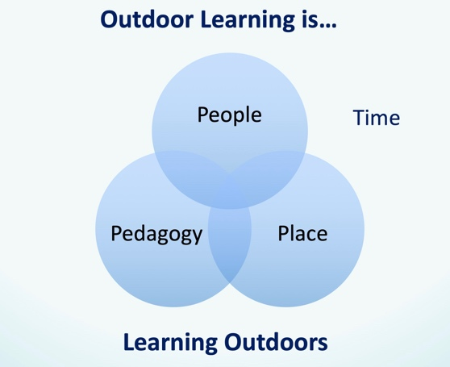
The course was developed as a 3-day training programme because it was felt that there was a lot needed to be included. The course and handouts look at the practicalities around:

- Place – Finding and preparing a site including appraising it and undertaking a risk benefit of the site.
- People – Observing children in an FK session, preparing children, working with staff and parents.
- Pedagogy – Being in nature and relying on the wood as a source of inspiration, creativity and imagination; integrating FK into the routine and life of a nursery all year round.

The first pilot of the Forest Kindergarten training took place in February 2012. North Lanarkshire trialled the model. Since then many more courses have run in this local authority and others in Central Scotland. Edinburgh City Council currently runs Forest Kindergarten as an in-house qualification. Aberdeen City have provided “Wee Green Spaces” training based upon the Forest Kindergarten model.

Furthermore, additional training has, in the past, been offered to give practitioners an opportunity to learn how to use fire, tools and ropes as well as the use of family fun bags. There was also an introduction to Forest Kindergarten specifically aimed at school and early years and childcare managers developed by Marian Cairns. The three-day training and follow up support offered by Scottish Forestry was been independently evaluated in 2014-15 and received very positive feedback.

Since the first training course pilot in 2012, the Forest Kindergarten model has been continuously refined and developed. Scottish Forestry is keen ensure that the model is manageable, sustainable and remains fit for purpose.

There are now a range of videos which may help, e.g.
- In Focus: Forest Kindergarten https://youtu.be/g8WWrRzf7ZU
- An Introduction to Forest School https://youtu.be/NV6YYfQl3RI
- Middleton Park Launch of Wee Green Spaces: https://vimeo.com/120621575

Forest kindergarten: key things to know

The FK course is built around the needs of EY practitioners to be upskilled in regard to being outdoors and off-site
The course has been developed by early years outdoor professionals for the early years sector. It is about practicalities of setting up frequent and regular visits, usually weekly, all year round and in almost all weathers to local woods. Use of fire, tools and rope work are not included. These skills can be acquired later, once the routines of using a local wood have been established.

The FK course builds upon the skills and role of an EY practitioner
EY practitioners are skilled professionals who know about the need to observe, reflect on their practice, be responsive to their children and ensure their care and learning needs are met. The course does not go into observations, approaches to planning and so on, because this is something EY practitioners already know. It does not ask participants to create an FK handbook but rather integrate FK into their practice. For example, a nursery’s safeguarding policy would include reference to safeguarding at an FK session. There would not be a separate policy for Forest Kindergarten.

The FK course empowers EY practitioners to set up and lead FK sessions as part of their weekly routine
It's a course designed for those who are working as EY practitioners in a nursery and not external providers or partner organisation to run FK sessions for a nursery. This misses the point of empowering EY practitioners and ensuring permanent, sustainable changes to practice within the early years sector.

The FK course is not an alternative to, or substitute for, Forest School training
A Forest Kindergarten-trained practitioner could go on to undertake FS training to further deepen their practice. Likewise, Forest School-trained EY practitioners are able to attend FK training and come away with skills, knowledge and understanding that they did not previously have.

The FK course takes a sustainable and rights-based approach
A key emphasis of Forest Kindergarten is taking a participatory approach to establishing FK sessions that involves children, their families and other stakeholders. It is set in the context of Curriculum for Excellence and the suite of outdoor learning and play documents that exists to support EY practitioners. Furthermore, it makes links between the UN Rights of a Child and the rights and responsibilities of all as outlined in the Scottish Outdoor Access Code.

The FK course is now an SQA national workplace award https://www.sqa.org.uk/sqa/82694.html
Since 2018, Scottish Forestry has run five training sessions for EY college lecturers and other SVQ centres wishing to offer this course as an accredited qualification.

Expanding the horizons
In recent years, the Scottish Forestry Forest Kindergarten course has had to broaden the scope of its cover. More settings are looking to increase the time spent in woods and greenspace for a variety of reasons. For example, some ELC organisations choose to offer a whole session in a local greenspace for all its children. This impacts on toileting, shelter, site wear and tear and so on compared with a small group visiting for part of a session.

Models as described in the Care Inspectorate Practice Note: Delivering Play and Learning Environments Outdoors http://bit.ly/31JM3dL are also impacting on expectations. The range of options is considerable and place-specific. For example, the effectiveness of a compost toilet is dependent on many factors including climate, site accessibility and secondary processing options available. The amount of ecological wear and tear to a site depends on its ground rock, soil type and vegetation amongst other factors.

Useful book list

There are now many books available to support practitioners to develop their outdoor and nature-based practice. The list below is illustrative.

A Sense of Place: Mindful Practice Outdoors (2019) Annie Davy ISBN ISBN-13: 978-1472953650
Supporting early years practitioners to enable children to engage with nature. Very accessible text.

Nature Kindergartens by Claire Warden (2010) ISBN 978-1-906116-10-1
Covers key principles about nature kindergartens and links this to education theory and practice.

Outdoor Learning: Past and Present by Rosaleen Joyce (2012) ISBN-13: 978-0-33-524301-3
This book breaks new ground by placing ‘outdoor learning’ in a theoretical, historical and social context of changing understandings of children, childhood and the use of the outdoors.

I Love Forest School by Martin Pace (2014) ISBN-13: 978-1472906076
A personal book about how one setting has developed their practice through embedding Forest School based upon a Reggio-inspired approach.

A Practical Guide to Nature-Based Practice by Niki Buchan (2017) ISBN-13: 978-1472938350
Good basic guide with case studies from around the UK.

Last Child in the Woods by Richard Louv (2005) ISBN 978-1565-125223
This bestselling book has started the growth of a movement dedicated to reconnecting children with nature. It is a worthwhile read for any adult who works with children.

Childhood and Nature: Design Principles for Educators by David Sobel (2008) ISBN 978-1-57110-741-1 This book looks at activities children get up to when playing in a natural space.

Risk, Challenge and Adventure in the Early Years by Kathryn Solly (2014) ISBN-10: 0415667402
Kathryn is a former head teacher of the Chelsea Open-Air Nursery. This book describes how very good practice can be developed.

Relevant national websites

- Scottish Forestry https://forestry.gov.scot
- OWLS Scotland: Outdoor and Woodland Learning https://www.owlscotland.org
- Outdoor Learning Directory http://outdoorlearningdirectory.com
- Scottish Natural Heritage https://www.nature.scot
- Learning through Landscapes Scotland. Formerly Grounds for Learning. www.ltl.org.uk/scotland
- Children and Nature Network (US, not UK organisation). Biggest collection of research summaries about the benefits of learning and play outdoors https://www.childrenandnature.org
- Thrive Outdoors
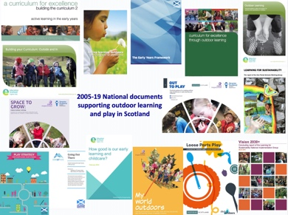
National documents about outdoor learning and play

The Creative STAR Learning website has a list of key national documents that gets updated: https://bit.ly/2WnhvNe Click on this link to reach the national documents listed below.

Inspiring Scotland (2019) Loose Parts Play: A Toolkit (2nd Ed)
This contains advice about loose parts which includes natural materials, the concept of affordance and curriculum links about free play outside.

Scottish Government (2018) Out to Play: Practical guidance for creating outdoor play experiences in early learning and childcare
National guidance for early learning and childcare settings wishing to extend their outdoor provision by using local greenspace.

The Scottish Government (2017) Space to Grow timely design guidance for early learning and childcare settings and out of school care settings. It has a good emphasis and set of questions for consideration of outdoor as well as indoor environments.

Care Inspectorate (2016) My World Outdoors
This document shares good practice and sets out the expectations of the Care Inspectorate with regard to play and learning wholly or partially outdoors.

Vision 2030+: Concluding report of the Learning for Sustainability National Implementation Group (2016)
The report about progress made in implementing the recommendations around Learning for Sustainability. It’s part celebration, part reflection, part forward thinking.

The Scottish Government (2013) The Play Strategy
There are two parts to the Play Strategy.
- Our Vision
- Our Action Plan
This document is particularly relevant as a Forest Kindergarten not only is about addressing play in schools and early years and childcare settings but also about ensuring children have spaces to play in their local community. Both documents cite the need for children to be able to have daily free play opportunities in natural spaces.

The Scottish Government (2012) Going Out There
This is the national guidance about off-site excursions. Every local authority will have their own guidance which must be followed by local authority run settings.

Education Scotland (2011) Outdoor Learning: Practical Guidance for Teachers and Practitioners in Scotland
This document has lots of advice which builds up Curriculum for Excellence Through Outdoor Learning.

Learning and Teaching Scotland (2010) Curriculum for Excellence Through Outdoor Learning
This is the official CfE document which states about the need for children to have frequent, progressive, regular experiences outdoors.

FINDING AND PREPARING A PLACE

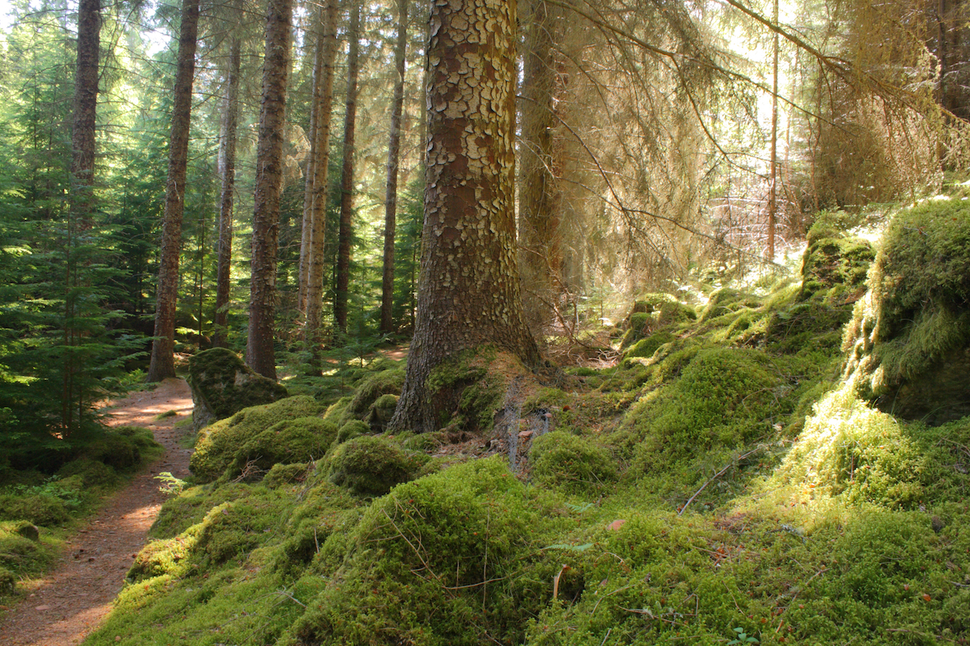

Forest Kindergarten Key Considerations: PLACE

1. You understand what Forest Kindergarten is, compared with other forms of outdoor learning and play.
2. You have identified a suitable woodland or greenspace site and undertaken a site appraisal. This includes considering emergency procedures.
3. You have permission from the landowner/manager to use the woodland or greenspace site. Agreements may need to be in place around the management, access and use of the site.
4. Check your insurance requirements. Local authority ELC centres accessing local authority managed woods and greenspaces is normally covered. However double-check, especially if you are a partner provider.
5. You need to think about the environmental impact of your visits on the site and how to positively manage this.
6. You have decided about group size, staffing, volunteers, frequency of visits. Not every child needs to attend from a nursery in the one go especially at the beginning when you are establishing routines. However frequently repeated regular visits all-year round matter, ideally weekly or more often.
7. Getting to the greenspace or woodland: walking; parent drop off; public transport or minibus. Walk/travel the route(s) and note any benefits and risks that arise.
8. Do a risk benefit assessment (RBA) of the greenspace you will be using including walking to and from the site:
- Make sure they accurately reflect your practice.
- Involve all stakeholders. For example, ensure your landowner/manager has copies and are invited to comment prior to the visits going ahead.
- Think about when and how your children and parents can feed into the process. This may be after the visits have started.
- Ensure your manager or head teacher reads and signs these.
- Put the RBA’s in an accessible place that allows everyone to easily update them on an ongoing basis.
- Complete any other off-site or excursion paperwork that is required by your manager or local authority.
9. Plan for transitions. It’s a good idea to have ante pre-schoolers involved prior to the summer holidays so they can continue to access the woods at the start of a new school year. Some ELC settings, begin by using their school grounds to establish routines before getting off-site. CI Practice Note Keeping Children Safe
10. Plan for a poor weather alternative. This may include using part of the school grounds if there are children who want or need the experience.
11. Go through your policies and procedures. Adapt these as needed for your planned Forest Kindergarten visits and vice versa. There is no need for a Forest Kindergarten policy – it’s part of your everyday practice.

1.1a: Defining woodland activity

Assessment criteria | Assessment method
- Define what a forest kindergarten is  - Use key words to summarise the main criteria for a forest kindergarten | Written assessment / questioning

There are lots of terms which describe children playing and learning in woods or other greenspace. Below there are six examples.

Have a discussion about the descriptions:
- Have any of the participants had experience of any of these approaches? If so in what capacity?
- What sets Forest Kindergarten apart from the other approaches? Encourage everyone to pull out the key words that they feel are important.
- Look at the UN Rights of a Child poster and talk about how the Forest Kindergarten sessions have to consider the Rights of a Child. As practitioners, we need to reflect upon how children’s rights need to underpin our practice and their relevance and importance to Forest Kindergarten.

Forest School
“This is an inspirational process, that offers ALL learners regular opportunities to achieve and develop confidence and self-esteem through hands-on learning experiences in a woodland or natural environment with trees. It is a specialised learning approach that sits within and compliments the wider context of outdoor and woodland education.”

To create and run these sessions, a practitioner must obtain a Level 3 OCN or similar qualification from a recognised training company. These sessions must have qualified leader in attendance.

Woodland learning or play
This is the term used for any activity or learning experience, regardless of approach or number of sessions or age of the children and young people involved. It is led by a practitioner or teacher during the childcare or school hours, within their local woodlands.

Nature play
This is about giving children and young people of any age opportunities to have free play in a natural habitat using natural materials. However, the term is also used to describe the play that takes place in artificial natural playgrounds mainly created from natural resources.

Outdoor setting
This is the term the Care Inspectorate use to describe nurseries that have registered specifically as an outdoor early learning and childcare establishment. In these settings children are outdoors all of the time except in extreme weather conditions. Children and staff will have access to a sheltered area this could be a permanent or temporary structure. There may also be a meeting point, premises or a base camp used for the drop off and collection of children. These settings will have a comprehensive contingency plan which has been articulated and agreed with parents in the rare occasion where severe weather conditions prevent children from being outside.

Nature Kindergarten
This is a general term which may be used by early learning and childcare staff to describe anything from a weekly session outside in a wild, natural space to a situation where children spend more than 75% of their time outside all year round.

Forest Kindergarten
This experience offers young children frequent, regular opportunities to learn through play in a woodland. It involves repeated visits by the same group of children, usually weekly, to the same site, throughout the year, in all most all weathers. During the sessions, the children are free to play, explore, have fun and learn.

It is a child-centred approach. Sessions are led by the creativity, imagination and problem-solving skills of the learner. Staff extend learning through thoughtful interactions, creating secure routines and other appropriate support.

The repeated and extended time in woodland connects children with the natural world, leading to long term environmental awareness and understanding. The woodland or other greenspace provide a stimulating environment that helps children thrive and learn through a real-life context. The sessions have a positive impact on the physical, cognitive, social and emotional development of the children and their overall health and wellbeing.

UN Convention on the Rights of the Child

These are the specific Articles which the approach advocated in this approach to organising woodland visits. The wording has been taken from the Scottish Government (2008) The UN Convention on the Rights of the Child — A Guide for Children and Young People.

Article 3: If any decision is being made by any organisation about a child’s well-being, then the child’s best interests must be considered.

In terms well-being there is sufficient evidence from research that suggests that children benefit from frequent regular time in a natural setting. It can have a restorative effect, lowering stress levels and providing an opportunity for children to be physically active as they play in the woodlands.

Article 4: The government has a responsibility to make sure your rights are protected and to create an environment where children can grow up safe.

A safe environment is more than addressing health and safety issues in relation to woodland visits. It’s about providing healthy and safe places to grow through play. A place that is free from the stresses and strains that some children experience in their lives. It helps children and their families perceive woodland environments as safe and healthy places to be which can be used for many purposes such as recreation, work and rest.

Article 12: Children have the right to speak up and have their opinions listened to and taken seriously by adults on things that affect them.

The children need to be consulted and involved in all aspects of the woodland visits from planning and preparation to the play activities in the woods. The course aims to encourage participants to ensure ongoing dialogue about the routines and practice as it becomes embedded in the life of the setting.

Article 28: Children have the right to an education.

The woodland visits are every bit as important as any other aspect of pre-school provision. All Curriculum for Excellence experiences and outcomes can be covered through woodland visits. Participants are expected to observe, interact where appropriate, evaluate and extend children’s learning through play.

Article 31: Children have a right to play.

Pre-school aged children learn best through opportunities to freely play. This is the main purpose and activity at the woodland sessions.

1.1b: The benefits of woodland visits

To enable participants to consider why using a local woodland or greenspace is important and adds value to the childcare provision in a setting.

Assessment criteria | Assessment method
- List ten or more benefits of frequent, regular visits to woods or nearby greenspace all year round.  - Explain five different opportunities provided by woodland experiences, which are not present in other learning contexts. | Written assessment / questioning

The research snippets below are updated each time the course is run. It is important that you keep up to date with research around the benefits of time in nature for our children and ourselves. You may wish to add these to newsletters, displays, poster and other information for parents and your wider community.

Being outside affects children’s behaviour

A Swedish study was carried out at two day nurseries, one was an outdoor nursery, and the other a traditional nursery in new, spacious premises. The research team studied children’s behaviour as a whole: how they played, how often they were outside, their play routines, and also the development of motor function and powers of concentration during the course of a year.

“When it comes to concentration capacity, the children within I Ur och Skur (outdoor) pre-schools are more than twice as focused as children within a normal pre-school. Their motor skills are better, they are less frustrated, restless and sick.”

Grahn, P., Martensson, F., Lindblad, B., Nilsson, P., & Ekman, A. (1997) Ute på Dagis Stad and Land 145. Håssleholm, Sweden: Nora Skåne Offset.

Adults mentors have a positive life-long impact on children and young people

Many adults who choose to take action to benefit the environment have had an adult mentor as children. The adult mentors demonstrated:

- care for the land as a limited resource essential for family identity and well-being;
- disapproval of destructive practice (e.g. pollution of water, littering, etc.)
- a fascination with the details of other living things and elements of earth and sky and simple pleasure when being in nature.

Chawla, L. (2006) Learning to Love the Natural World Enough to Protect It in Barn nr. 2 2006:57-58. Norsk senter for barneforskning.

Children find winter play attractive and challenging

Children (age 4-6) in a Norwegian Nature Kindergarten participated in this study which was conducted during the coldest time of the year. Winterscape is generally understood “to be a cold, white or grayish environment, partly or fully covered by snow and ice.” In this study it refers to “an environment for play and growth that children shape, understand and make their own through their activities.”

This understanding of winterscape highlights how the environment – rather than being neutral and a backdrop for children’s play – is “always becoming” in response to the children’s activity. This concept is consistent with the idea of “affordances” which refer to possibilities for various activities. Affordances emerge “from a combination of the surroundings and the ways in which the individual child understands its possibilities.”

The researchers found that play in/with snow and ice provides opportunities for children to develop knowledge and skills regarding who they are and who they can become. The children found the winterscape attractive and challenging.

Jostein Rønning Sanderud, Kirsti Pedersen Gurholt & Vegard Fusche Moe (2019) ‘Winter children’: an ethnographically inspired study of children being-and-becoming well-versed in snow and ice, Sport, Education and Society, DOI: 10.1080/13573322.2019.1678124

Poverty affects children’s experience of wild places

Research about the health impact of the John Muir Trust Award found that “1 in 10 participants had never visited a wild place before their award involvement.” and that “Those living in the poorest circumstances were over 6 times more likely to have had no previous experience of wild places.”

Mitchell, D. and Shaw, R. (2009) Health Impacts of the John Muir Award Glasgow University’s Public Health and Health Policy Unit.

Nature is a buffer of life stress

Nearby levels of nature moderate the impact of stressful life events on the psychological well-being of children. The life stress impact is lower among children with high levels of nearby nature than among those with little nearby nature.

Wells, N.M., and Evans, G.W.(2003) Nearby Nature: A Buffer of Life Stress Among Rural Children Environment and Behavior. Vol. 35:3, 311-330

A “draw-and-write” technique provides various insights into preschool children’s relationship with nature

Over 200 students from four kindergartens and 13 nursery classes in Kastamonu, a city in Northwest Turkey, participated in this study which found:

- 85.8% of the children used a positive tone in talking about their relationships with nature.
- 70.8% of the children preferred to draw a natural area as their setting
- Younger children tended to talk about their relationships with nature in more positive terms than older children.
- Girls tended to emphasize natural areas more than boys. Girls were also more likely than boys to draw picking fruit as an activity, while boys tended to depict tree climbing as their favourite activity.
- The children included animals more often than plants in their drawings; and, in many cases, included human figures and “man-made devices” (cars and bikes).
- Many of the children’s drawings depicted play as an activity performed in nature.

The findings suggest starting environmental education at an early age and enabling children to spend more time engaging with nature are important.

Ahi, B., Atasoy, V., (2019). A phenomenographic investigation into preschool children's relationships with nature through drawings. International Research in Geographical and Environmental Education, 28(4), 281-295. http://dx.doi.org/10.1080/10382046.2019.1649248

Greenness of residential neighbourhoods is associated with less problematic behaviour in children

This study examined the association between the greenness of children’s residential area and their neurobehavioral health in South Korea. It looked at levels of anxiety, depression, withdrawal and sleep complaints. It also considered rule-breaking and aggressive behaviours and attention problems. Over 1800 children aged 6-18yrs old were involved in the study.

The findings add support to the research-based understanding that greenness in urban neighbourhoods offer numerous benefits for the residents.

Lee, M., Kim, S., Ha, M., (2019). Community greenness and neurobehavioral health in children and adolescents. Science of the Total Environment, 672, 381-388. http://dx.doi.org/10.1016/j.scitotenv.2019.03.454

Nature experiences during childhood can have long-lasting consequences on attitudes toward and tolerance of wildlife

This research looked at the influence of childhood nature experience on attitudes and tolerance towards problem-causing animals in Singapore with more than 1000 residents.

The overall findings indicate that nature experiences during childhood can have long-lasting consequences for attitudes toward and tolerance of wildlife. This research highlights “the importance of childhood nature experience in shaping adult perceptions of wildlife and their willingness to coexist with wildlife.”

Ngo, K.M., Hosaka, T., Numata, S., (2019). The influence of childhood nature experience on attitudes and tolerance towards problem-causing animals in Singapore. Urban Forestry & Urban Greening, 41, 150-157. http://dx.doi.org/10.1016/j.ufug.2019.04.003

Short-sightedness in children is affected by time spent outside

Australian Government research suggests that myopia, or short sightedness, in children appears to be affected by the amount of time spent outside.

The vision of 6 and 7-year-olds of Chinese ethnicity in Singapore and Australia was compared. 10% of the Australian children were short sighted compared with 30% of the Singaporean children.

All the children spent a similar amount of time reading, watching TV and playing computer games. However, the Australian children spent on average 2 hours a day outdoors which was 90 minutes more than the Singaporean children.

Rose, K. A., Morgan, I.G., Smith, W., Burlutsky, G., Mitchell, P. And Saw, S. (2008) Myopia, lifestyle and schooling in students of Chinese ethnicity in Singapore and Sydney Arch Ophthalmol 2008 126 (4): 527-530.

Children are significantly less physically active during preschool/childcare hours than outside care hours

The study involved 71 childcare centres, 65 preschools, and 1002 preschool children. Accelerometers worn by the children measured the frequency, intensity, and duration of their physical activity. Both boys and girls spent a significantly lower percentage of time being physically active during care hours than outside of care hours. The number of spaces with natural ground covering was important for boys’ physical activity.

Hinkley, T., Salmon, J., Crawford, D., Okely, A.D., Hesketh, K.D., (2016). Preschool and childcare center characteristics associated with children’s physical activity during care hours: An observational study. International Journal of Behavioral Nutrition and Physical Activity, 13(117)

Physical coordination is affected by landscape

Two groups of pre-school children attending the same nursery were studied during a 9-month period. One group had daily access to natural landscape for at least 2 hours, the other group only occasional access.

Significant differences were found in balance skills, coordination and agility.

The researchers concluded, “Nature affords possibilities and challenges for the children to explore their own abilities. The children feel more comfortable being in the natural environment and their knowledge about nature increases.”

Fjørtoft, I. & Sageie, J.(2001) 'The Natural Environment as a Playground for Children: The Impact of Outdoor Play Activities in Pre-Primary School Children', Early Childhood Education Journal 29(2): 111-117.

Access to neighbourhood parks and green space is linked to higher activity levels in children in Norway

This study analysed data from 23000 children. Results showed that:
- Children with access to a park in their neighbourhood were more physically active during the summer than those without access to a park.
- Children who lived in neighbourhoods with more green space were more physically active during the winter than children who lived in neighbourhoods with less green space.
- Children living in more densely populated areas and with access to facilities such as playgrounds/ sports fields and schools participated more in organized activities and socialised more with friends than children in other neighbourhoods.

Nordbo, E.C.A., Raanaas, R.K., Nordh, H., Aamodt, G., (2019). Neighborhood green spaces, facilities and population density as predictors of activity participation among 8-year-olds: A cross-sectional GIS study based on the Norwegian mother and child cohort study. BMC Public Health, 19 http://dx.doi.org/10.1186/s12889-019-7795-9

‘Doses of nature’ for children with Attention Deficit Hyperactivity Disorder (ADHD)

Children with ADHD demonstrated improved concentration when completing a task, after a 20-minute walk in a city park. The difference was comparable to what is achieved with standard ADHD medication.

"Doses of nature" might serve as a safe, inexpensive, widely accessible new tool in the tool kit for managing ADHD symptoms.

Faber Taylor, A. and Frances E. Kuo, F.E., (2009) Children with Attention Deficits Concentrate Better After Walk in the Park Journal of Attention Disorders, Mar 2009; vol. 12: pp. 402 – 409

Early parenting practices, mothers’ physical activity level and screen time use predict level of outdoor play and screen-time in 2- to 5-year-olds

This longitudinal study took place in Sydney, Australia from 2007 to 2013. Early childhood years represent a critical time for establishing physical activity and sedentary behaviour patterns. 667 pregnant women participated.

Findings indicated that mothers’ screen-time during pregnancy and children’s daily screen-time at age 1 predicted children’s daily screen-time across ages 2 to 5.

The mother’s physical activity level, a baseline understanding of the importance of playing with her child, and practicing tummy time daily predicted children’s outdoor playtime across ages 2 to 5.

These findings indicate that mothers played an important role in their children’s outdoor play and screen-time in the first years of life, and that children’s early exposure to screen devices could be associated with their later screen-time.

Xu, H., Wen, L.M., Hardy, L.L., Rissel, C., (2016). A 5-year longitudinal analysis of modifiable predictors for outdoor play and screen-time of 2- to 5-year-olds. International Journal of Behavioral Nutrition and Physical Activity, 13(96)

The health benefits of the great outdoors

Greenspace exposure is associated with numerous health benefits in intervention and observational studies.

This meta-analysis found that there were decreases in stress, heart rate, blood pressure, cholesterol, diabetes, hyper-tension and coronary heart disease.

The findings should support practitioners and policymakers to give due regard to how they can create, maintain, and improve existing accessible greenspaces in deprived areas and develop strategies and interventions for the utilisation of such greenspaces by those who stand to benefit the most.

Twohig-Bennett, C., Jones, A., (2018). The health benefits of the great outdoors: A systematic review and meta-analysis of greenspace exposure and healthy outcomes. Environmental Research, 166, 628-637.

Natural settings help children focus and enhance cognitive abilities

Proximity to, views of, and daily exposure to natural settings increases children’s ability to focus and enhances their cognitive abilities.

Wells, N.M. (2000) At Home with Nature: Effects of 'Greenness' on Children's Cognitive Functioning Environment and Behavior. Vol. 32, No. 6, 775-795.

The impact of outdoor learning cannot be assumed. It depends on the activities undertaken and how they are facilitated

The delivery of outdoor learning, the aims and focus of the experience make a noticeable difference to what is learned.

“Simply ‘being outdoors’ is not sufficient for young people to express an ethic of care for nature or develop an understanding of natural processes. These things seem to be learned when they are an explicit aim of experiential activities and when they are mediated in appropriate ways.” (Key finding 14).

Nicol, R., Higgins, P., Ross, H. and Mannion, G. (2007) Outdoor education in Scotland: a summary of recent research Scottish Natural Heritage, Further research section.

New perspectives

New insights into innate skills and learning styles of children. Murray & O’Brien (2006) found that Forest School provide a basis for staff to gain different perspectives of the children they work with.

The Forest School enables both children and staff to see each other in a different environment whilst, at times, facing similar challenges, such as bad weather.

Staff are able to build a picture of the whole child and see how the outdoors can support their educational needs without sole emphasis placed on academic development.

(Forest Kindergarten Pilot, Psychological Services Evaluation Report. North Lanarkshire Council. (2011)

The ripple effect

Families go into woodlands more and view risk taking differently. Nursery staff gain new skills which inform and changes nursery practice.

Murray & O’Brien (2006) highlight the impact of forest school spreads far beyond the children who attend. There are also ‘ripple effects’ throughout the family, the wider community and the child’s school.

Many parents have noted that their child’s enthusiasm for forest school means that they bring that experience home. This can result in changes to hobbies, interests and behaviour, with parents supporting their child’s interest in the outdoors at home.

(Forest Kindergarten Pilot, Psychological Services Evaluation Report. North Lanarkshire Council. (2011)

Time in ‘wild’ nature matters

“Domesticated” nature activities such as picking flowers or planting seeds while having a significant, positive effect, did not have as great an influence as that of “wild” nature on environmental attitudes and had only a marginal effect on environmental behaviours.

Wells, N. M., & Lekies, K. S. (2006). Nature and the life course: pathways from childhood nature experiences to adult environmentalism. Children, youth and environments, 16(1), 1-24.

Child who free play in wild natural environments are more likely to have pro-environmental behaviours and attitudes as adults

When children become truly engaged with the natural world at a young age, the experience is likely to stay with them in a powerful way shaping their subsequent environmental path. People who have had frequent childhood experiences in natural spaces are more likely to visit such places as adults.

Ward Thompson, C., Aspinall, P., & Montarzino, A. (2008) The childhood factor - Adult visits to green places and the significance of childhood experience Environment and Behaviour, 40(1), 111-143.

Vegetation diversity protects against childhood asthma

The researchers assessed the association between the natural environment and asthma in 49,956 New Zealand children born in 1998 and followed up until 2016. Children who lived in greener areas were less likely to be asthmatic.

Donovan, Geofrey H., Gatziolis, D., Longley, I., Douwes, J. (2018). Vegetation diversity protects against childhood asthma: results from a large New Zealand birth cohort. Nature Plants. 4(6): 358-364. https://doi.org/10.1038/s41477-018-0151-8.

Green areas and Attention Deficit Disorder (ADD)

Results from a study of children with ADD indicate that children function better than usual after activities in green settings. The “greener” a child’s play area, the less severe his or her attention deficit symptoms.

Taylor, Andrea Faber; Frances E. Kuo; and William C. Sullivan, (2001) Coping with ADD: The Surprising Connection to Green Play Settings Environment and Behavior, Vol. 33, No. 1, January 2001

Could nature help children rise out of poverty?

The authors explore some possible explanations for how greenness might promote social mobility through related research to this study:

- There is a positive association between greenspace exposure and academic achievement.
- Children with limited exposure to nature are more vulnerable to illness and prone to behavioural challenges, conditions placing them at greater risk for academic difficulties.
- Exposure to greenness can promote cognitive functioning which plays an important role in academic success.
- Multiple studies provide evidence of a link between exposure to greenness and creative performance.
- The development of emotional intelligence including such skills and traits as self-regulation, self-awareness, empathy, social skills, and intrinsic motivation.

While this study found only a weak association between greenness and children’s social mobility, mounting evidence supports increasing the provision of green space in children’s neighbourhood environments as a way of improving their chances of a physically, emotionally, socially, and economically healthy future.

Browning. M.H.E.M., Rigolon, A., (2019). Could nature help children rise out of poverty? Green space and future earnings from a cohort in ten U.S. cities. Environmental Research http://dx.doi.org/10.1016/j.envres.2019.04.016

WHAT’S UNIQUE ABOUT
WOODLAND AND GREENSPACE?
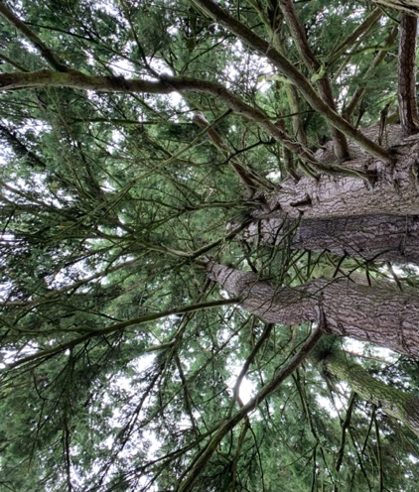

PERSPECTIVE: being able to look toward the horizon. See the sky, look down below ground level, into ditches and drains. Not being inhibited by walls, doors and ceilings.

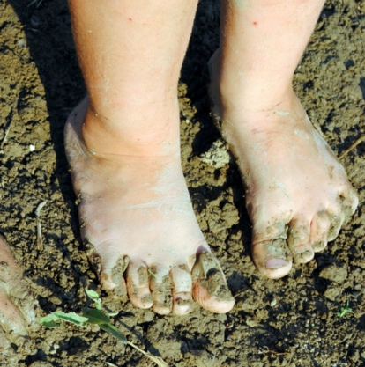

Using our SENSES: sight, touch, taste and smell. Developing an awareness of who we are and the space that we occupy.

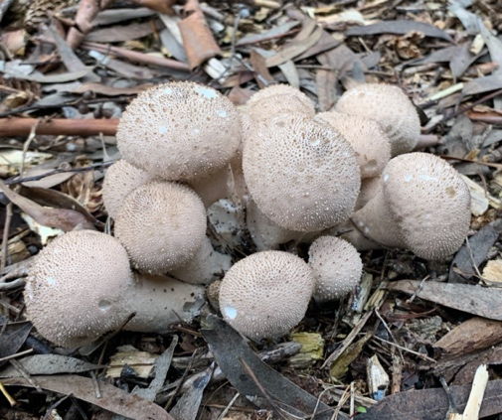

EXPERIENCING THE UNEXPECTED, rain falls and changes the ground surface, the ground changes levels and texture as you walk, plants and branches spring back or trip you up.

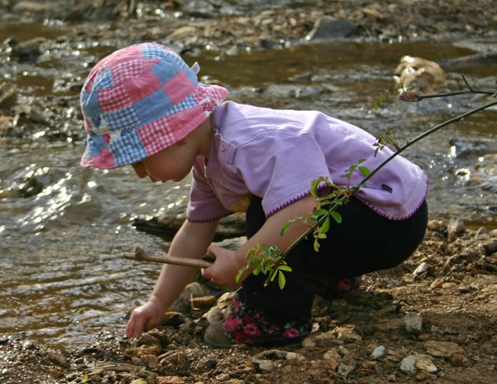

MOVEMENT: indoors things only move when we move them. Outdoors there is movement everywhere, almost nothing is still. The ground, trees, traffic, birds, people, air, light.

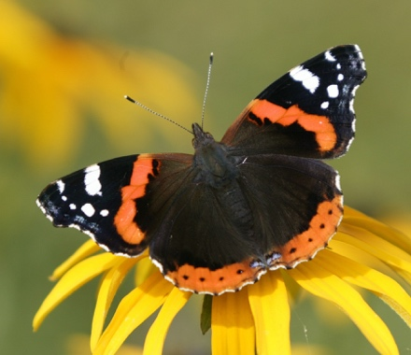

FRESH AIR: it changes as the wind changes and brings different sounds and smells.

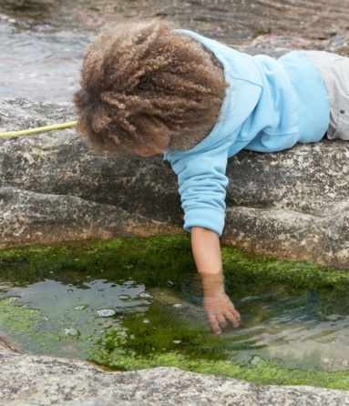
TEMPERATURE: changes throughout the day, session, hour by hour. It depends on where you stand and can change as you move between areas of shelter, open ground and when feeling the surfaces of a tree or a stone.

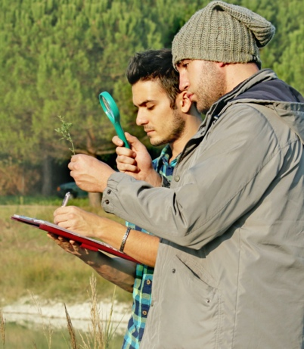
NEW PEOPLE: sharing public spaces means we meet familiar people in a new environment. This can open up many rich opportunities for communication, exploration and extending relationships.

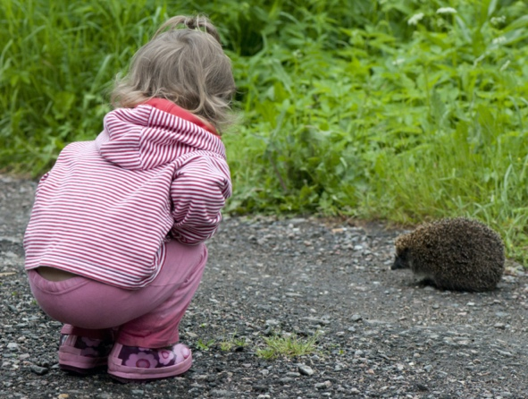

NATURE: we are part of a wonderful world. By being kind and caring for and looking after all living things, we also benefit and can learn more about ourselves and how to be outside. It’s a reciprocal relationship.

Outcome 1.1(c): Scottish outdoor access code: rights and responsibilities

Assessment criteria | Assessment method
- Summarise the three key principles of rights and responsibilities whilst outdoors | Written assessment / questioning

The Scottish Outdoor Access Code (referred to as ‘The Code’ or ‘SOAC’)
The Code is an important piece of Scottish legislation which affects everyone. It is about our rights and responsibilities when outdoors and off-site. The Code is an excellent framework for thinking about woodland visits and addressing concerns or issues that may arise, in a sustainable and informed way.

You will need to check the Scottish Outdoor Access Code website regularly so that your information is up-to-date and accurate. http://www.outdooraccess-scotland.com You can download a copy of ‘The Code’ onto your smartphone or tablet.

This will help you understand how to lead off-site visits. The Code is based upon three key principles and these apply to both the public and to land managers:

- Respect the interests of other people. Acting with courtesy, consideration and awareness is very important. If you are exercising access rights, make sure that you respect the privacy, safety and livelihoods of those living or working in the outdoors, and the needs of other people enjoying the outdoors.

- Care for the environment. If you are exercising access rights, look after the places you visit and enjoy, and leave the land as you find it. Help maintain the natural and cultural features which make the outdoors attractive to visit and enjoy.

- Take responsibility for your own actions. If you are exercising access rights, remember that the outdoors cannot be made risk-free and act with care at all times for your own safety and that of others.

Remember that everyone only has access rights if they exercise them responsibly!

Environmental sustainability

With the expansion of outdoor provision that is happening in Scotland, more woodland and greenspace is likely to be used more often by more ELC settings. One key aspect of the Scottish Outdoor Access Code is caring for your environment. Thus, you must work with the landowner to ensure that the damaged caused by their group visiting a woodland or greenspace is minimised.

Scottish Forestry have produced Forest Kindergarten Guidance for Landowners. https://tinyurl.com/2fkycpwp Appendix 2 has lots of suggestions about actions staff and children can take to ensure a pro-active approach to minimising impact is undertaken.

Summary

- Select impact-resistant sites for Forest Kindergarten and Outdoor Nursery activity. Avoid environmentally sensitive sites.
- Involve children in practical approaches to caring for the site and engage in shared sustained thinking based upon their understanding and experience of playing in these sites. The Scottish Forestry Forest Kindergarten approach encourages ELC staff to use age-appropriate strategies to ensure children adopt and remember how to be outside.
- Improve site resistance through informal management techniques that the group of children and staff can also assist with. Manage adaptively and informally. See the suggestions in the table below.
- Groups should adopt low impact activities in a sensitive way which does not overly constrain children’s free play. In some sites, this will be a ‘Leave no trace’ approach. In others it may be more appropriate for ‘Leave less trace’ practices to be adopted to enable children to play without constantly having to consider the environmental impact.

In Aberdeen, there are two interesting examples of how ELC groups and land managers are working together to ensure the principles of The Code are adhered to:

1. Cruickshank Botanic Garden. The curator always meets the lead staff prior to site use, undertakes a tour of the gardens and shares the expectations. This includes where to gather, which trees may be climbed, protocols around use of the gardens, where rope structures may be sited. Because the approaches are consistent, over time there has been very little wear and tear to the Aboretum.

2. Wee Woodland Care Programme. This is a pilot project in Spring 2020. It involves the Countryside Ranger team working with a group of nurseries in the Northfield area that are beginning to use their local woods. The staff and children will be shown what simple management techniques they can adopt to minimise their impact and also how to undertake small scale woodland work such as clearing paths, pruning and removal of deadwood from trees. The nurseries will be given the basic tools they need to do these jobs as part of their play sessions. The aim is to develop staff and children’s awareness of the impact they have on a woodland but also to empower them to take preventative action.

Working with children and helping them to understand their rights and responsibilities

It simply isn’t possible for any child or EY educator to know and learn all the ins and outs of being outside and off-site within a few sessions. Hopefully the washing line decision game has helped you, as a participant, see that The Code is the first port of call. However not every eventuality is covered by The Code. Good ethics, a wider knowledge of how ecosystems and habitats work and common sense are all needed. Sometimes you will have to weigh up and make decisions that are not easy around how children play in woodlands and local greenspace and what is and is not okay to do. This is also why keeping in contact with your landowner and seeking their advice matters.

When an issue does arise, it’s important that you take time to consider and respond to this is a positive and solution-focused way. The following approaches can work well with children to help them learn about how to behave and why:

- A story and discussion works well as stories stick in our minds better than instructions. Often children empathise better with an animal who makes a mistake and learns from their behaviours.
- A small world illustration acted out
- The use of drama
- The use of a character: puppet, adult pretending to be someone else, model, soft toy
- Songs are great for memorising routines
- A game to reinforce a particular behaviour
- Adults role modelling the correct behaviours and language and being seen by children to take positive action.

Embedding ‘The Code’ into Woodland Visits: Summary Sheet

Practitioners can model good practice and ensure that very young children enjoy the outdoors responsibly and safely. Think about ways of making sure the Scottish Outdoor Access Code summary below is part and parcel of how everyone must act when going off-site and into woods:

- Take responsibility for our actions
- Be aware of natural hazards
- Recognise that many places outdoors are working environments

- Respect people’s privacy and peace of mind
- Use paths or tracks when passing by houses or gardens
- Keep a sensible distance from houses when there is no path or track
- Take care not to act in ways which might annoy or alarm people living nearby, especially when it’s dark

- Help land managers and others to work safely and effectively
- Don’t hinder operations e.g. tree felling and harvesting. Keep a safe distance and follow advice/instructions from workers and avoid these areas
- See if there’s alternatives before entering a field of animals
- Never feed farm animals
- Avoid crop damage. Use paths or tracks, go round the margins of fields or use alternative route
- Leave all gates as you find them

- Care for your environment
- Avoid intentionally or recklessly disturbing or destroying plants, birds and other animal or geological features
- Following any voluntary agreements land managers and recreation bodies
- Not damaging or disturbing cultural heritage sites
- Not causing any pollution and taking all your litter away with you

- Keep your dog under proper control
- Don’t let it worry or attack livestock
- Never take it into a field with calves or lambs
- Keep it on a short lead or under close control in fields where there’s farm animals or during the breeding season (April to July) on moorland, in forests, grassland, loch shores and the seashore
- Picking up and removing faeces from public open places

- Take extra care if you are organising an event or running a business.
- Contact land managers if planning an educational visit to a farm or estate
- Obtain permission if you need facilities or services or if it will hinder others enjoying the outdoors or land management operations
- Talking to the land managers who are responsible for places that you use regularly or intensively

Outcomes 1.2 and 1.3: Site appraisal, audit and survey

Whether you are accessing the outdoors on an ad hoc basis or setting up an outdoor nursery, the first step is to locate and identify the right space. Woodland, fields, beaches and mixed habitats all currently host successful outdoor provision. Whatever you’re considering, you’ll need to weigh up many important factors to ensure a potential new site has the capacity to provide a range of high quality play-based learning experiences for young children which are positive, challenging, playful and enjoyable. Out to Play, p11

Assessment criteria | Assessment method
- Complete a site survey  - Identify features, hazards and play potential | Outdoors: Completion of a site survey form ensuring all aspects are considered.

Assessment criteria | Assessment method
- Assess a site for its suitability to be a forest kindergarten site, based upon three characteristics: access, site character and potential hazards  - Justification for the rationale | Outdoors: Completion of a site survey form ensuring all aspects are considered.

Site information and appraisal
When looking for suitable woodland to use on a regular basis, it can be useful to consider some of the criteria you think would be useful. There are no fixed recommendations and much of your assessment will be based on common sense.

When finding and choosing a site, the environmental impact of your visits must be considered along with a range of other factors that are outlined in Section 4 of the Out to Play guidance. You need to find a site that can withstand the impact of your visits.

When you first visit a woodland or greenspace to see if it is suitable, it’s important you take the time to explore the whole area. This includes the walk to and from the woodland, the access points, the layout of the land and so on. One visit may not be sufficient. You may also find it is better to complete a site appraisal with another person. Your local countryside rangers and other outdoor professionals may be able to assist, especially if they manage the land you are looking to use. The steps we went through in the training include:

- Stage 1: What does the group notice about this area in terms of features? Encourage everyone to explore different parts and then provide feedback together.
- Stage 2: What hazards can the group identify and why? Encourage everyone to provide feedback together.
- Stage 3: Find the play potential of this site. How could children use the site? Encourage everyone to provide feedback together.

SITE APPRAISAL – Its suitability for use by your setting

When commenting, tick or add a brief note. You may wish to rank each consideration from 1 (very poor) to 6 (excellent).

Remember that many things are not permanent; think about how easily changes could be made to improve an aspect for security, wellbeing or learning.

ACCESS - In terms of access it is important that the group can enter and leave the site with relative ease. For example, if the ground is too tricky to negotiate then it may be necessary to look elsewhere.

CONSIDERATION | Comment
Is the site within walking distance or will it is necessary to request that parents drop off and pick up children from the woods?

Look for safe parking/drop off and assembly points including for emergency access within or just out with the greenspace. Consider other access to the woods too, e.g. by walking or by bicycle. Are there any locked gates, etc.?

Think about the network of paths – does this exist? If not, how easy is it to walk across the area, especially for pre-school children?

Think about the ground cover – leaves, grass, needles, heather. Or is it very boggy, or have too many “inhibitor” plants such as brambles and nettles? Remember this will change with the seasons. Will thinning be needed in the summer?

Terrain– ideally a mix of flat and sloped areas with dips and hollows. Think about its aspect (north or south facing) and when the sun reaches the slope or whether it is in shade during your session.

Boundaries – are there natural boundary features within the area you want to be, e.g. a line of trees, a hedge, path, etc?
Will you need a marker system to identify boundaries?

Think about a designated place of safety in the event of a serious incident. Is this going to be your setting or another facility that is nearby?

Is there a suitable gathering place or shelter where equipment is put and snack is organised? Is the shelter natural or man-made or will you need to provide temporary shelter?
Are there historical or archaeological remains nearby?

SITE CHARACTER

This is how the place feels. Ideally it should have a feeling of “wildness” about it. Do remember that even small places can feel wild and isolated for a young child.

CONSIDERATION | Comment
Traffic noise, including that from air or rail transport

Mix of trees: young, mature, different species

Mature trees, especially those with limbs suitable for low level tree climbing and for rope swings and structures

Young trees for coppicing and shelter building

Shrubs for hiding, den building, hanging things on

Stumps for standing on, using as a table, mixing potions in

Fallen trees for climbing on, walking along

Open canopy and cover – glades of light

Variety of plants and fungi

Availability of sticks and other loose materials on the ground

Presence of stones, rock outcrops

Multi-sensory variety: sights, sounds, smells, shapes, colours

A variety of places: enclosed, open, to hide, roll, sit, have physical challenge, be quiet, a good view, etc

Evidence of wildlife. Opportunities to watch wildlife.

Presence of water, e.g. stream, river, loch, bog/wetland, ditches, sea, etc. and safe access to it.

Historical evidence, e.g. old walls, buildings, ditches, tracks. Are there any restrictions around these places?

Ability of the site to cope with the frequency of your visits and numbers in your group so that environmental impact is minimised.

POTENTIAL HAZARDS

Think about whether these are manageable and the level of risk posed. What can be done to enable visits to go ahead? Bear in mind the risks may also be seasonal. Think about “heads, shoulders, knees and toes” when looking for hazards at different levels in the woodland canopy.

CONSIDERATION | Comment
Litter – including drug paraphernalia and sharp objects

Standing dead trees or dead wood in trees. Do you need an aboriculturalist to check your trees and provide advice? Check with your council or the landowner if they can advise
Water – location, feature, ease of access. Will this require measures to prevent young children from accessing unsupervised?

Steep drops

Animals, e.g. excessive midges, ticks, livestock, dogs and dog mess, nesting birds, use of wood by ponies and riders

Quantity and type of potentially harmful plants – ask owner or environmental professional for advice here, if needed

Security of the area – think about whether structures and children’s creations are likely to remain or be removed/destroyed. How important is this?
The amount and type of
- passers-by
- other users – who else uses the site and is it appropriate for children to be playing there?
- degree of seclusion needed – consult your local crime prevention officer, if necessary
Informal toileting options – seclusion, ability of the site to cope with waste. Will you need to erect a toilet tent? Availability of public toilets
Power lines and electricity substations: location and possible ease of access by children

Site work by landowner: tree felling, footpath improvement, grass cutting, spraying, timber operations and their aftermath
Wifi and mobile phone connectivity. Note location of any blackspots.

Nearby industry which may create pollution (noise, air, land, water, etc.)
Location of nearest GP surgery and hospital

Outcome 1.4: Landowner’s permission

Assessment criteria | Assessment method
- Explain how to gain landowner’s permission and how you provide evidence of it?  - Explain the correct insurances and policies that need to be in place | Questioning

The Scottish Outdoor Access Code emphasises the need for dialogue with the landowner or manager of a woodland. Once you have identified a suitable site, you need to find out who owns or manages the land and to get in touch. You will need their permission to use the woodland or greenspace, even if it is publicly owned. Different local authorities have different systems for giving permission. Some require forms to be completed prior to beginning.

Publicly-owned greenspace is often closer to populated areas and easier for families to access, minimising the social, environmental and financial impacts of providing private transport. What’s more, when children spend time in local greenspace, they benefit from gaining an intuitive sense of place, belonging and stewardship of their environment and community. Out to Play, p16

The information from the site appraisal forms can be used to note the key points that need discussing with the owner or manager. For example, there may be some maintenance work needed prior to the site being suitable or a matter that requires clarification. It is important that you engage positively and proactively with the landowner or manager and explain clearly and fully what you hope to achieve by using their woodland.

Forest Kindergarten groups have a responsibility to treat the woodland environment with care and respect. There may be matters that have not been identified in the site appraisal which the landowner knows about. It is important to avoid any conflict with any other planned activities on the land. You need to go through the matters raised in the site checklist below. You need to ensure that the landowner is fully aware of your intentions and has the detail in writing so that you have a shared understanding of the agreed expectations.

With the right to use a woodland, comes the responsibility of caring for it. Whilst at the Forest Kindergarten, the staff and children can be, at the very least, extra eyes and ears:
- Report immediately any concerns: overflowing litter bins, vandalism, lots of dog mess
- Discuss the stewardship work your group could do. This may be planting bulbs or trees, creating habitat piles and so on
- Make connections with any volunteer groups that use the woodlands
- Do a two-minute litter clean up every visit
- Follow the ‘Leave Less Trace Nature Play Principles’

The site information checklist below is an abbreviated version of a more detailed form that can be found within the Forest Kindergarten Guidance for Landowners document which is available to download on the OWLS Scotland website. https://tinyurl.com/2fkycpwp This is worth looking at particularly in relation to outdoor settings.

It also has information about the ‘Leave Less Trace Nature Play Principles’ which are useful for developing a nature play ethic. It also has information about actions Forest Kindergarten groups and landowners can take to minimise the impact of the sessions. This document and the landowner discussions are explicitly referenced in Out to Play, Section 4.

REMEMBER:

- Do not turn up to a woodland site with a group without having discussed your intentions with the landowner/manager and have their permission in writing.
- Landowners and managers are busy people. It is your responsibility to be proactive and keep in contact with the landowner/manager. This may seem daunting but it can lead to lots of positive outcomes
- It’s a privilege to be able to use a woodland. What can you and your nursery do to keep the site cared for? How can you “give back” to the land?
- To follow up the meeting with the landowner with a letter or email to confirm what was agreed and discussed.

Liaising with Landowners and Managers: Site information checklist

Name of Wood: Grid Reference: Post Code:

Owner: Contact details of owner/site manager:

Consideration | Yes/No
Do you have permission to use the site from the owner/manager?
Have you informed the owner/manager about the intended:
- Size of the group (adults and children)
- Frequency of use and times
- Any additional support needs or specific considerations that need to be taking into account including the age and developmental ability of the children?
- Gathering place
- Need for temporary fixings and structures such as temporary shelter, a hammock, etc.
Does the owner have insurance for enabling your group to use the site?

Does your ELC and/or local authority have sufficient and appropriate insurance in place?

*Have you permission to:
- Establish and maintain a toilet system, if no public facilities exist nearby?
- Have a controlled camp fire (NB even a disposable barbecue is a fire)
- Cut branches and do small scale wood work such as creating a log seating ring

Are there any “no go” areas e.g. because of:
- Safety
- Wildlife protection
- Private property
- High risk of environmental impact
- Cultural heritage or archaeological value
Are there any seasonal or woodland management factors which may impact on the group using the woods? Examples include:
- Timber operations and tree maintenance or felling work
- Spraying of crops. The wind can carry the chemicals or slurry into areas used by the group.
- Movement of livestock that impacts on the group’s normal access
- Hunting, shooting or similar estate work.
- Work or situations where a water supply used by the children for play becomes contaminated
- Archaeological excavations
- Management of invasive species, particularly those which are potentially harmful.
Do neighbouring land owners/managers need to be consulted or informed about the use of this site by your group? Will any of their activities impact on your group whilst coming and going from the site or whilst you are there?

How robust is the site? Consider how often you will be using the site, the numbers of children and seasonality.
You may need options to minimise the environmental impact of your group’s use, e.g.
- The creation of simple pathways to make the site more accessible
- Regular checks of the trees in the main site
- Use different areas in rotation or at different times of the year
- Agreeing to abide by a “Leave Less Trace Nature Play Principles”
- Reporting anything that is amiss or not okay

Any specific requests re behaviour of the group or management of the woods?
Will your group be able to undertake small-scale simple environmental stewardship tasks to help care for the site?

Is there any site management work needed before your nursery can use the site? When will this happen and by whom?
Do you have a written agreement in place? (Please attach and keep safe). It should:
- Include the site appraisal form and clarification of any matters arising from this.
- Include the risk benefit assessments required for your off-site visit
- Outline any maintenance work that you have mutually agreed needs to happen, who will do this and when
- Have a start date from which the site can be used

*This course does not cover the fire lighting or using tools with children. If you undertake bush craft or Forest School Leader training courses then you may wish to do these activities at some point in the future. These activities must be discussed and agreed with the land manager/owner and undertaken in line with local authority and ELC setting guidance.

Action required (State by whom and expected date of completion)

Example communication to a landowner

Dear

Thank you for meeting with me last week.

I am writing to ask permission to take a group of nursery children from xxx Nursery to xxx Woods (Grid Reference xxx) on a weekly basis. We hope to begin on (state date of proposed first visit)

I hope the following information is helpful. Please let me know if you need to further discuss any aspect of our intended approach or suggest alternative procedures. We know and will contact you should we make any significant changes to our practice.

Number of children in the group:
Age of children:

Number of adults in the group:
Frequency of use (state which day of the week):
Approximate gathering area in the woods: | See attached map (screenshot of Google satellite image, marked up)
Approach to toileting: | - Using same area, remove leaf litter, pee into the ground. Cover back prior to leaving site.  - Use of potty for children who need a poo. This will be bagged, removed from the site and disposed of back at our nursery.  - Rotation of area used every 3 months
Intended approach to shelter | - Use of tarp attached to the trees, that is put up and taken down within the session.  - Children and staff wearing suitable clothing for the weather conditions
Use of fires | No
Approaches to managing environmental impact of our visits | - Using paths where they exist for walks away from our main play area (boundary)  - Rotating our gathering spot if we notice wear and tear or you advise us to do so  - Removing all rubbish including food scraps  - Removing any play structures at the end of the session  - Abiding by the Leave Less Trace principles  - Use of scarves to avoid rubbing on trees if we put up a hammock or simple rope structure.
Helping to care for the site | - Reporting any fly tipping, vandalism or other significant adverse incidents  - Picking up litter when appropriate (litter pickers taken for this purpose)

We have included our site appraisal and following Risk Benefit Assessments for our visits:
- Off-site
- Woodland
- Tree Climbing

Finally, is there anything we need to know about the site prior to using it? For example, are there any:
- Historical or archaeological remains we need to be aware of and avoid?
- No go areas or areas to be avoided (including seasonal factors such as nesting birds)
- Places that are particularly vulnerable to wear and tear?

Yours sincerely

…………………………………………………………………………………………………………………………………………………………………

Insurance

If you work in a local authority run early learning and childcare setting, then you will need to check what your local authorities’ policies and guidance about insurance for outdoor and woodland activities.

Private, voluntary or partner provider settings will need to check their own insurance. You will have to also ensure that you have all of your activity and site risk benefit assessments in place.

The Out to Play document references insurance in Section 4.7, p23

“Suitable insurance is a requirement, although some insurance companies are unclear about what an outdoor setting involves. You may need to explain the difference between an outdoor setting and an outdoor activity centre. Some insurance companies may add specific conditions to the insurance relating to your specific site, for example if it is mature woodland or your service offers activity opportunities (kayaking etc). It is a good idea to speak to fellow outdoor early learning and childcare providers who have navigated the insurance issue before you. The Care Inspectorate website lists existing registered outdoor settings. Each local authority and landowner is different so check their expectations about public liability insurance. Ensure all your activity and site risk assessments are in place, as you will be asked about these when enquiring about insurance.”

Likewise the landowner must have insurance in place. There is guidance for landowners available on the Outdoor and Woodland Learning Scotland website https://tinyurl.com/2fkycpwp This guidance also includes issues around the environmental impact of your group’s presence and what measures you and the landowner can both take.

Leave Less Trace Principles

The Leave Less Trace Principles are referenced in both of the above documents. Children need a space to play where they can learn how to be outside and how to care for the land the play on. There is a lot to learn so time and patience is needed, particularly when getting Forest Kindergarten established. For this reason, an ecologically sensitive site with lots of protected species may not be appropriate for use by a group of young children.

The Leave Less Trace Principles recognise that if a group is using a site all year round, then it is likely that there will be an environmental impact to some degree but this can be actively managed. The damage created through play is off-set by the benefits to the child, (when effectively facilitated) which include a greater understanding of our role and relationship with the land. The Leave Less Trace Principles are also useful guide and discussion framework with staff and children.

The Leave Less Trace concept was created by Matthew Browning, a US researcher who investigated the impact of play on natural sites. It is derived from the Leave No Trace Principles https://lnt.org/learn/7-principles These provide guidance about how to enjoy the natural world in a sustainable way that avoids human-created impacts. However, rigorous interpretation can sometimes restrict children’s need to play in nature. The Leave Less Trace Principles acknowledge that a balance is needed.

Leave Less Trace Nature Play Principles
(adapted from Matthew Browning’s work)

Prepare to Play
- Play in small groups – avoid large numbers on a site or break into smaller groups.
- Wear sensible outdoor clothes.
- Avoid littering – go for litter free snacks and take home all scraps of food waste.
- Go to the toilet in the designated space and follow The Code.

Build and Dig with Care
- Build dens in places that aren’t really fragile - for example, in sand, rock, gravel, grass, and snow.
- Build with sticks found on the ground - not on trees.
- Dig holes - but fill them in afterwards.
- Remember that trees are alive - hugs are great but cuts and breaks are painful!

Respect Things you Find in Nature
- Ask adults what’s safe to handle.
- Start a small nature collection - bring a favourite object home and leave the rest. Not everything is okay to take.
- Build a large “virtual” collection - take photos of lots of objects!
- Climb trees branches bigger than your wrist.
- Let plants stay home - avoid moving them and their seeds from one area to another.
- Find which trees are okay to climb. Some are more fragile than others.
- Try to only pick common wildflowers, berries and fungi. Only pick one or two even if there is a lot around.
- Find out if there are any invasive plant species which are safe to pick and play with.
Find out if there’s any plants you can help grow.

Be Nice to Animals
- Gently catch minibeasts, frogs and toads with hands or nets.
- Keep hands wet when handling toads and other amphibians.
- Return captured animals to where you found them.
- Remember that people food is not good for animals.
- Make homes for wildlife and then leave them in peace so the animals move in.

Remember You’re Playing in A Special Place
- Treat others as you would like to be treated.
- Return rocks, logs, and moss to where you found them – they are plant and animal homes!
- Remove any mud clods from wellies before paddling in a stream.
- Use scarves other protection to minimise bark damage from use of ropes or hammocks.
- Agree the boundary of the main area to be used.

Outcome 1.5: Developing risk benefit assessments (RBAs)

Assessment criteria | Assessment method
- Conduct a risk benefit assessment  - Explain what information needs to be included | Written assessment, outside

There is now lots of support and advice about the risk benefit assessment process. The key message on the Forest Kindergarten course is to acknowledge that everyone has different perceptions of risks and benefits and that as a team, these can be used positively and constructively to support children to play in local woodland and other greenspace.

Every issue is a learning opportunity
The other key message from the Forest Kindergarten training is that all the concerns that staff, parents or children have are opportunities to learn. This can happen through experience, games, songs, stories and so on. For example if dog mess is a problem, children can meet the local dog warden for advice, play jump the dog poo game, learn how to check an area and mark up dog mess safely.

Begin with the benefits
Risk management when working with children involves balancing risks and benefits in a strategic way. Since the reason for providing an off-site session is its benefit to children and young people, the starting point — and most important consideration for risk assessment and decision-making, should be an understanding of the benefits that the activity offers.

The Compensation Act 2006 states that courts may take into account the benefits of activities when considering duty of care.

There is no legal requirement to eliminate or minimise risk, even where children are concerned. Likewise, the Health and Safety at Work, etc. Act requires that risks be reduced ‘so far as is reasonably practical’.

Written risk benefit assessments do not need to be complicated. They should be a statement of agreed procedures and routines that reduce the risk as far as is reasonable and practical.

Do not rely on a generic risk benefit assessment and assume that is enough
Every group and situation is different. Every woodland is different. The weather and seasons change. Thus time set aside to discuss amend RBA's is always required on a regular basis. Your RBA’s need to be working documents. There are many ways of doing this:

- Keep the RBA’s with the rest of the paperwork you have for your woodland visits. After each visit, encourage everyone -all staff, children, parents and volunteers to add in any unforeseen hazards and ways of managing these. After all, the unexpected does happen and hazards can be seasonal.

- Share the RBA with other staff and parents and volunteers. Positive communication about expectations is really important. You may need to think about how the best way is to do this as RBA’s can look very official and the language and presentation can be off-putting. It could be a pictorial display, story book or leaflet.

- Think about how you involve children in assessing their own risk taking. Be very careful about how you do this to avoid an over-emphasis on risk and safety when the focus should be on playing in the woods. See the ‘Preparing the children’ section of this handbook.

Below are some useful things to remember.
- Age of children — and the constraints on play, learning, retention, concentration, developmental understanding, strength and skill.
- Health and physical condition of the group — know who has hay fever, asthma, allergies, recent illness, etc.
- Remember adults — pregnant women, people with heart conditions, minor injuries, etc.
- Additional needs — Children with physical or learning disabilities may be more
vulnerable to the weather, or slow down the pace of the group, etc.
- Adults and children who have English as an additional language, who might not understand safety instructions and emergency warnings.
- Code of behaviour — have procedures in place for the prevention of children running away, knowing what to do if they get lost, going to the toilet, etc.
- Emergency procedures — a missing child, a designated and named place of safety in the event of an emergency, a serious accident, a sudden change in weather, etc.
- Procedures for dealing with strangers, or unexpected visitors (inc. stray animals!) — especially if there is a child at known risk from abduction.
- The terrain, weather, season and changes in the woodland site as well as what happens when getting to and from the site.

It is very important that children and adults at the centre are fully briefed about the benefits of the woodland visits, possible risks and the precautions, which can be taken by everyone. This should be included in the induction process for any new staff, volunteers and children.

Outcome 1.6: Dynamic risk assessments

Assessment criteria | Assessment method
- Evaluate the site for potential hazards  - Administer the necessary action | Outdoors. Observation

Staff working with children are generally experienced with an in-depth knowledge of the children in their care and who have a healthy dose of common sense. In most activities, this allows staff to be regarded as ‘competent leaders.’ Dynamic risk assessment refers to the minute-by-minute observations and potential interventions by these adults who are responsive to the needs of the children in their care. This often makes a huge positive difference to managing risks on an outing.

Involving young children in the risk benefit assessment process
There are a number of benefits to involving children in the planning process. These include increased responsibility, greater ownership of the trip and more understanding of the issues around going off-site

This should not be laborious. However, it may be worth considering these possibilities:
- A brief discussion or activity at the start of the outdoor session to remind children, e.g. ‘Wet wood is slippery,’ or ‘Are there any trees which may not be safe to climb in this weather?’ This can be part of your daily site check.
- On-going observation and intervention. You may not see all the risks at the start of the session so appropriate reminders or interventions can help when a child is about to enter a risky situation. This is known as ‘dynamic risk assessment’.
- Visual signs and/or photographs to help children remember rules and routines.
- Use puppets, soft toys or small world props and tell a story around the routines and safety awareness needed.
- Singing a song that helps children remember the correct behaviours.
- Playing a game that ensures children know the routines and procedures.

Normally this takes place on an ongoing basis. Your risk benefit assessment documentation can show photos of how children have been involved.

Developmental considerations for practitioners

Opportunities for challenge and managing measured risk help to promote children’s confidence and motivation as they learn to persevere and adapt to different situations. Environments and resources which are skilfully planned and organised, with challenge and risk in mind, can be flexible and appropriate to suit each child’s interests and unique stage of development. The benefits of risk taking can be considered as ‘pathways to learning’ as children learn effectively from discovering what works well and what does not. Being encouraged and well supported through such experiences also helps children to understand that not getting it right first time is just a way of learning. This healthy view of play as ‘trial and error’ promotes resilience, improves self-esteem and helps to generate a positive sense of emotional wellbeing. Pre-Birth to Three: Positive Outcomes for Scotland’s Children and Families (2012, Scottish Government, p32)

The age and developmental level of a child or person affects their understanding and recognition of associated hazards. Children’s needs differ from adults when it comes to considering risk.

There are no absolute ages by which children can be expected to understand given issues of safety and recognise hazards. General guidelines can only be given and much relies on the informed judgements of staff who know the individual children in their care. Furthermore, children learn within a social and cultural context. There can be differences in perception and assessment of risk both within and between groups of people, including children.

Babies and toddlers
According to Lindon (2003, p14):
- Babies have no understanding of safety and risk and no words nor experience to make sense of any adult warnings. They need close supervision and nurturing to support their natural curiosity. In a child’s second year, their need for physical challenge remains and often results in slips, trips and tumbles.
- They can get so absorbed in their play that they can forget the lessons of past experience.
- They have a limited idea of cause and effect. So often toddlers do not understand how and why they got hurt.
- Toddlers can begin to understand that some things are not okay to touch such as nettles. However they are prone to misunderstanding and some words may not have any real meaning for them. They need safe ways to explore and a safe position from which to watch interesting adult activities which are not yet possible for them.
- When explaining to toddlers the difference between tools that they can use, to be used only with an adult or only by an adult, give a simple reason such as “too hot” and offer an alternative such as “but you can watch me” or “you can hold this instead.”

Children aged 0-2yrs are vulnerable. The reasons for this include:
- Being naturally curious, able to climb and move quickly, yet having less coordination than older children. Thus, slips and trips are more likely once a child starts walking.
- Not understanding or reacting to danger. Whilst a child may naturally be wary of some dangers, adults should not presume that a toddler understands the dangers of an open fire or the environmental consequences of an uncontrollable fire.
- Being reliant on adults to control their environment and keep it safe.

Adults need to remember
- Babies and toddlers are too young to know how or remember to behave safely. Keeping a baby or toddler safe is the adult’s responsibility. However, research by Kleppe (2018) this age of children can still access the categories of risky play proposed by Ellen Sandseter. Their experiences need to be modified for their developmental abilities.
- Telling them and teaching them about danger does not keep them safe.
- Many toddlers are curious. Items which can cause harm such as seeds, bulbs, lighters should be out of reach and out of sight of young children.
- Adults should model appropriate behaviour around water, fires, wasps, and other hazardous situations.
- Ensure emergency and evacuation plans give due consideration for the need for babies and toddlers to be carried to a place of safety.

Early Years (3-5yrs)
Children gain a lot of experience and their ability to apply what they have learned grows. They will be ready to be trusted with some activities that were not possible when they were younger. They are more able to think ahead, to remember what you have told them on a previous occasion and to consider that something ‘might’ happen.

Learning how to be outdoors requires frequent practice over a period of time. Focus on what children can do, the benefits of routines and expectations around behaviour. Younger children often need to do rather than discuss. A “Tell, Show, Do” approach works well, with an adult on hand to offer help by:
- Giving firm suggestions in simple, explicit and respectful ways
- Offering words of encouragement and constructive feedback which acknowledges a child’s efforts
- Helping them to persevere

Preparing children to acquire new skills requires an awareness of what these skills involve. Be ready to break a task down into simple steps, and explain why you choose to work in a particular way. Be specific about safety rules:
- Tell the children what you are going to do.
- Let children watch you as you explain and demonstrate the safety aspects.
- Answer questions and show the children, e.g., sharing tips such as how to move around with equipment
- Let them try the activity with your support.
- Gradually allow as much independence as the children can manage safely.
- If some activities are just for adults, then give the children clear reasons for this.

For example, if children are not used to walking as a group, this can be practised prior to going on the trip:
- Practise putting on outdoor clothing including backpacks. These items can be in the dressing up box.
- Children can walk together around the outdoor space.
- Practise keeping a distance from the pair in front to avoid crowding.
- Play the ‘walking bus game’.
- Extend this to walks in the neighbourhood. Start with a walk to a street or round a block. Give children lots of opportunities to look, listen, feel, smell and explore.

This practice gives the children a chance to see, hear and learn about the risks, which arise with the activity. Children will only learn about how to walk as a group with practice and encouragement.

The above approach gives the children a chance to see, hear and learn about the risks, which arise with the activity. Many children of this age like and want to be trusted. Where possible children need opportunities to revise or revisit their learning. A one-off opportunity to toast marshmallows on a fire will be unlikely to have a long-term impact in terms of their conceptual understanding of fire and the safety messages which need to accompany such experiences.

Making the experience relevant to children
In recent years there has been a welcome and renewed interest in activities such as use of tool or having a fire. It is important that practitioners and settings have a clear rationale for their approach and practice. The experiences have to be relevant and meaningful to their children. With experiences such as using fire, tools and creating rope structures, can the practitioners and the setting demonstrate competency and show clear procedures and protocols.

Risky play is a concept that is discussed in My World Outdoors http://bit.ly/2M6aoXl, p17-23. It is also exemplified in the Play Scotland (2017) Play Types Toolkit, http://bit.ly/2GNSCnu . Much of the emphasis outside is based on six physically risky experiences proposed by Sandeseter (2007) which include:
- Play with great heights
- Play with high speed
- Play with harmful tools
- Play near dangerous elements
- Rough‐and‐tumble play;
- Play where the children can ‘disappear’/get lost.

We need to be aware that children also have to face and manage emotional, and cognitive challenges. These impact on children’s confidence, ability to make appropriate judgements and their decision making in moments of duress. Staff need to have discussions about this and work out what is appropriate and what is not to facilitate and the measures that should be put in place to support risky play. This involves knowing each child very well.

I need spaces that encourage me to test my sense of risk. I need you to notice when I need you to step into support my risky play and when you should step back. RtA, p29

Daily site check form

As part of your risk benefit procedures, you will need to undertake a site check.

- Undertake weather check prior to each visit and to help make the as decision as to whether to go.
- The rest of the site check should be done beforehand or upon arrival, depending on your site. Encourage children to look for changes compared to the last time you visited. If you are unable to visit your site before you take your children there, then it is extremely important you have a plan B and an alternative place to go that has also been considered as part of your risk benefit processes.
- The met office and BBC weather apps are free, easy to read and automatically locates where you are! It provides information about average wind speed and likely gusts over the course of the day.

Always check the site
- Look for dead trees and have procedures in place so that everyone avoids any that need avoiding.
- Look up at the branches in the trees and look for dead limbs as these can fall off unexpectedly.
- Listen out for cracking and creaking noises that could indicate a tree is about to fall over
- Never go into a wood where forestry operations are taking place.
- If a woodland has just been thinned and there has been heavy rain, this can cause the roots to become unstable and increase the risk of trees of falling down.
- After a storm or snow, be extra careful. The weather can loosen the limbs of trees, especially broadleaved ones.
- If the windspeed is gale force then it is inadvisable to visit woods – however if your wood is in a sheltered location, be aware that the windspeed could be much lower. Also, staff need to make the decision about whether a site is safe to visit or whether to cut a session short because of changes to the weather or other factors which affect site safety.

Truly inclement weather
Different people and organisations have different thresholds of tolerance based upon the activities they are carrying out, the precise nature of their site, such as the age and species of trees, other uses of the woodland and so on. It also depends upon the ability and experiences of your group and what you are intending to do. This is why Scottish Forestry do not have cut-offs around wind speed or other weather. If there is a severe weather warning, then practitioners should take this into account.

Always have a Plan B so that if you need to cut short an outdoor session in the woods that you have an alternative place. This may or may not be outside.

Regarding the wind speed, when checking the weather, you need to look at the speed of the predicted gusts rather than the mean windspeed. The Met Office and BBC weather websites both show this information.

Daily site check form
Some settings integrate this into their planning formats

Hazard | Date Checked by | Date Checked by | Date  Checked by | Date Checked by | Date Checked by | Date Checked by
Windspeed
(what’s your cut off based on gusts?)
Other weather
Precipitation, temperature
Plants and trees
- Low level
- Bush
- Canopy
Ground conditions

Climbing tree(s) check
Litter

Dog mess

Structures
Landscape or environmental work
Phone reception
Other site users
Other
Comments including action taken to reduce risk and report concerns | Date and Initials

Daily off-site register
Remember to leave a copy at your setting and take this sheet with you. Your setting may have its own format

Name and location of wood inc. grid reference: _____________________________

Nursery emergency contact: _____________________ Phone number:__________
Designated group leader and mobile contact: _______________________________

Date(s) __________________________________________________________________________
Child | Name | Medical/Dietary Information | Care Plan | Permission Forms:  Consent, Sunscreen, other….
1
2
3
4
5
6
7

8

9

10

11

12

Staff/  Helpers | Name | P.F.A  E.F.A | Medical/Dietary  Information | Disclosed/PVG | Mobile Phone Number
Nursery Staff
Nursery Staff
Staff/
Helpers

Please attach any other relevant information.
Health and safety outdoors

Playing outdoors is a fun and memorable experience for children. By taking time to plan carefully and consider the health and safety issues, you can relax and enjoy being outside more, knowing that you have adequately prepared yourself, other adults and the children in your care.

Being outside and undertaking play activities can initially create anxiety and uncertainty. No manual or document can answer every issue or cover every eventuality. Practical experience does make a difference for children and adults. The more time everyone spends outside, the more everyone becomes aware of the risks and measures needed to manage them. Lots of discussion is needed amongst staff in any setting to support each other and make sensible decisions around risk management and enabling children’s play.

Hygiene outdoors
It is important that hygiene outdoors is given the same attention as indoors. Health Protection Scotland (HPS) regularly update their Infection Prevention and Control in Childcare Settings document. It is recommended that you regularly check this publication for the most recent update and follow the advice explicitly.

HPS advise that children and adults wash their hands with soap and warm water:
- Before and after eating, or handling food or drink
- After using the toilet, potty or changing a nappy
- After blowing your nose, coughing or sneezing
- After touching animals/pets or anima/pet waste, equipment or bedding
- After contact with contaminated surfaces (e.g. food-contaminated surfaces, rubbish bins, cleaning cloths)
- When returning from outside play or breaks, e.g. playing with sand.

When away from the childcare facility, and if there is no running water available, handwipes may be used on occasion (children and staff should wash their hands at the first available opportunity). This should be included in your risk benefit assessment. It may also be sensible to let your parents know of this practice. If a parent requests that soap and water must be used, you may have to comply with this request for the individual child.

Carrying a bottle of warm water, a little soap and a few paper towels for hygiene purposes is a sensible precaution if your trip is some distance from a public toilet.

Toileting outside
Many sites have toilets which can be used by your group. When a site does not have toilet facilities, or you are too far away from a toilet, it is important to follow the Scottish Access Code guidelines (http://www.outdooraccess-scotland.com/) when going to the toilet outside but still applying the hand hygiene advice from Health Protection Scotland. You will also need to consider procedures that enable an adult to go to the toilet.

Child protection procedures apply outdoors as indoors as well as consideration of the dignity of a child. If you have to change nappies, children’s clothes or assist with toileting, follow your setting or local authority procedures. For nappy changing, pop-up shelters or pods can be handy, along with a roll up changing mat. Always take spare clothes, pants and socks in case a child does have an accident.

Snacks and drinks
Keeping warm, well-fed and having access to water are basic necessities for all children and adults. Everyone in the group, including the adults, should drink and eat enough when away. Plan and provide opportunities for healthy snacking. Keeping blood sugars up, but not too high, is important for energy levels, good behaviour and positive outdoor learning experiences. Often everyone is hungrier when outside.

As with any food preparation and storage, the Food Standards Agency guidelines must be followed outside as well as in. It is worth brainstorming ideas for snacks that can be easily carried into the woods. The Out to Play guidance also has advice about food provision and safety.

If it is cold then provide flasks of warm soup. The Setting the Table guidance should be followed when planning and preparing snacks for off-site visits. This document is regularly updated, so check your intended snacks and drinks match the current advice.

Group leaders should also have a bottle of water with them for drinking purposes. Children must not drink from ponds, streams or other sources.

Foraged food
Humans have foraged for thousands of years. Using plants for different purposes is a core part of being human. So, teaching children to forage is an important part of our natural heritage and can help us identify with our ancestors and how they lived. Children need to see, feel, listen, smell and occasionally taste wild plants to connect with nature and learn that we are part of it. Out to Play Guidance, p66

Should you wish to support children to forage for food, then follow the guidance in Out to Play. It is found in Section 6 and Appendix 5.

Reflective thoughts
In line with reducing litter and unnecessary waste, have a think about how your setting could provide litter-free snack times which rely on re-usable containers and having only compostable litter left.

Health and safety websites and useful books

The Health and Safety Executive website www.hse.gov.uk is a valuable source of information. It includes:
- A specific HSE education website http://www.hse.gov.uk/services/education/
- Managing Risks & Risk Assessment at Work – https://www.hse.gov.uk/simple-health-safety/risk/index.htm
- A link to the paper Outdoor Learning Activities and School Trips and Outdoor Learning Activities:Tackling the health and safety myths http://bit.ly/2vruIM5
- Children’s Play and Leisure: Promoting a Balanced Approach. HSE advice about health and safety and working with children. http://www.hse.gov.uk/entertainment/childs-play-statement.htm

Care Inspectorate (2016) My World Outdoors, p16-23 considers risk in the context of safety. http://bit.ly/2M6aoXl

Child Accident Prevention Trust www.capt.org.uk Lots of advice leaflets for parents in straightforward language

Gill, T., (2007) No Fear: Growing up in a risk averse society Calouste Gulbenkian Foundation ISBN 978-1-903080-08-5 This little book examines some of key issues with regard to children’s safety. It advocates a philosophy of resilience and how to strike a balance between protecting children from genuine threats and giving them rich, challenging opportunities through which to learn and grow. It is free to download: https://timrgill.files.wordpress.com/2010/10/no-fear-19-12-07.pdf

Gill, T. (2010) Nothing Ventured: balancing risks and benefits outdoors This is about outdoor education but useful reading for early years staff. http://bit.ly/2RQE0sl

The Group Safety at Water Margins advice covers learning activities that might take place near or in water such as a walk along a riverbank or seashore, paddling or walking in gentle shallow water: https://www.rospa.com/rospaweb/docs/advice-services/leisure-safety/groupsafety-watermargins.pdf

HPS Infection Prevention and Control in Childcare Settings 2018 http://bit.ly/2t39lje

Jennie Lindon (2011) Too safe for their own good? ISBN 1-900990-97-0
This is a small book with lots of great commentary about enabling young children to take risks outside.

London Play has huge amounts of practical advice on different aspects of risky play. http://www.londonplay.org.uk/

NHS Setting the Table guidelines, 2018 http://bit.ly/2TWrn1C

Play England (2012) Managing Risk in Play Provision – Implementation Guide This document looks at the process of risk benefit assessment and a balanced approach to managing risk in children’s play spaces. https://www.playscotland.org/resources/managing-risk-in-play-provision-implementation-guide-2nd-edition-4/

Royal Society for the Prevention of Accidents gives sensible advice about health and safety outdoors as well as indoors. http://www.rospa.com/

https://education.gov.scot/improvement/learning-resources/realising-the-ambition/
For outdoor settings, this may involve booking and using your designated indoor space, e.g. community hall, leisure centre, etc. Ensure there is planned and a good range of quality play experiences, both child and adult initiated. During cold weather, sometimes the emphasis has to be on keeping warmer. So strategies and games which help children do this need to be developed and practised.
For more information visit the Forest School Association website: https://www.forestschoolassociation.org
See the Outdoor and Woodland Learning Scotland website https://www.owlscotland.org
A good example is to look at the Australian Nature Play organisations https://natureplaysa.org.au
See Care Inspectorate (2019) Early Learning and Childcare: Delivering High Quality Learning and Play Environments Outdoors: Practice Note https://hub.careinspectorate.com/media/1157/delivering-play-and-learning-environments-outdoors-practice-note.pdf
To give you an idea of the range, have a look at the Fire Nature Kindergartens Case Study: http://creativestarlearning.co.uk/wp-content/uploads/2020/01/Nature-Kindergartens-in-Fife-.pdf and visit Mindstretchers Auchlone Nature Kindergarten website: https://www.auchlone.co.uk
The OWLS Scotland provides links and info about Forest Kindergarten: https://www.owlscotland.org/local-options/forest-kindergarten
Summarised from http://www.cyh.com/HealthTopics/HealthTopicDetails.aspx?p=114&id=1996&np=305 Accessed 7.7.18
Kleppe, R., (2018). Affordances of 1- to 3-year-olds' risky play in Early Childhood Education and Care. Journal of Early Childhood Research http://dx.doi.org/10.1177/1476718X18762237
Ellen Beate Hansen Sandseter (2007) Categorising risky play—how can we identify risk‐taking in children's play?, European Early Childhood Education Research Journal, 15:2, 237-252, DOI: 10.1080/13502930701321733 https://www.tandfonline.com/doi/abs/10.1080/13502930701321733

