PEDAGOGY

Using local greenspace and woodlands for learning

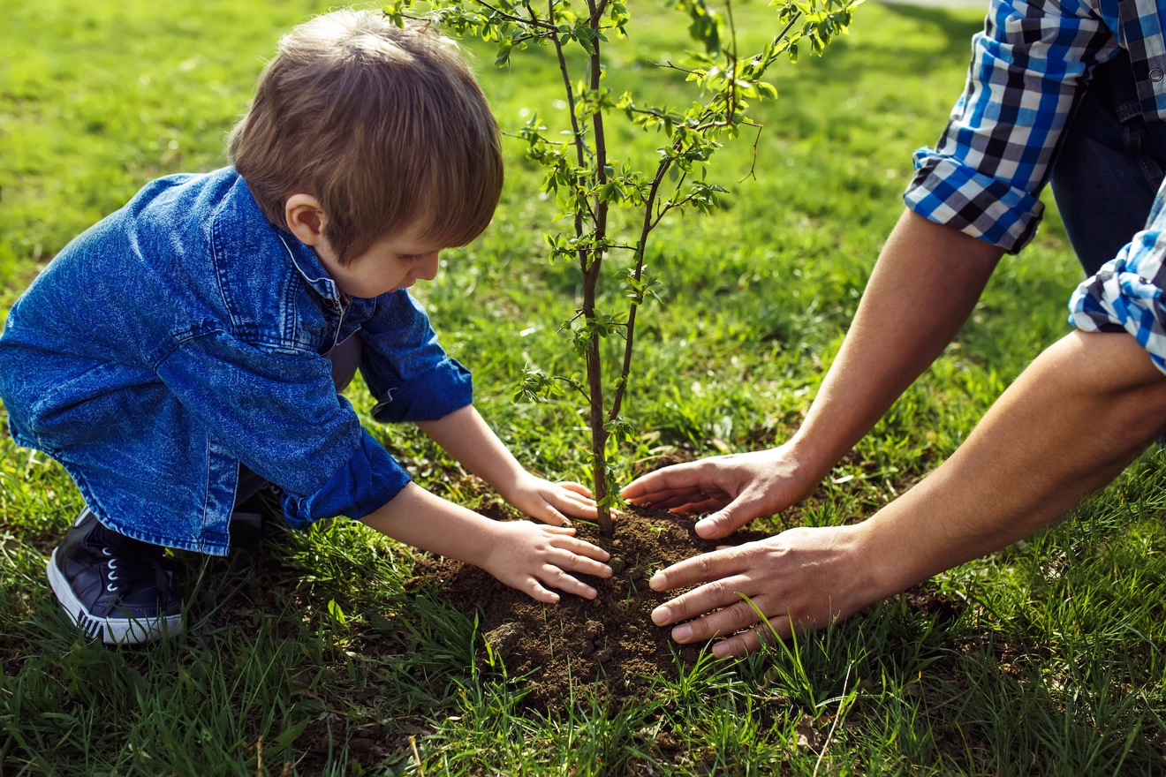

Index

P3 Introduction

P4 Outcome 3.1: Set up and organise a Forest Kindergarten site
P5 Embedding routines
P6 Embedding the curriculum into Forest Kindergarten routines

P8 Outcome 3.2: Nature pedagogy
P9 The importance of values and beliefs
P10 Loose parts and the connection to play in woodland and greenspaces
P12 The nature play themes
P14 Indigenous perspectives

P15 Outcome 3.3: Curriculum for Excellence through woodland visits
P21 Developing your outdoor practice
P22 When practitioners are unsure what to do or say or how to interact in a natural space
P23 Possible lines of development
P27 A natural curriculum
P28 Forest family bags – involving families

P30 Outcome 3.4: Forest Kindergarten observation visit
P31 Forest Kindergarten observation visit reflections
P32 Evaluating the impact of Forest Kindergarten
P33 Finally

Introduction

Traditionally, local woodlands, nature walks and the use of a garden as a place for children to play and learn about the world around them has been part of early childhood education for decades. There is also documented evidence from Pestalozzi, Froebel, Owen and others that span several centuries.

In recent years, with the rise in research about the benefits of children playing in natural spaces, the interest in how and why this matters has grown. Furthermore, we are now living in a world where climate change is a serious reality. Learning for sustainability has a gravitas and urgency that the early years sector can adopt, adapt and demonstrate sector-leading practice through the emphasis on getting children outdoors.

In order to ensure that children have broad, rich outdoor experiences underpinned by the Curriculum Design Principles and SHANARRI wellbeing indicators, there are several concepts and ways of thinking that can help. Scottish Forestry and the Forest Kindergarten course does not advocate one type of pedagogy over another but hopes that all ELC establishments can integrate good principles and practices into their ethos and ways of working outside.

The Forest Kindergarten SQA course has four practical outcomes in the Pedagogy Section. In order to achieve these, it is helpful to consider not simply the function of going to a local woodland or greenspace, but the way in which we do this and why. A high quality Forest Kindergarten experience takes full account of the child-centred pedagogy described in Realising the Ambition national guidance:

Pedagogy is a word that is in everyday use now, but do we all have a clear and shared understanding of what it really means? And how do we use that understanding to implement play approaches in our settings? Stewart and Pugh define pedagogy as ‘the understanding of how children learn and develop, and the practices through which we can enhance that process (2007:9). This definition is rooted in the values and beliefs about what we want for children, supported by knowledge of the child backed up by what we know about early childhood development and our experience as practitioners. RtA, p47

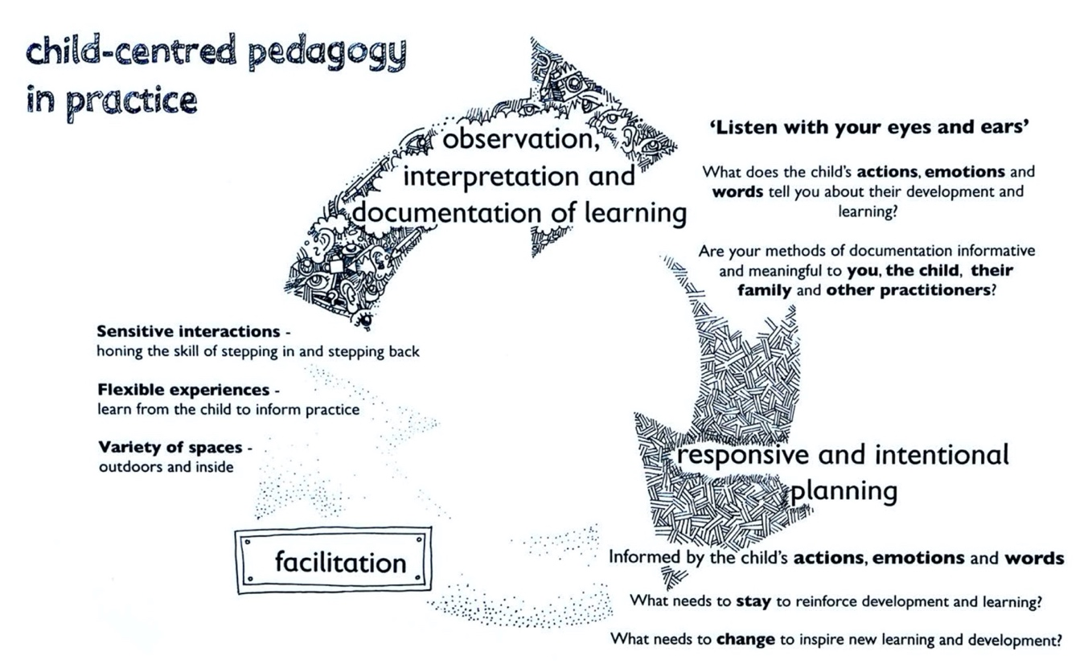
The illustration above is taken from RtA, p48

Outcome 3.1: Set up and organise a Forest Kindergarten site

Assessment criteria | Assessment method
Demonstrable practice of setting up a forest kindergarten site | Outdoors: Observation, photographs, video

This section is about demonstrating your readiness to put your training into practice.

A quick summary
- Find a suitable wood that your setting can use on a regular and frequent basis. Complete the site appraisal form.
- Seek permission to use it and get agreements in place about management and access.
- Check that you and the owner/management have appropriate insurance in place.
- Do a risk benefit assessment of the area you will be using.
- Work out how the group will get to the woods: walking; parent drop-off; public transport or minibus.
- Inform and involve parents. Find extra adults to assist with the sessions. Remember that 1-to-1 informal approaches often work well. Make sure they know what to expect.
- Prepare the children.
- Set up systems and routines for the woodland visits.
- Ensure everyone knows their role. Have a designated lead person for each visit.
- Do a site check prior to each visit and remember to dynamically risk assess throughout the session. Have alternatives and cancellation procedures in place if forecast is particularly poor.
- Go to the woods
  - Keep a close eye on all children and their well-being and engagement.
  - Let the children have freedom to play, explore and discover independently. There is no need for structured activities unless it particularly fits with something the children have been interested in or there’s a special event.
  - When it comes to risky activities, trust your children. They will rarely do anything beyond their ability if they have been given time and space to assess and consider what they can do. You know your children. You know the importance of free play and the value of meaningful, sensitive interactions with children.
  - The more you visit the woods, the greater your own and everyone else’s ability to read, assess the risks involved and respond appropriately to what’s happening.
  - Avoid putting a child into a risky situation such as helping them up a tree. Also have the expectation they can get themselves out of anything they get into! Sometimes help will be needed.
  - Occasionally accidents will happen, and this is an inevitable part of childhood. Ensure that you have policies and procedures to deal with this.

- Follow up interests back in the nursery and vice versa.
- Ensure on-going dialogue between staff and with children and parents to find out how the visits are going and to manage concerns raised.
- Enjoy the experience and have fun.

Embedding routines

Children like to know there is a routine and rhythm to their off-site sessions. This creates a sense of security for children and provides a framework which enables play to happen as safely as necessary.

The development of the routines takes time and will change in response to children’s needs, the weather, seasons and changes that happen in nature. Furthermore, as children and staff become acclimatised to the woodland sessions, routines may shift and change. For example, boundary markers may no longer be needed or children are able to any tree of their choosing within a designated area rather than just one designated tree.

Realising the Ambition specifically mentions the role of responsive routines (p33). Our routines for our off-site experiences need to take account of this advice including:
- Small routines: this is the systems we have in place for things such as getting dressed to go outside or come back in
- Big routines: this is the rhythms of the day – the way we set up our day with times for setting up the site, playing and tidying up. These help children mark the passing of time and provide comfort.
- Ensuring there is a regularity and predictability that gives security and a sense of safety. This may include things such as ensuring the visits happen on the same day at the same time;
- Avoiding the over-regimentation which results in children’s choices getting side-lined, or valuable activities are interrupted because “it is now time for …” An element of flexibility is needed. This also applies to the frequency of visits. Blocks of time such as a set of six-week sessions for a group of children is unlikely to be sufficient for children to learn the routines, acclimatise to being in a new place and develop a deep and lasting connection with the natural world. Gentle routines and transitions that enable one or two children to finish their off-site sessions and allow a couple of new children to join provide opportunities for the more experienced children to demonstrate the expectations and practice. This is enabling them to develop leadership skills in a real situation.

The routines around off-site visits take time to develop when setting up off-site visits. Particularly over the first year, where everything is new, there are likely to be ongoing adjustments. After that, routines will always need tweaked to meet the needs of each new cohort of children. It can be helpful to consider off-site visits as a horizontal transition (RtA, p90). This means thinking about the routines and what consistencies are needed between the off-site and on-site experiences. For some children, this means personal adaptations may be needed to ensure they feel fully included in the experience.

We also have to be aware that children learn routines gradually and at their own pace. We have a role in showing children what to do, supporting and promoting choice, and in explaining what is happening. Some children may not have enough receptive language to cope with this, especially when under stress, so visual and sound prompts can be helpful. RtA, p33

Embedding the curriculum into Forest Kindergarten routines

The routines below demonstrate how the curriculum can be embedded into the Forest Kindergarten routines and make getting ready to go a fun and interesting experience for the children. Participants should be encouraged to adapt these to their children’s interests and abilities. For example, it simply may not be appropriate for one group to line up. However, others will love and enjoy this routine.

Routine | Learning links
Singing a song to signal that today is a Forest Kindergarten day  - LIT 0-01a  - MNU 0-10a  - EXA 0-16a EXA 0-18a | - Develops rhyme and analogy skills  - Easier to remember a song than an instruction  - It’s a non-standard unit of time  - Children can make the transition more easily and have time to respond.  - Children can progress by changing the words of the song or asking for a different song
Putting on outdoor clothing and backpack  - HWB 0-11a, 0-14a  - LIT 0-01a  - MNU 0-02a  - MTH 0-17a  - HWB 0-22a | - Develops independence – core life skill  - Need for sequencing and remembering order. 1-to-1 and other number correspondences  - Learning the concept of left and right  - Development of motor skills required to do zips, put on jackets, etc.  - Develops sequential memory skills which are essential for learning to read
Children do weather check  - SOC 0-12a | - Recognition of weather symbols. Text also supplied  - Use of a digital device to search for relevant information. Children can discuss additional weather factors if they show an interest.  - Comparing to the actual weather outside  - Consideration of appropriate clothing  - Consideration of any personal or group safety measures required
Use of a woodland character: soft toy or puppet  - HWB 0-17a  - HWB 0-04a  - SCN 0-01a | - Modelling how a fantasy character thinks, speaks and behaves: creative pre-writing skills  - Helps develop empathy: essential for understanding different viewpoints and social skills  - Can model how to behave outdoors and off-site  - Can be re-assuring for an upset child to hold and cuddle  - Company for a child who may prefer or need to be on their own  - Name can help children identify local wildlife, e.g. badger, red fox, owl
Doing a head count  - MNU 0-01a,  - MNU 0-02a,  - MNU 0-03a | - Estimation of group size, then check through counting using 1-to-1 correspondence progressing to passing object and counting aloud  - Adding on the number of adults to demonstrate partitioning of numbers  - Modelling and use of mathematical language: eventually children can lead activity  - Number recognition: magic number, progressing to the partitioning of numbers
The 1m lead stick for child at the front  - MNU 0-11a,  - MNU 0-17a  - HWB 0-18a | - Developing leadership and responsibility  - Demonstrating trust  - Embodying the sense of a standard unit of measure  - Recognising key features and remembering the route to the woods  - Beginning to develop aspects of road safety

If practitioners backlink all the learning happening within the routines to Curriculum for Excellence, it is then easy to see how full-on the woodland sessions are as an opportunity to learn through doing.

Once your routines are set up, have a sweep of the Early Level Experiences and Outcomes. Many of these will naturally cover a lot of the experiences and outcomes. For example, think about:
- Road safety and accessing the site
- Routines around snack and toileting arrangements
- The rules agreed with children for playing in the woods
- The safety practices in place, e.g. 1,2,3 Where are you?
- The nature of the play taking place as a consequence of the natural materials and features in the woodland, e.g. balancing along tree trunks, climbing up trees, making dens from branches, etc.

The balance between adult-led structured activities and child-led play in the woods

Some practitioners struggle knowing what to do when in the woods or feel under pressure to plan a structured activity to demonstrate that children are learning. As can be seen from the above illustrations, a lot of learning can happen if intentionally planned for through the routines around Forest Kindergarten sessions.

Sufficient time to play is really important. It is when children start to connect with the woodland in an intimate and personal way. In the Loose Parts Play Toolkit (2nd Ed), Appendix 1 has linked the CfE Experiences and Outcomes to free play to demonstrate that learning is still happening.

Outcome 3.2: Nature pedagogy

Assessment criteria | Assessment method
Provide a range of nature-based activities | Outdoors: Observation

A developmental progression of experiences

Forest Kindergarten and other outdoor experiences can be facilitated in ways that build upon child development theories. This relies on the adults understanding child development. In Sweden, the model below is used to help children cherish nature, have increasingly adventurous experiences and ultimately take action to conserve and look after nature and the wider environment. Natural Resources Wales used this concept to create their natural progression poster: http://bit.ly/2lOVskF

The basic steps are:

Age | Understanding and action
0-4yrs | Being in a natural environment, enjoying it and feeling comfortable in it.
5-6yrs | Connecting with nature – observing and experiencing
7-9yrs | Developing knowledge and understanding of nature
10-13yrs | Understanding own and others impact on nature and why sustainable management is needed
14-17yrs | Developing values and beliefs about natural that demonstrate care and positive action
18 yrs + | Influencing society as an active, responsible and ethical citizen

The I Ur och Skur – In Rain or Shine outdoor nurseries who mainly work with children aged 2-6yrs collectively all sign up to a set of agreed principles. These are:
- The pedagogical approach is that children’s need of knowledge, activities and togetherness is fulfilled by being in nature.
- Children learn how to be in nature and how to protect it. This is achieved by having fun together in the forest, fields, mountains and on lakes in all kinds of weather, all year round.
- Cooperation with the children’s parents maintains quality outdoor activities.
- Nature is not indestructible. By improving knowledge about nature and understanding of the interrelationships in nature, this can change people’s attitudes.

The pedagogy is based on the conviction of the founders that “children receive help in their development from things found in nature. They learn to crawl, jump, balance and climb on fallen trees and mossy rocks. This is an ideal playground. Children get a feeling of togetherness as they listen to fairy tales under a tree whilst sharing a picnic. Their senses are trained by tasting, smelling, touching, looking, listening and comparing anything that can be found in a meadow, woodland or lake. Curiosity and an inquiring mind soon become directly stimulated when children are outdoors. Every caterpillar, beetle or flower can provoke a cluster of questions and thoughts. All this helps children in I Ur och Skur schools to attain a built-in feeling for nature which will last a lifetime.”

The other interesting aspect to the I Ur och Skur nurseries is that when establishing one, there is an expectation that within walking distance children will have access to:
- A body of water, such as a stream, pond or lake
- A hill for rolling down, climbing up, sledging on
- An orchard or places where food can be foraged
- A woodland or forest, for exploring usually at least twice per week

The importance of values and beliefs

Development also happens within the social and economic (socioeconomic) culture which surrounds the child. We want our children to have the strongest start in life, in a culture where they receive the right kind of support and experiences to lead secure and flourishing future lives. RtA, p15

The values and beliefs of practitioners are of paramount importance. They shape how children think, feel and perceive the world. Young children will also copy the actions of adults. Consider the following scenarios:

An adult who:
- Shrieks and runs away when a wasp comes near.
- Is not appropriately dressed for being outside and looks unhappy and uncomfortable
- Ignores litter on the ground
- Uses a site but never does anything to care for it

Compared to an adult who:
- Takes an interest in a spider discovered by a child and wonders how it spins such a beautiful web
- Is dressed for the weather and is looks happy and comfortable outside
- Looks and sounds disappointed when litter is found and picks some or all of it up
- Listens to children’s ideas to care for the site and ensures some of these are acted upon

This may initially be challenging for some staff who have not spent much time outside and have not had pleasant experiences. It’s important to take the time to acknowledge genuine fears and dislikes and as a team work together to support each other to develop the mindset and habits that give our children a chance to have positive outdoor times. For example, an adult who is frightened of insects could carry around a pot or bug box that has a magnifying lid and a teaspoon. When I child brings an insect up to show, then it can be popped in the box without the need to touch or express fear.

I am constantly learning my likes and dislikes and am learning how to communicate these in a thoughtful manner. You are helping me develop this through your kind responses. You and I share ideas and verbalise what’s happening and I feel that you notice and understand me. RtA, p27

Loose parts and the connection to play in woodland and greenspaces

Simon Nicholson’s 1971 article, The Theory of Loose Parts: How NOT to Cheat Children is worthy of a close read and a lot of reflection. Some key ideas include:

1. Everyone can be creative and inventive. You can see this when you observe children of all abilities play with loose parts.

2. Loose parts are variables. Nicholson’s definition goes beyond open-ended materials to include phenomena such as music, gravity, and playing with words, concepts and ideas and much more. This is considerably broader than natural, junk and recycled materials. We need to be mindful of the breadth of possibilities in any given environment.

3. Children need environments that have lots of loose parts or variables. When an adult, such as an architect or planner designs a space that is “too clean and static and being impossible to play around with”, Nicholson suggests that they have had all the fun during the design process and have effectively stolen the creativity from the children. Thus, the concept of loose parts extends to the environment in which the variables occur. When applied to a woodland or wild greenspace, the practitioners will have had limited input into the creation or development of the space. A nursery room or outdoor space where the layout, design and flow around the space has been largely decided by adults. One could argue that there is a subtle shift of power and the woodland enables children to have greater agency and autonomy over what, how and where they play. However, it relies on practitioners being able to facilitate this.

4. Children need to have “space-forming materials in order that they may invent construct, evaluate and modify their own” This in turn links to how children learn particularly well in a “laboratory-type environment where they can experiment, enjoy and find things out for themselves.” When applied to a woodland context, eventually, children and staff will need to use tools and will want to shape and modify the space accordingly. It’s what humans do. It is also why being aware of our impact on the ecology of the site matters.

5. That everything is place-specific. What works in one woodland may not work in another. It may sound obvious but it’s amazing how often we see models being imposed from one place to another and then wonder why they don’t work. This is particularly important in natural spaces where the climate, landscape and ecology will create more variables than in a designed outdoor space.

6. Nicholson suggested that when considering the impact of curriculum development, educators should ask:
- What did children do with loose parts?
- What did they discover or re-discover?
- Did they carry their ideas back into the community and their family?
- Out of all the possible materials that could be provided which ones were the most fun to play with and the most capable of stimulating the cognitive, social and physical learning processes?
The latter two questions are not always given sufficient consideration, yet are highly valuable as we need to be ensuring connections between children’s school and home and community lives. The materials which are most fun and stimulating start moving into the concept of affordance – the range of possibilities that children perceive in any given resource or environment. This is made even more interesting when we use Nicholson’s examples of variables and phenomena.

7. Nicholson valued environmental education in a holistic way, perceiving humans to be part of the bigger ecosystem and also acknowledging that they had created within this values, concepts, alternatives and choices. “To express this in the simplest possible terms, there is a growing awareness that the most interesting and vital loose parts are those that we have around us every day in the wilderness, the countryside, the city and the ghetto.” This is indicative of the ecological thinking, that Jan White, David Sobel and others have since explored – see the Nature Play Themes section.

The Loose Parts Play: A Toolkit – 2nd Edition
The document is a good guide for getting going with developing this aspect of your outdoor provision both on and off-site. One limitation of the document is that it is a generic guide and not early years specific. The main difference between a play session, e.g. at a primary school lunch time and in a nursery is about intentionality.

Practitioners need to:
- Know and be able to articulate the learning benefit of every resource and how to extend the learning through their interactions with their children and building upon their interests.

- Understand the developmental behaviours and perceptions of children and adapt what is offered accordingly.

- Realise that outside, the play and learning comes alive because of the interplay between the child, the loose parts, the environment and the weather/seasons. This cannot be replicated inside which is why outdoor play is unique and special.

- Ensure that the entire outdoor space – all zones/areas need loose parts that can be used flexibly. Have sufficient materials and items to engage all children without overload. This applies equally to outdoor settings and also to their indoor spaces, however basic.

- Have clear systems in place for checking new loose parts for their suitability, introducing them to children including any safety matters around the use of the resource, managing them outside: storage, access, etc. and how to maintain and eventually dispose of the loose parts. In a woodland or greenspace, daily site checks and proactive communications with the landowner/manager is the equivalent.

- Facilitate children’s play in sensitive and timely ways. This can make a huge difference to how children experience and use loose parts. The second edition has a much greater emphasis on this.

- In an educational context, Anna Ephgrave’s Planning in the Moment approach seems to complement the Theory of Loose Parts well, particularly around children’s freedom to choose from all the available resources to develop their learning in their own way.

The nature play themes
(Extracted from Casey, T. and Robertson J. (2019) Loose Parts Play: A Toolkit Inspiring Scotland http://bit.ly/2NXizaf p13-15)

The concept of loose parts and their affordances can be interwoven with studies about how children play outside, particularly in natural environments. There appear to be patterns to children’s play which emerge almost regardless of climate, culture, class, gender, developmental level or age. They link to how humans grow and their need for identity, attachment and a sense of connectedness to place, as well as people. In our rapidly changing world, we need to ensure children have opportunities to develop this sense of belonging and being with nature.

Jan White (2014) , considered the work of David Sobel, Jay Appleton and Ann Pelo. Noticing similarities in their ideas, from different decades and from work with children and young people of various ages, she proposed that the themes could be merged to provide a framework of reference. This can:
- Increase adults’ understanding of how children play
- Provide ways to support children’s attachment to nature and place
- Suggest engaging environments for playing with loose parts.

When playing in a woodland or greenspace, practitioners can reflect upon these play themes to ensure that their provision supports their children to follow these inherent human interests.

Play Theme | Loose parts play provision
Adventure  Seeking out the unknown, stretching limits of possibility, taking calculated risks, anticipation, discovery and invention. | - exploring away from adult eyes (or perception of this)  - establishing a culture where adventure and uncertainty is supported  - creating spaces with many layers to discover  - providing time to listen to and hear children’s experiences, should they wish to share.
Enclosure, dens and special places  Creating space, shelter, security, hiding and secret places, refuge and territorial boundaries. | - Resources for building dens  - Props for developing the play within a den or secret place  - Scrap cardboard and writing materials for creating signs  - Nooks, crannies, trees and bushes or undergrowth to hide in or be alone  - Large cardboard boxes and pieces of material both see-through and dark
Prospect (height)  Searching out high places, views and look outs, surveying the landscape and mapping areas. | - Being high up – top of a hill  - Climbing trees, boulders and other objects  - Balancing on features  - Play on different levels  - Spyholes, gaps and see-through spaces, including windows and doorways
Paths and journeying  The need for exploration, mapping out an area in many ways, finding short cuts and secret routes, tunnels, knowing the local area, making one’s mark in the landscape. | - Map making and using opportunities – both real and through digital devices  - Trail making with natural resources and props such as ropes or chalk  - Freedom to explore and get to know a local area  - Finding your way
Hunter-gatherer activities  Searching, finding and collecting, stashing and hoarding, treasure hunts, traditional games like hide ‘n’ seek, foraging, bushcraft skills, fire, tool use. | - Time to invent and play games  - Collecting and using natural materials  - Containers such as pockets, bags, baskets and buckets  - Using real tools to create, make and take apart different objects  - Experiencing fire,  - Bushcraft type activities: whittling, fishing, foraging
Animal allies  Projecting self onto other living things, feelings for, and empathy with, plants and animals of all kinds, developing personal connections to wildlife through direct experience and fantasy, the significance of names. | - Ensuring time and space to discover wildlife on children’s terms  - Creating places to hide and watch wildlife, creating habitat piles, bird feeding stations and nesting boxes, etc.  - Simple props for dressing up and being animals
Imaginative narratives (stories, imagination and fantasy)  Making sense of the world through fantasy play, small world play and creating stories and accounts of experiences that connect and deepen friendships and relationships between each other and the places they play, creating memories and reaffirming order and meaning. | - Constructing and deconstructing miniature worlds  - Dressing up inside and out with open-ended props such as quick dry materials and simple, open accessories, marking or painting face and body  - Making and creating fantasy characters  - Listening to the stories children tell and recording them where appropriate  - Ensuring ample undisturbed time for play to spark and emerge
Making rituals  Deliberate, ceremonial, meaningful actions often with metaphysical or transformational intent, invented by and participated in by individuals or groups; honouring or celebrating events, places, features through art, music, dance and role play; giving and receiving gifts. | - Attending to, honouring and supporting the development of the simple but significant rituals of children  - Providing space, time, freedom and space for children to dance, make music and explore art inside and out  - Celebrating play  - Re-visiting places regularly and frequently such as local greenspace
Indigenous perspectives

World-wide there is a recognition of the intimate relationship many indigenous groups have with the natural world. Very often the relationship is highly respectful and based upon gratitude, reciprocity and kindness. Sacred places are beginning to be acknowledged and languages on the verge of extinction recorded and revived. The central role of traditional stories about plants, animals, customs, history and food within each group is recognised.

As practitioners, we can find out more about traditional practices in Scotland and re-discover our connection not just with nature but to the land, landscape and our natural heritage. Sustainable practices involve re-framing our thoughts and acknowledging the rights of more-than-human species. This also includes stones, rocks and the earth as a whole living entity. It’s about accepting there are different ways of knowing and being, beyond our Western or colonialist forms of knowledge and habits.

When making key decisions, it can be helpful to consider the social, financial, ethical and environmental sustainability of the matter-at-hand, for example, whether or not to keep chickens. Often key roles can be taken during the decisions that help children and staff think sustainably based upon the work of indigenous groups:

The Earth Keepers protect traditions and connections to the land and the impact of our actions on animals, plants and the environment. Thus when thinking about hens, they might consider:
- Whether there is enough space for chickens to live happily
- What might change? For example, hens like to scratch around and this can cause wear and tear.
- What are the advantages and disadvantages in terms of the impact of keeping hens on the grounds?

The People Persons are concerned about the daily well-being of the family and workable systems based on human relations. They may consider:
- Who will look after the hens and how this will happen?
- Who can help with this job and how can we all do our bit to keep the hens happy?
- What are the benefits of looking after hens in terms of our own well-being?

The Practical Problem-solvers focus on things necessary for security, sustenance and shelter including practical strategy, logistics and action. They may consider:
- How much money will keeping hens cost? Can we afford this?
- What actions need to be taken to protect the hens and keep them safe from harm?

The Future Thinkers are the people with creative energy, who yearn for change that will bring a better future. They are interested in innovative possibilities and carrying these out. They may consider:
- Enterprising ways of fundraising to keep hens
- Ideas for future possibilities to do with hens, such as making their pens more interesting for the hens.

Outcome 3.3 Curriculum for excellence through woodland visits

Assessment criteria | Assessment method
Identify Curriculum for Excellence at the early level experiences and outcomes and the cross curricular areas that relate to each activity | Outdoors: Observation, photographs, video

Helping children to become responsible through outdoor experiences can put them in touch with their local environment and community. It can lead naturally into learning about ecology, sustainability and global citizenship, helping them to become responsible citizens – one of the four capacities the Scottish Government aims for children to achieve through the Curriculum for Excellence. My World Outdoors, p53

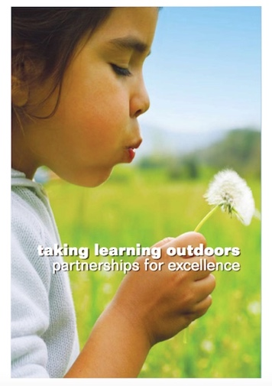
When considering Forest Kindergarten in relation to Curriculum for Excellence (CfE) we need to reflect on the core elements of CfE and use these to ensure that Forest Kindergarten is fit for purpose – that is, it develops the whole learner and not simply ‘delivers’ on the curriculum.

The text below is extracted and adapted from Learning and Teaching Scotland (2007) Taking Learning Outdoors. Whilst one of the older documents, the advice remains valid. It is useful for educators to use the statements and reflect upon whether their Forest Kindergarten experiences are of a high quality and match these expectations.

Curriculum for Excellence is a holistic curriculum that is flexible and adaptable to children and their learning environment. It establishes clear values, purposes and principles for education from 3 to 18 in Scotland. It sets out to enable children and young people to develop their capacities as:

Successful learners
- Outdoor learning can have a positive impact on long-term memory.
- There is substantial evidence that in outdoor learning, learners develop their knowledge and skills in ways that add value to their everyday experiences in the classroom.
- There can be reinforcement between the affective and the cognitive, with each influencing the other and providing a bridge to higher order learning.
- Substantial evidence that outdoor learning has the potential to raise attainment and improve attitudes towards the environment.
- Evidence that outdoor learning fosters the development of specific academic skills, as well as improved engagement, achievement and stronger motivation to learn.

Confident individuals
- There is substantial evidence that outdoor learning can impact positively on children and young people’s attitudes, beliefs, and self-perceptions, for example: independence, confidence, self-esteem, locus of control, self-efficacy, personal effectiveness, coping strategies.
- There are examples of outdoor learning programmes yielding benefits in the promotion of positive behaviour and improved physical self-image and fitness.

Responsible citizens
- Renewed pride in community with greater sense of place, of belonging and responsibility.
- There is significant evidence of the effect of outdoor learning on social development and greater community involvement.
- In outdoor learning, pupils develop more positive relationships with each other, with their teachers and with the wider community.
- Clear evidence that outdoor learning increases knowledge and understanding of the natural world and environmental systems and processes, and that this knowledge and associated affective development are related to responsible attitudes to the environment.

Effective contributors
- Strong evidence across a wide range of outcomes identifies positive effects in the short term and continued gains in the long term.
- There is substantial evidence that outdoor learning can impact positively on children and young people’s interpersonal and social skills such as: social effectiveness, communication skills, group cohesion and teamwork.

Process/methodology outdoors

A Curriculum for Excellence recognises that learning is embedded in experience. By taking learning outdoors we remove some of the barriers that the traditional classroom can put up between children and young people and first-hand, real-life experiences. Outdoor learning is hands-on and direct, and the knowledge that pupils gain from it is real, first-hand and often unforgettable. Contextualised, applied learning outdoors often stimulates and intrinsically motivates learners who attend to engage with learning longer with less disruptive behaviour.

Outdoor learning can be the space for learning beyond subject boundaries, so that learners can make connections between different areas of learning. Through interdisciplinary activities of this kind, children and young people can develop their knowledge, understanding, enterprise and organisational skills, creativity, teamwork and the ability to apply their learning in new and challenging contexts.

The wealth of opportunities for personal achievement associated with outdoor learning enriches the life experience of learners. Taking part in these activities plays an important part in widening a child or young person’s horizons, developing confidence, progress and achievement. These achievements must be recognised for the significance they have to learners, their families and communities.

Outdoor learning curriculum design principles

- Challenge and enjoyment: active learning, engaging and motivating
- Coherence: draws on different strands of learning, often into a single extended experience.
- Relevance: contextualises learning to the world and life beyond the school.
- Choice: opens horizons to the variety of learning for life beyond the class setting.
- Breadth: a wide variety of contexts and environments for learning and experiences exist over the doorstep.
- Depth: direct experience of the complex interdependence of life on Earth enables reinforcement of the link between cognitive and affective learning, providing a bridge to advanced understanding.
- Progression: for all young people from 3 to 18 years demands
a wide range of outdoor learning experiences. Progression in settings from school grounds to (potentially) international travel, progression in pedagogy from didactic to self-led, progression in activity from simple observation to technical forms of travel, progression in values and content.
- Expression and creativity: through working in smaller groups and responding imaginatively to stimulating settings, contexts and activity.
- Holistic: intellectual, physical, emotional, aesthetic and spiritual development can occur together.

Eight curriculum areas
- Language (includes Literacy, English, Gaelic and other languages)
- Maths and numeracy
- Technologies (includes food, textiles, craft, design, graphics, information technology, engineering)
- Health and well-being (includes physical education)
- Sciences
- Social subjects (includes history, geography, modern studies, aspects of business)
- Expressive Arts (dance, drama, art)
- Religious and moral education

Cross-curricular themes
These must be addressed when implementing a Curriculum for Excellence but also worth reflecting about how Forest Kindergarten helps children develop the skills, knowledge and understanding through an experiential approach for all these themes:
- Citizenship
- Enterprise
- Outdoor learning
- Creativity
- Thinking skills and problem solving
- Education for sustainable development
- International education
- Culture
- Community links
- Health promotion
- Leadership (all staff)

Contexts for Learning
There has been a greater emphasis in recent years on the contexts for learning. This includes:
- The ethos and life of the school as a community
- Curriculum areas and subjects
- Interdisciplinary learning
- Opportunities for personal achievement

As woodland visits will be a frequent and regular part of a setting’s routine, then it is important to remember that practically all the experiences, outcomes, approaches and other educational expectations can happen within this time. Within the principles and purposes of Curriculum for Excellence (CfE) as well as through the experiences and outcomes there are lots of opportunities for learning outdoors. It can be helpful to consider the woodland as simply another learning environment or space. You have traditionally used your indoor and outdoor spaces at your setting. Now you have another space that can be used.

In particular the health and well-being aspect of going to the woods and playing there is of big value. The Education Scotland document Outdoor Learning: Practical guidance, ideas and support for teachers and practitioners in Scotland cites many benefits of free play in natural settings in terms of children’s well-being, meeting their needs and fostering creativity in addition to sustainable development education.

Rather than assuming that everything is being covered, it can be useful to undertake an audit through observations and evaluations of the woodland visits. Observations are essential to understand how learning is supported through child-initiated activity. There are many ways to consider the benefits and impact of woodland sessions. Remember too, the observations and recordings will help you articulate the benefits of the woodland sessions and the relevance of the time spent to other parts of children’s lives. Below are suggestions which you may wish to undertake:

1. Observe individual children’s play
There are some children who truly flourish when involved in a woodland session. Others take time to acclimatise. Use your settings normal approaches and procedures to record individual progress. For example, you may wish to observe one or two children using the Leuven Scale of Wellbeing and Involvement at both the nursery and woodland environments. From here, specific support measures can be considered.

2. Ensure the woodland visits are planned, assessed, recorded and evaluated in line with your setting’s practice
Woodland visits should not be not an “extra” or special addition to provision. Thus, using the formats normally used in your setting should apply to the woodland sessions too. Many establishments used big book planners with children to think about their woodland experiences. Little books and journals are also popular which can be shared with parents or kept in the reading corner for children to access as they wish.

3. Curriculum design principles and woodland visits
The curriculum design principles can be used as a basis for continuing review, evaluation and improvement. When starting out, consider the totality of the woodland session in terms of what it offers children on the basis of the principles:
- Challenge and enjoyment
- Breadth
- Depth
- Personalisation and choice
- Progression
- Coherence
- Relevance

After a few months, revisit your original thoughts and see if anything has changed. It will also give you an indication on how your own thinking and ideas have changed through undertaking the woodland sessions

4. Reflecting upon the SHANARRI wellbeing indicators
When you are undertaking a significant change to your practice, such as embedding woodland visits, it can be helpful to reflect using the wellbeing indicators. This ensures that children’s wellbeing is a primary consideration whilst you embed your approaches. Furthermore, children and any volunteers can usually feed into these reflections. The Care Inspectorate (2016) My World Outside has lots of positive examples to assist. Realising the Ambition (2020) is also a useful reflective tool to help embed quality.

The use of the Wellbeing SHANARRI indicators is a useful approach particularly when starting out, to ensure that the establishment of Forest Kindergarten is addressing these fundamentals. It can be useful to take one indicator at a time and as a team discuss and look for supporting evidence. Children and volunteers can also be involved in discussions, such as:

- How do we keep ourselves safe when visiting the woods?
- In what ways can we look out for each other?
- What routines have we put in place to ensure the safety of everyone?
- What makes us feel safe when we are in the woods?
- Is there anything we worry about? What can we do to address our worries?

It is important that staff reflect personally on these questions as well as thinking about what they are doing for their children. A practitioner who is genuinely concerned about an aspect of practice needs to have a safe space and time to express these concerns and to know that the team is there to listen, acknowledge and agree strategies that are workable.

Below is an example of a staff journal kept by one nursery that used this approach. They kept their reflections and evidence in a big book so that it was all in one place and any part-time members of the team could easily look and find out what was happening week-on-week.

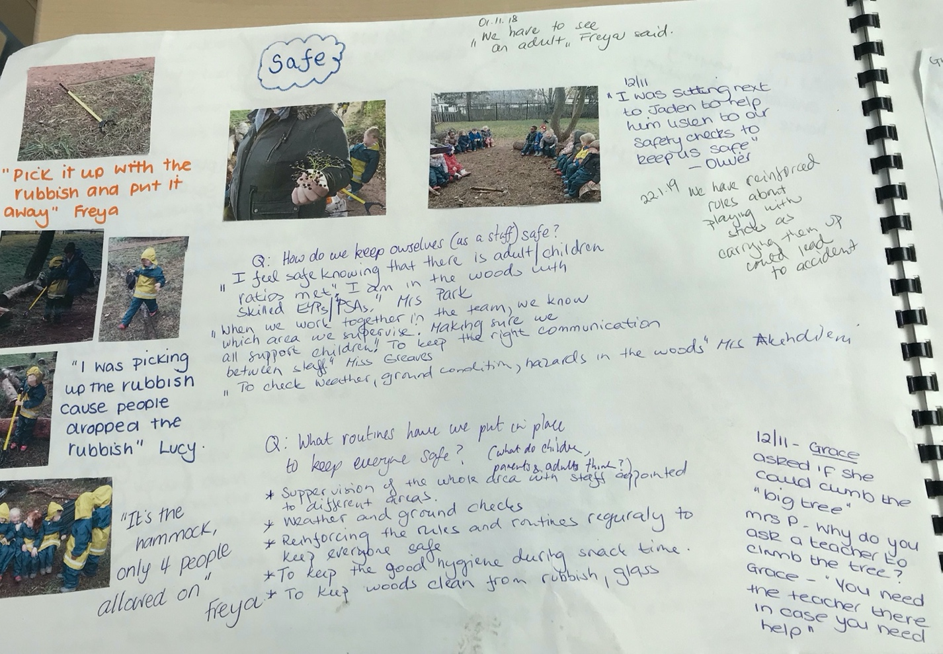

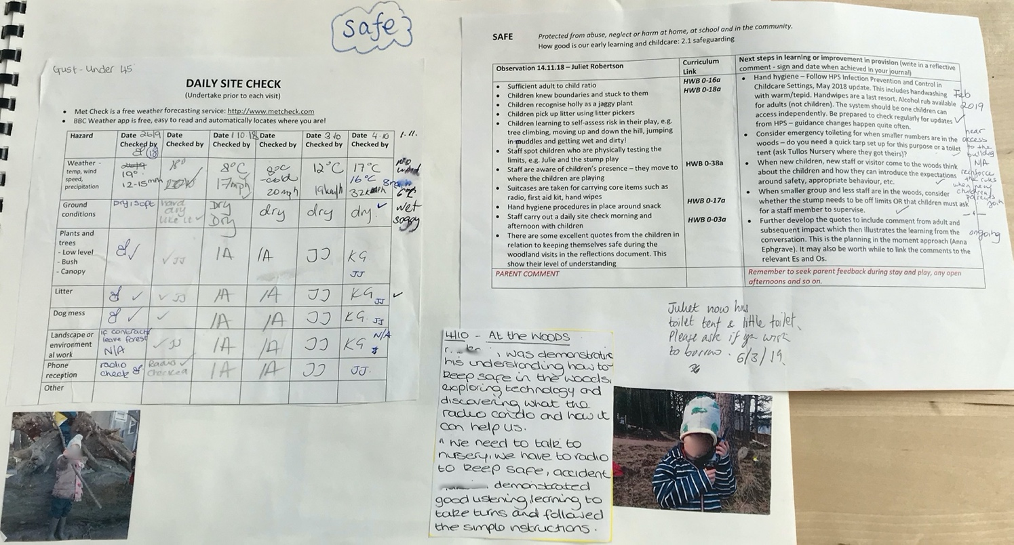

4. Audit specific curriculum areas or skills
Very often visitors which may include parents, inspectors, other child professionals and staff from other settings will ask questions about aspects of learning. It can be helpful to observe the development of specific skills such as numeracy or literacy so that you can reassure yourself and others that the woodland environment develops and extends these skills. It is an opportunity to demonstrate the transfer of skills from one context to another.

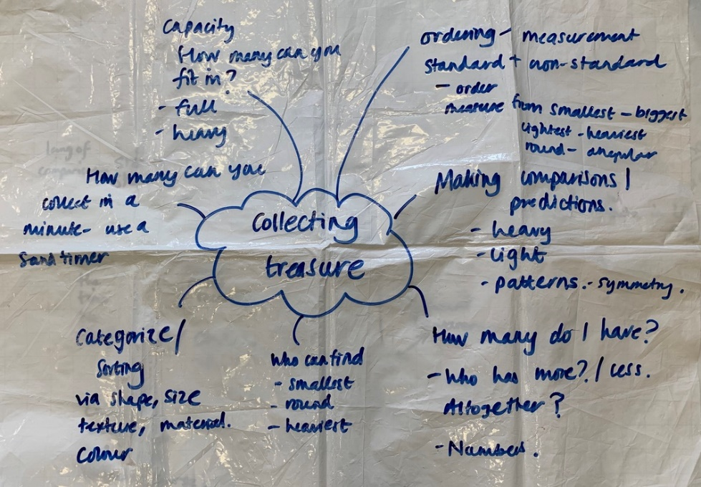
For example, one week observe and record mathematical skills being used by the children. See which experiences and outcomes are being covered and what practitioners can do to extend the children’s mathematical knowledge, understanding, language and skills. Another time, look at another aspect of the curriculum such as talking and listening. This can help all practitioners tune in to the educational value of the woodland visits and how they can complement and extend the experiences children have at their setting.

Developing your outdoor practice

The time spent in your local woodland is a valuable part of any child’s pre-school experience. This section contains suggestions about how learning and play can be extended, following children’s interests and the experiences they may encounter whilst playing in the woods. Many of the activities can be undertaken in your outdoor spaces providing a flow of learning between the woods and nursery. Some can be undertaken en route to and from the woodland or other greenspace.

Stories, songs and rhymes – oral literacy
Invest time putting together songs, stories, fairy tales, poems and rhymes ready to be used when an interest is sparked. These do not all need to be taken with you but can be used to follow up a session in the woods or to take along to the next session. Often children enjoy a song to sing at the start and end of a session. Also build up songs, stories, rhymes and poems that suit specific places within the woods. For example, if you let children run to the “spider tree” the children who arrive there first can look for spiders on the tree. Then once everyone’s arrived, you can all sing “Incy Wincy Spider” or another song. The repetition of rhymes linked to places is very powerful.

Develop simple stories associated with key features. These can be based upon folklore or relate to how a feature looks. For example, a big boulder might be nicknamed the “shelter stone” by the children. You can make up a simple story about two children who got lost one day and took shelter there until their mum found them. The children can help create these stories. At a bridge, the theme might be looking for evidence of the troll that lives underneath it. You may never see the troll but it might leave messages on leaves, or marks in the mud. It will be a friendly troll of course!

Games
Many children like and enjoy playing games in the woods. It’s worth building up a selection that work well and develop a range of skills. Often the well-known games can be tweaked, such as “Grandmother’s Footsteps” which has a different feel when played in a wood. Do not force a child to play a game against their will. Some children like to see how a game works first before joining in. Try and avoid games where some children lose and have to wait passively. Keep all the children active all of the time.

Plant and animal identification
Do not feel you have to know the names of all the plants and animals in the wood. A flexible approach is best where you discover, search and experience together with the children. Generally, you know when children are ready to experiment and look for knowledge when they ask, “What’s that?”

- Build up simple identification books for children to use based upon the common plants and animals seen in your woodland and take these with you. Keep them simple, e.g. spider, worm, slug, blue tit. Over time, everyone’s knowledge and ability to observe the surroundings increases.
- Children also enjoy looking at the illustrations in guide books or the Field Study Council sheets.
- Every now and then, preferably in different seasons, invite a ranger or naturalist to accompany the group and capitalise on their skills and knowledge.
- Use people to help you out. Many parents and grandparents may know local names for plants and animals too and can be wonderful source of inside knowledge about sighting wildlife.
- Use online help. Nature ID apps such as Seek enable you to upload a photo and have it identified.
- Take a camera and let children photograph the flora and fauna they are interested in.
- Often it is the stories and history of our plants and animals that make them interesting and relevant. It’s worth learning little snippets of information for this purpose.
- Try and avoid plunging in, being a “fountain of knowledge” and naming everything when a child asks. It’s better simply to use the names of plants and animals you know as part of your normal everyday conversation.
- Do not expect or ask a child to constantly follow up identification. Follow the child’s lead. If they are really interested and want to know more, then go for it. However it can be off-putting if an adult’s response is constantly “I don’t know, let’s find out.”
- If you are allowed to bring back natural materials from the woods (this depends on the management of the woods) then use this as an opportunity to extend the play back at your setting. For example, leaves can be added to your documentation. Remember to follow the Code and gather sustainably in accordance with local advice.

When practitioners are unsure what to do or say or how to interact in a natural space…

1. Observe a child playing in the woods, e.g. with a stick, stones or other natural objects
2. Put the observation in the middle of large sheet of paper along with the natural object, if possible.
3. Brainstorm the learning that is happening through the play.
4. Ask “tell me more” to others in your team. Get the conversation going and add to the ideas. Often, a challenge, invitation or problem solving ideas are generated along with lots of play possibilities.
5. Look at the Nature Play Themes (see p12) and see if these provide any further sparks of inspiration.
6. Finally look at the possible lines of development below. Usually practitioners have come up with lots more ideas than on the sheets.

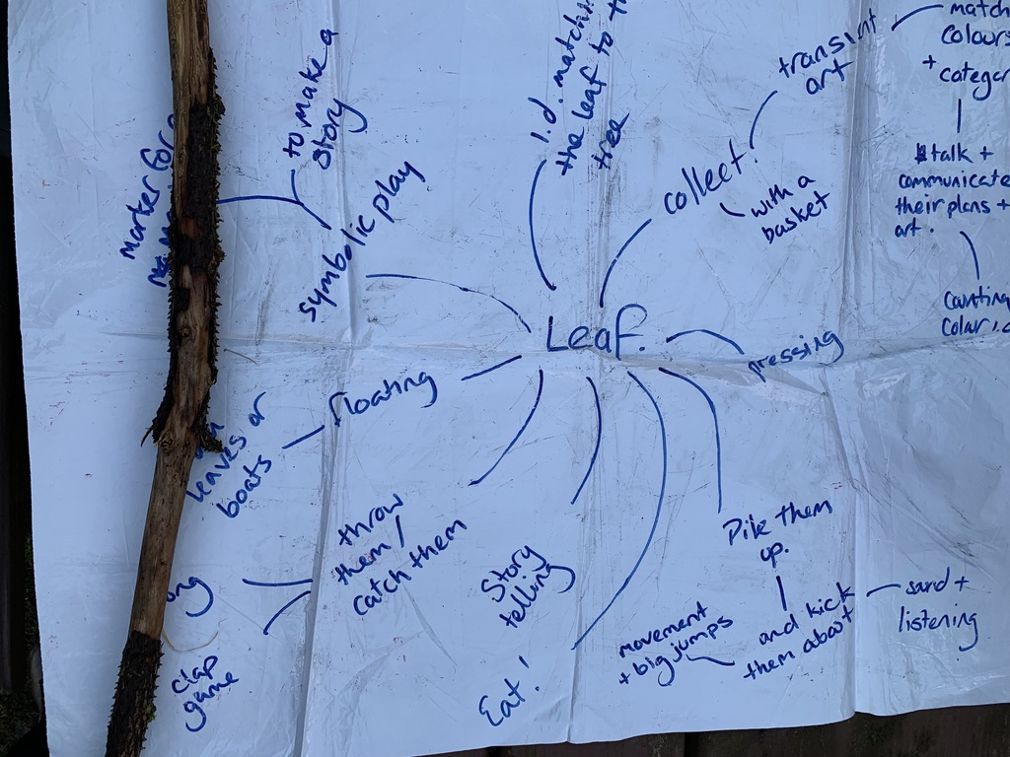

Possible lines of development

Below is an example of ways of developing and extending children’s interests developed from the Creative Star website. They should complement the collaborative approach taken above which leads to more creative and rich thinking if regularly undertaken in relation to how your children are playing in the woodland or local greenspace.

These activities and ideas are not prescriptive and should not be used as forward planning for a programme. Instead, when children’s interests and themes have been observed, these ideas can be used to extend the learning.

STICKS

Literacy  - The Stick Man by Julia Donaldson  - Not a Stick by Antoinette Portis  - One, two, buckle my shoe nursery rhyme  - Use sticks for mark making | Maths  - Using sticks to measure length  - Making measuring sticks  - The stick ordering game  - Use of sticks when making shapes and patterns
Sciences  - Knowing what a stick is and where it comes from. Finding out if all sticks have the same properties. | Expressive Arts  - Sticks for rhythm making and keeping a beat  - Making a rain stick  - Making sculptures and pictures with sticks
Technologies  - Invent a game that uses sticks  - Build things with sticks  - Challenge children to build a tower as high as themselves with sticks | Social subjects  - The lead stick – the person is the way finder  - X marks the spot! The use of sticks to make symbols and signs.
RME  - Life and death. When does a branch or twig die and how do we know? | H&W  - Pick up sticks game  - Think about how we can use sticks safely  - The talking stick at Circle Time

Possible lines of development: STONES

Literacy  - On my beach there are many pebbles by Leo Lionni  - Everybody needs a rock by Byrd Baylor. Follow the instructions for finding your perfect rock  - Mark marking with and on stones | Maths  - Comparative work on weight, size, colour, texture. How will you decide to sort, classify and order stones?
Sciences  - Exploring the properties of stones. Using a magnifier to look.  - What questions can we ask about stones? What is the smallest prettiest stone you can find? | Expressive Arts  - Stones in tins and boxes to make shakers  - Stones as treasure or special objects in role play (using the environment as a resource and stimulus)
Technologies  - Creating stone stacks, miniature houses and other structures from stones.  - Finding stone walls and wondering how these are created. | Social subjects  - Looking at walls, and other stonework on the way to and from the woods. How do we use stones?  - Traditional games with stones – compare with those from other countries, e.g. noughts and crosses, nine-men’s morris, chuckies
RME  - Stones as symbols and markers. Useful for discussions about what changes and what doesn’t  - The use of stones as way markers, e.g. Inuksuks, cairns, etc.  - The story of St. Peter | H&W  - How can we use stones safely?  - Moving and transporting stones of all shapes and sizes

Possible lines of development: WEEDS (Common wild flowers that may be picked)

Literacy  - The Flower Fairy stories by Cicely Mary Barker  - A Little Guide to Wildflowers by Charlotte Voake  - Daisy, daisy, give me your answer do song | Maths  - Estimate the number of flowers growing under a tree.  - “She loves me, she loves me not” – pick the petals off a daisy.  - Tell the time using a dandelion clock.
Sciences  - Have a look at a weed and learn the names of all its parts: roots, leaves, stem, petals.  - Go on a flower hunt for the brightest flowers and the ones which are hardest to see. | Expressive Arts  - Make dandelion chains and crowns  - Press flowers to dry them and make pictures  - Hammering leaves and flowers onto cloth – Hapa Zome
Technologies  - Make a recipe for flower perfume. Tell it to someone else and see if they can make the same perfume too.  - Make daisy chains or dandelion crowns | Social subjects  - Create a trail using a weed flowers for another person to follow. Which sort of flowers would work best and why?
RME  - The Daffodil Principle. How can we do something for others to enjoy? | H&W  - Find out who likes butter in the group. How can this be done with a buttercup?

Possible lines of development: STUMPS

Literacy  - The Giving Tree by Shel Silverstein  - I’m the king of the castle rhyme  - Sitting on stumps as a place to meet and chat.  - Drawing or mark making on stumps | Maths  - Working out how old a tree was from the number of rings on its stump.  - How many children can stand on a stump together? Will this always be the same number?
Sciences  - Working out the type of tree. Pine stumps develop points. Spruce stumps develop holes.  - Looking for interesting cracks and crevices as the stump degrades – biological weathering | Expressive Arts  - Look at the textures of stumps through rubbings. What can the patterns become?  - Inventing sounds by adding things into a stump holes and mixing with a stick. How can you describe the noises made?
Technologies  - Making potions in stump holes. What ingredients make the smelliest potion? | Social subjects  - Creating miniature worlds on stumps.  - Standing on stumps to get a different perspective of the ground.
RME  - Stumped for words? What things leave you feeling stumped and why?  - Learning that stumps are left when trees fall or are cut down. The stump is dying yet new life grows out of the stump. Can we find other things growing from things that are dying?  - Read The Tenth Good Thing about Barney by Judith Viorst. | H&W  - Stumps for climbing on and jumping off.  - Can you jump off a stump in different ways?

A natural curriculum

Being in nature provides ongoing changes which provide endless learning opportunities for children as they play, investigate and discover outside. As practitioners becomes more acclimatised to working outside, then their confidence and skill of using these changes grows. As the plant and animals’ life cycles respond to the prevailing weather, adults have to be ready to respond. The natural events can be merged with ongoing community, religious and cultural events that happen through the academic year. The examples below should be mainly child-led where possible and are illustrative rather than fixed activities.

The other core part of outdoor provision is the ongoing gardening and wildlife jobs. By building maintenance and care work into the ongoing life of the nursery, then children learn many practical skills. In most instances when an adult starts doing a job like planting a tree or pruning a willow den, there’s always a few interested children who are up for assisting.

January and mid-winter

New Year begins with acts of kindness and hospitality and with promises for the time ahead. The emphasis is on sharing with animals and with everyone in the community.
- New year: gathering or walking discussion. What new things have happened in our lives? What new things can we find in our woodland site? What are we looking forward to?
- Discovering the first snowdrop. Observe them, pick just one or two – leaving plenty in the ground. Press the snowdrops, sketch them (white, green and black explorations of colour). Learning the story of snowdrop and discovering the origins of Snow White, discovering different types of snowdrops
- Do a winter clear out of the garden. Remove the dead plant material and compost. Leave a pile with leaves for animals to nest and hide in, in a corner. Link this to the New Year – new beginnings and spring clean.
- Collect dried seed heads for use in art work, e.g. collages. Add to cardboard tubes and tins for rattles, especially for babies
- In consultation with children, decide what flowers and vegetables will be grown this year. Visit a garden centre to buy seeds or ask for donations from parents and families
- Put out food and water for birds and wildlife. Break ice daily so animals can drink and bathe. Older children can participate in the RSPB Early Years Bird Watch. Make binoculars from cardboard tubes and create a bird hide den outside
- Look at buds and bark on trees. Take rubbings – calico cloth often works better than paper as it can be used on wet items
- Look for Jack Frost and find out more about him
- Read books about winter, snow and hibernating animals. Sing songs and poems
- Read traditional stories about people helping each other through the hard winter, frost, snow and ice, e.g. Robin and the Fir Tree, Elves and the Shoemaker
- Hold a Burn’s supper for a special snack
- Develop “Right Wee Ceilidh’s” – an informal, fun circle time with stories, songs, poems and dances being shared and children’s contributions to this valued
- Remember to find out when the Chinese New Year is to celebrate this event too, if relevant for any children
- Make the most of any snow. Have a snow festival.
- Epiphany 6th January. This was the day the wise men visited the newly-born baby Jesus in Bethlehem. It also celebrates the baptism of Jesus by John the Baptist in the River Jordan. It is also the day that Jesus officially performed his first miracle of turning water into wine.
- The Feast of St. Bride at the end of January. More information can be found here: http://www.sacred-texts.com/neu/celt/cg1/cg1074.htm It is a celebration of the impending spring and links Christianity to traditional celebrations in Celtic lands.

Forest family bags – involving families

This concept was developed by Marian Cairns, a former Scottish Forestry education officer as part of their Forest Kindergarten training course. The aim is to encourage children and their families to re-visit their local woodland outwith the Forest Kindergarten sessions.

It was trialled in two local authorities and the feedback was very positive. The small rucksack contains a range of items to assist families to explore the wood in a child-size backpack. The key benefit of this approach is children and families are encouraged to play in the woods, not undertake a directed activity. It’s a wider focus than literacy or numeracy which is common in home learning packs. It does not rely on complicated instructions – it’s up to the families to decide how to use the resources and what to do.

Additional bags could be developed for different places: a park, the sea, the mountains, etc. These could match what is available locally.

Developing your own version

There is guidance in the bag but as part of your approach to embedding Forest Kindergarten, you may wish to develop your own rucksack in consultation with your own children and families. It is probably a good idea to wait until your sessions are embedded and your children are settled and know the routines around the visits. Take your time and be up for trialling different resources until you know you have a good collection.

Think about:

- How you could introduce this to your children and families? For example, could you show your own group of children the bag and take it to the woods? Observe how the children respond – what do they say, do, think and feel about it? Does anything need changed? What advice would your children give about taking the rucksack home?
- Seeking advice and feedback from your parents. If you start with just one rucksack, then it is easier to ask the family what worked well and their thoughts about if anything needs improved.
- How to let parents know about the rucksack and how record which families have used it.

Forest Kindergarten
A natural approach to learning

Welcome to the Forest Family Bag

Thank you for borrowing the Forest Family Bag. We hope you have fun going to your local woodland area with the rucksack.

The contents have been designed to help you and your children explore the woods and have fun.

In the bag you will find the following items (for example) – please take care of them so they can be used by other families:

- Tarpaulin for sitting on, providing shelter or making dens
- Pegs for making dens, clipping to trees or marking boundaries
- Sitting mat
- Binoculars
- Magnifying glass
- Magnifying tub
- Pots to collect things
- Stanley’s Stick story book
- Red Squirrel finger puppet
- Nature Detectives activity sheets

In addition to the above items you may also want to take a first aid kit, wipes, sun cream, change of clothes and anything else you think you might need. Your nursery can provide further advice if necessary.

Please ensure you are all suitably dressed for being outdoors – warm waterproof clothing and suitable outdoor footwear are all advisable. Again, please contact your nursery for further advice.

Have fun, stay safe and enjoy your forest adventures!

Outcome 3.4: Forest kindergarten observation visit

Assessment criteria | Assessment method
Ability to relay positive aspects of a forest kindergarten session. | Questioning

OBSERVING A FOREST KINDERGARTEN SESSION
Participant Briefing Sheet

The visit to a Forest Kindergarten session is a powerful learning experience for most participants. To see children playing in the woods and have the opportunity to ask the early years educators and volunteers about the sessions is often the highlight of the Forest Kindergarten training.

The purpose of the Forest Kindergarten visit
It is for you to see a session in action: how it is organised, what the children do, what the adults do, routines and procedures in place.

It is an opportunity to ask questions, take notes and reflect upon what you will need to do in your setting to set up and manage Forest Kindergarten sessions.

It can be unsettling for children to have a large number of visitors descend upon their session. It is therefore important that you:

- Respect the requests made by the staff before, during and after the session
- Be mindful that the children’s needs come first. If a child comes up to an adult you are talking with, stop and let them engage.
- Do not interfere with the running of the session.
- Be polite and considerate at all times. You are representing yourself, your organisation and your FK trainer when you are there.
- Be respectful of the photo protocols in place.
- Think carefully about the comments and questions you have.
- Look at your reflective task and complete for the follow-up session.
- Remember that there is no such thing as a perfect or ideal woodland session. We are not there to inspect practice but to use the opportunity wisely to help us reflect.
- Thank the staff and children at the end of the visit.

After the visit, time is made to reflect upon what everyone observed.

Enjoy this opportunity. In future we may be visiting your Forest Kindergarten and observing your practice!

Forest Kindergarten observation visit reflections

- Describe the session – how it began, what children did, what adults did, how it ended.

- What three positive aspects to the practice you observe that you feel you could learn from?

- What challenges was this setting facing regarding the woodland visits? How were these being addressed?

- How are the sessions integrated into the wider life, ethos and routines of the setting?

- Remember to look at the documentation around the sessions. How is the learning captured and shared with others?

- What self-evaluation processes are being used to ensure that the sessions are meeting the children’s needs particularly around their wellbeing and learning?

- How are the children benefiting from the woodland sessions? What do you notice about their levels of engagement during the sessions?

Evaluating the impact of Forest Kindergarten

Systems should be put in place to continually evaluate the setting. Effective systems help ensure good outcomes for children and continuous improvement. The Wellbeing SHANARRI indicators provide a good model for assessing and reporting on the positive impact outdoor experiences have on the overall outcomes for children. The views of children, carers and other stakeholders should be part of the evaluation, and you can use a wide range of approaches to gather ideas and the views. Out to Play, p75

When Forest Kindergarten was first piloted, it was assumed that practitioners would evaluate the impact of Forest Kindergarten in line with their quality assurance processes. This remains the position – that the planning, implementing, observations, documentation and self-evaluation approaches used within an ELC setting apply to, and, must include Forest Kindergarten.

Throughout this handbook, examples have been given about ways of consulting and actively involving children in the development of Forest Kindergarten. Once the approach has become embedded in the life of the setting, it should be constantly examined and fine-tuned to ensure it is meeting the needs of your cohort of children.

Finally

The Scottish Forestry Forest Kindergarten training is a starting point for further professional development that can support you to deepen your outdoor practice.

As part of your settings skills and needs analysis, you will be able to work out what your team needs as a holistic approach to meeting your children’s needs outside.

The Outdoor and Woodland Learning Scotland website contains a directory of trainers who can support your outdoor practice. Look for local opportunities too. Often a specific interest or talent can be put to good use outside.

Most importantly, keep talking, sharing, reflecting and growing. From little acorns, mighty oak trees grow.

https://www.inspiringscotland.org.uk/wp-content/uploads/2019/07/Loose-Parts-Play-Toolkit-2019-web.pdf
Robertson, J. (2008) Rain or Shine: Swedish Forest Schools, p5 https://creativestarlearning.co.uk/wp-content/uploads/2013/06/Rain-or-shine-Swedish-Forest-Schools.pdf
Nicolson, S. (1971) Theory of Loose Parts: How Not to Cheat Children Landscape Architecture, October 1971 p30-34 https://media.kaboom.org/docs/documents/pdf/ip/Imagination-Playground-Theory-of-Loose-Parts-Simon-Nicholson.pdf
White, J. (2014) Ecological Identity – Values, Principles and Practice in Duckett, R. and Drummond, M. J. (eds.) (2014). Learning to Learn in Nature. Sightlines Initiative: Newcastle-upon-Tyne.
Sobel, D. (2008). Children and Nature: Design Principles for Educators. Portland, OR: Stenhouse Publishers.
Appleton, J. (1975) The Experience of Landscape. New York: John Wiley & Sons.
Pelo, A. (2013). The Goodness of Rain: Developing an Ecological Identity in Young Children. Redmond: Exchange Press.
https://hub.careinspectorate.com/how-we-support-improvement/care-inspectorate-programmes-and-publications/my-world-outdoors/
http://www.educationscotland.gov.uk/thecurriculum/howisthecurriculumorganised/principles/index.asp

