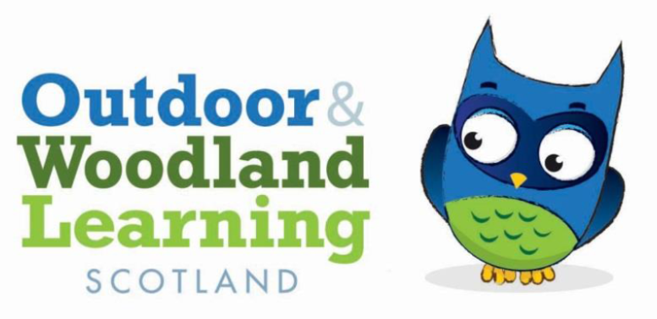
TAYSIDE OWL GROUP EQUIPMENT & INSTRUCTIONS FOR BORROWERS

You are welcome to use this Tayside Owl group kit if you are a member of the Tayside OWL Group (https://www.owlscotland.org/local-groups/tayside_fei_cluster_group)

Not a member? Contact the Secretary Anne-Marie Mackin
E: ammackin@aol.com if you would like to join – it’s FREE!

Equipment can be used either inside or out in the woodland around the Shed on Kinnoull Hill. It must not be removed from site and used elsewhere.

SAFETY NOTE: Regarding use of fire equipment or tools, check with the Tayside OWL Group first, and refer to OWL Scotland Tool use Guidance, and OWL Scotland Fire Guidance

Permission for use of fire outdoors on this site must be first obtained from Robin Lofthouse, Forestry & Land Scotland (Dunkeld office) 0300 067 6380.

All activities should be covered by the appropriate Risk Benefit Assessment.

If you are a member and would like to use the equipment, please inform the Group Secretary Anne-Marie Mackin E: ammackin@aol.com or Treasurer Penny Martin Penny.Martin@nature.scot in advance.

To check availability and book the Shed, contact Sue Brown at Forestry & Land Scotland (Dunkeld office) 0300 067 6380.

Please use the signing out sheet located in the equipment store for any equipment used – name of borrower, date used/ returned. Please note any loss or damages on the sheet, and let us know via the contact emails above.

We hope this helps you to enjoy play and learning outdoors.
HAVE FUN!

Tayside OWL group equipment 2017 |  | Last updated: 20/7/17 |  | Tub 1 | Tub 3
 |  |  |  | Tub 2 | Tub 4
Description/ use | Item | Present | Borrowed by (name/ organisation) | Date Used/ Returned | User to note any damage/ loss
Catering | OWL Mugs X 15
Craft | PVA Glue - 600ml
Craft | Sisal String - Massive ball
Craft | (Large) String - Cotton Twine (8kg Load)
Craft | Scissors - Box of 12
Craft | Acrylic Pens - fine nib
Craft | Acrylic Pens - broad nib
Craft | Mini Pegs - Bag of 40
Craft | Pebbles | ?
Craft | Chalks - Beaker of 12
Craft | crayola crayons
Craft | Chalks
Craft | charcoal
Craft | plastic clothes pegs
Craft/ cooking | (small) Chopping Board - Plastic x 3
Dens/ shelter/ camp | Parachute
Dens/ shelter/ camp | Hammock - DD Scout
Dens/ shelter/ camp | Group shelter in Muddy Faces bag
Dens/ shelter/ camp | DD Hammock
Display | OWL Scotland flag & base
Fire/ cooking | Haba cooking shelf
Fire/ cooking | Haba fire lid
Fire/ cooking | Haba thick grill
Fire/ cooking | Haba wire grill
Fire/ cooking | Barbecue (Haba)
Fire/ cooking | Leg Extension for Barbecue (Haba)
Fire/ cooking | Storm Kettle - Popular  1 litre
Fire/ cooking | Black fire pit folding legs
Fire/ cooking | Storm/ Kelly kettle (black) & bag
H&S | Fire Lighting and Safety Kit - Group: fire lighting kit/ fire gloves/ fire blanket/ kneeling pad/ 1st Aid kit/ storm kettle/ water container
H&S | Orange safety survival bag with 1st Aid Kit
H&S | First aid kit
H&S | Safety gloves x 5 pairs
H&S | wipes x 2 packs
Literacy aids/ play | Tub - Shallow | ?
Literacy aids/ play | Story Shaping Stones | ?
Literacy aids/ play | Wooden Figure Set (3 sets)
Literacy aids/ play | Hand Painted Hedgehogs - Set of 5
Literacy aids/ play | Hand Painted Foxes - Set of 5
Literacy aids/ play | Hand painted Badgers - Set of 5
Literacy aids/ play | 25 Wooden Cookies - Size 2 with drilled hole (2 bags)
Literacy aids/ play | Tree House Hand Puppets: owl, badger, fox,hedgehog, bluetit, squirrel
Nature investigation kit | Name Trail - Fungi
Nature investigation kit | Field Guide - Bugs on Bushes
Nature investigation kit | Pooters - Pack of 5
Nature investigation kit | Bug Viewer x 4
Nature investigation kit | Magnifier (small) x 5
Play | Wooden games (misc)
Reading books | The Leaf Man by Lois Ehlert
Reading books | The Very Busy Spider by Eric Carle
Reading books | The Scariest Thing of All by Debi Gliori
Reading books | The Gruffalo's Child by Julia Donaldson
Reading books | Owl Babies by Martin Waddell
TLP? | Whiteboard
TLP? | Mogo table stand
TLP? | White enamel mugs x 30
Tools | Tayside OWL Toolkit in large white plastic box containing:
Tools | 5 pairs bypass loppers
Tools | 4 x bahco bowsaw
Tools | 9 x child waterproof trousers
Tools | 1 x climbing rope
Tools | Stanley trolley containing:
Tools/ H&S | 1 Forestry First Aid kit
Tub 1 | Tub 3
Tub 2 | Tub 4

