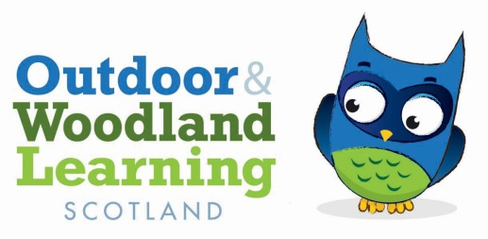

Tayside OWL Committee Meeting 25/08/21 by Zoom

Present Alison Wilson (Chair), Anne-Marie Mackin (Secretary), Kirsty Adam, Mel McRae, Penny Martin (Treasurer), Cara Roberts, Tabitha Arnold, Katie Eadsforth ( both part of the meeting), Jillian Ritchie

Apologies: Cara Roberts, Bonnie Maggio

Minutes of last meeting on 01/06 were proposed by Alison and seconded by Kirsty

Summer Review POP

There is now a FB group with 254 followers and lots of interest in the work.

There were 10 sessions. 2 with Alison, 4 with Kate Hookham, a storytelling session and 3 volunteer led sessions.

126 families are now members

There is some interest in running sessions for older children

2 of the volunteers attending the First Aid training are keen to run sessions for older children

The group was filmed this week for the Scottish Finest Woods award ceremony

Red String are looking at doing an article on the group and this might include a call out for volunteers

The Risk Assessment and Child protection policies are now finalised. There are funding reports to be written

Scottish Finest Woods award will be announced on 10th September

First Aid training will take place 4th and 5th September. 5 volunteers from POP plus 4 paid up spaces with 3 left to be filled.

Broughty Ferry Group had run 3 sessions, 2 with Kate and one with Dougie. All were felt to be brilliant and were well attended

It is hoped that there could be sessions in the October holidays. AM had checked re summer of play money and there isn’t going to be any left over for the Oct hols as had originally been suggested might be the case. We might be able to get a moth project from Play Scotland. Waiting to hear more about this.

General Update

We are needing to find out about shed availability. AM and KA both going to try Robin. We really want to get the Dan Puplett session organised and to have a winter crafts event of our own ( 6th November is chosen date if possible). We already have promo material ready for this which just needs to be tweaked and Alison will get this out to P and K once the event is finalised. We can circulate to other areas as well as our membership as well. Max 30 people.

Finance

Penny circulated a financial update. She is working on reconciling the POP money with Kirsty and Mel.

It was noted that the insurance is due in November

Alternative Venues

We discussed other potential locations for events. Belmont, Quarrymill and Newbigging all suggested.

Dundee/Broughty Ferry group

Tabby left at this point as we needed to discuss our links. The group is now a private business run by Tabby so the relationship is now different as we are a voluntary group. We agreed that we would keep informal links but wouldn’t be able to include the group in funding bids anymore. We agreed that we could pay Tabby to run sessions for us as a Forest School leader.

Katie is training as a First Aid trainer for Outdoor First Aid

AOB

Some people going to networking event 11th/12th September at Pillars of Hercules

**DTONM September 29th at 7.30 pm**

**Zoom 572 859 8151**