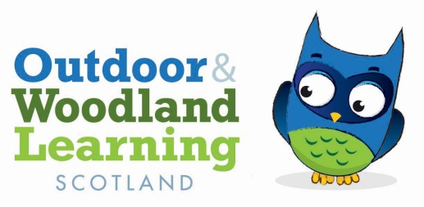

Tayside OWL Committee Meeting

04/08/20 by Zoom

Present Alison Wilson (Chair), Anne-Marie Mackin (Secretary), Penny Martin (Treasurer), Kirsty Adam, Melanie McRae, Tricia Carrigan, Jillian Ritchie,

Apologies: Cath Latham,

POP

Wee Adventures are able to run the first 4 sessions. Everyone felt the plan was well structured and well thought out. Kate Hookham has been contacted re term 2. Mel or Kirsty will be at every session to take responsibility for the RBA etc. Robin Lofthouse needs to be contacted and Penny will send the email address. The sessions are planned to run fortnightly ( dates tbc) and evaluation will be put in place including photos and post its. GDPR statement still to be done ( link to track and trace)

OWL events

The next event will depend on when The Shed is available. In theory we have a craft event in September and then our Dan Puplett Animal Tracking event in October but this is looking unlikely as things stand ( after the meeting we got an update from Robin that suggests The Shed isn’t a priority in terms of opening for the organisation) It has had a break in but our equipment wasn’t affected). In the mean time we will have a monthly catch up via zoom if we have anything to discuss.

Chairs Meeting

Alison has offered to host this (by zoom). Priorities for discussion would be to see how everyone is coping and Alison would talk about the POP plans and other branches could discuss their funded projects. It was suggested that perhaps Kirsty could attend.

Request for info

There had been a request for info re forest school type activities for school age children (in this case a 9 year old with autism) in Dundee. We had a discussion around this and the Scottish Outdoor Education Centre at Meigle was mentioned as were Red Squirrel and Wild Sparks although neither were doing any school age activities as far as we know this year. AM to pass this info on.

OWL Scotland Facebook Page

We were reminded about this which Bonnie is the administrator for and which is a good source of information both that we can use for our own publicity and also to find out what is happening elsewhere

Risk Assessment for POP

Penny suggested some tweaks and pointed the team towards the Inspiring Scotland and Scotgov guidance on outdoor activities. After discussion it was agreed that OWL work comes under the category of Education not childcare

Track and Trace information will be needed Action: Penny

Family Camping Weekend

This informal event might be an indicator of how many families might attend the sessions. 5 families had been planning to attend.

DTONM Tuesday 8th September at 7.30 for 1 hour

Apologies Penny