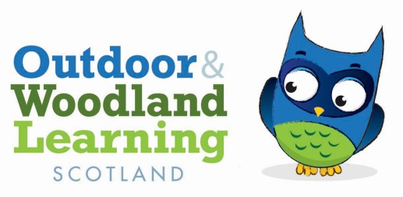

**Tayside OWL AGM**

Saturday 25th January 2020

The Shed, Kinnoull Hill, Perth

**Present Alison Wilson (Chair), Jillian Ritchie (Vice Chair), Anne-Marie Mackin (Secretary), Penny Martin (Treasurer), Kirsty Adam, Cath Latham, Melanie McRae, Christina McGillivray, Patricia Carrigan, Bonnie Maggio**

Jillian welcomed everyone to the meeting and went over the previous year’s activities. The committee had met regularly. We had run a well attended session on Literacy in the woods led by Alison with a short presentation on Mindfulness led by Anne-Marie in the spring. The crafts session in November had been postponed and today we were looking at the Woodland Workout pack and trying out some of the ideas.

We discussed the possible issue of competing CPD opportunities for school and nursery staff having an impact on take up for our training sessions.

Our next session is to be animal tracking in March with Dan Puplett which we know will be a popular event. We are also hoping to have a willow weaving event shortly.

The minutes of the previous agm were adopted as a true record

Proposed by Alison Wilson

Seconded by Cath Latham

**Finance**

Penny circulated the current financial information. She pointed out that we have included insurance in our admin grant.

The hourly rate for paid work is now £15 per hour not £20 in line with other OWL groups.

The accounts no longer need to be audited

**Election of Office Bearers**

Chair Alison Wilson proposed by Jillian Ritchie seconded by Cath Latham

Vice Chair Jillian Ritchie proposed by Alison Wilson seconded by Penny Martin

Secretary Anne-Marie Mackin proposed by Alison Wilson seconded by Penny Martin

Treasurer Penny Martin proposed by Cath Lathan seconded by Jillian Ritchie

The following members agreed to join/remain on the committee Cath Latham, Trisha Carrigan, Kirsty Adam and Mel McRae

This part of the meeting finished at 10.55 and was followed by a Woodland Workout session and the first meeting of the new committee.

It was agreed that we would look into having posters on display in and outside The Shed and Bonnie agreed to check with Robin Lofthouse about this.