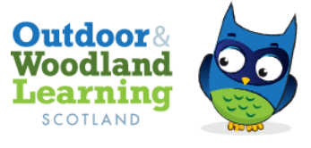
Ayrshire OWLs
SKILL SHARE
Thurs, 1O^{th} September, 2020
Virtual Meeting
- Welcome and Introductions - Lorna

- Video - Tippy Tap (outdoor handwashing) and discussion – Lorna, JMA https://www.youtube.com/watch?v=psiXHC3eRVA

- Video – Nature’s Calendar and discussion - Jo Dempster, Princes Foundation https://www.youtube.com/watch?v=EglL_eCKug0

- Activity – Speedy, No Resource Scavenger Hunt – Carolyn and suggestions from group

Think of a theme for Touch 3 then Me – e.g. Something Living, No Longer Living, Never Living OR Something White, Blue, Green OR Something Rough, Smooth, Soft

Meeting Suggestions – Maths theme (angles, shapes, lengths, relative age of objects), Sound (using sound map format, count up different bird song), Colour (different shades of green and describe – possibly using double-sided tape).

- Discussion – How do we go forward ? - All
What 3 things can members can bring to the group
What 3 things members would like to gain from the group

Members bring passion, enthusiasm, ideas; expertise (e.g. Teaching in Nature, the outdoors and mental health, Outdoor Access Code were specifically mentioned and were offered as potential Skill Share sessions).
Members would like to gain contacts, support from like-minded people, the chance to share the OWL message across Ayrshire, sharing of resources and information (specifically on Risk Assessment and Scottish Government guidance re Covid

- Video – Hapazome demonstration – Carolyn, EAC Learning Outdoors Support Team https://www.youtube.com/watch?v=Os3Z58Efcjk

Video not shown to allow more time for How do we go forward? discussion.

- Link to AGM beginning at 5 pm and coffee break

