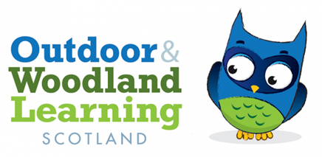
Outdoor & Woodland Learning North East Group
Zoom Meeting Friday 23rd June 2023 at 7pm
- Welcome and Apologies
Present: Douglas Gooday, Kate Malster, Julia Mackay and Dawn Ewan
Apologies: Stephen Reeves, Joanne Evans, John Malster and Neil Taylor
- Minutes arising from meeting on 10th March 2023
- Scottish Finest Woods Award – won by Fordyce Primary School
- Nature Nurture Equipment in shed – Julia spoke to Terri to remove the remaining equipment.
- Update on Events
- Greenmyres Networking Event Sunday 26th March went very well in partnership with Moray OWL group. Julia wrote a report and its been circulated and sent to Eilidh
- Seaweed Workshop on Tuesday 21st March 2023 went well but was poorly attended because of the mid-week, late afternoon timing. This was due to the low tide and best season to forage for certain seaweed. Julia wrote a report and its been circulated and sent to Eilidh.
- First Aid course was fully booked on 22nd & 23rd April and delivered by Duncan McNeill.
- Events for 23/24
- Willow Workshop at Oyne Primary School – action John Malster
- March 2024 networking Event at Camphill School – 4 round robin workshops - action Julia Mackay
  - Difference between Forest School & Outdoor Learning – Dawn Ewan
  - SJFA – raise awareness and activities – Doug Gooday
  - Connection with Nature activities – Jill Birch?
  - Nature Crafts – Justin & Petra?
- Scything Workshop – action John Malster & Douglas Gooday
- John Cree Workshop – action Dawn Ewan
- First Aid Course – 30th September and 1st Oct at Camphill School, Aberdeen delivered by Duncan McNeill. 9/12 so far booked on. Julia to invoice participants next week.
- Branching Out
Out 10th programme has finished and we hope to run 1 more from Aug – Dec 2023 if there are enough funds. Jill will share the report once its completed and give an update going forward – action Jill Birch
- SJFA & Skills Tenders – Doug & Julia have tendered for 2 OWL Scotland workshops.
  - Forest Kindergarten – tool & fire use
  - SJFA – Tool use & tree planting
- Treasurers Report
Balance on 23/06/23 - £33,246.94. Approx running total BOS -A £17,700.00 and OWLNEG - £15,450.00.
BOSA – we have been promised £3000.00 from Branching Out, Head Office for the last programme, but as yet we haven’t received anything. Action Julia
Jill Birch still needs to invoice for the last programme.
OWLNEG – a cheque has been sent for the next first aid course - £1,392.00
- AOCB
A reminder has come through for the shed insurance. Action Julia
Apply for OWL admin grant. Action Julia
- Date for Next Meeting
Friday 20th October, Aller Croft – Action Julia

