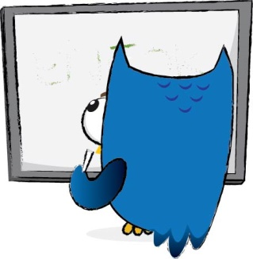
OWL Scotland North Highland Group Agenda
9th May 2019
Ankerville Nursery, Alness 4pm – 5pm

Agenda:
- Minutes from last meeting/Apologies
- Finance update from Shirley
Update on C.P.D events
- Creeping Toad
- Art/Science workshop
- Ian Patterson – Wild
- Outdoor Cooking and Food Hygiene Course
- Numeracy in Woods –South Highland Group

- Facebook page
- Skills Share session next time?
- A.O.B
- Fairy Fires and Kelly Kettle with Kerry Dolan

