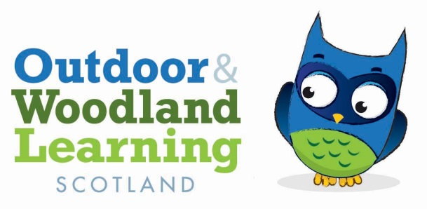

Minutes of the MORAY OWL Group Annual General Meeting
Transition Town, Forres
11th July 2022

Present: Ruaraidh Milne (Co-Chair)
Dan Puplett (Co-Chair)
Natalie Campbell (Secretary)
Julia Mackay
Neil Theodoreson
Chris Gransden
Joanna Richards

Apologies: Alan Smith (Treasurer)
Sandra McKinnon
Menita Roberts
Ged Connell
Elspeth Nawrocki
Dee Ryan

(FYI - action to be taken is in bold type)

- From previous AGM minutes (27/11/20) – minutes agreed Ruaraidh & Joanna.
- Chairs report:
The following organisations/individuals have borrowed the OWL kit over past 18 months to use with different school or community groups -
Outfit Moray
Nature 4 Health
Elgin Academy
Millbank Primary
Dee Ryan
Dan Puplett Nature Awareness

2 new fire bowls have been added to the kit and access to the shed is working well.
This report was proposed by Julia and seconded by Natalie.

- Treasurers report:

Moray OWLS Group

Financial Report – December 2020 to April 2022

Account balance December 2020 - £2255.52
Expenditure - £1363
Income - £0
Interest - £1.05
Account balance April 2022 - £893.57
Expenditure
Workshop fees - £850
Equipment - £190
Insurance - £323

This report was proposed by Natalie and seconded by Ruaraidh
- Election of office bearers:
The following positions were proposed and seconded:
Chairperson – Ruaraidh Milne
Vice chairperson - Dan Puplett
Treasurer - Alan Smith
Secretary - Natalie Campbell
- A members meeting followed the AGM

N Campbell
Secretary
Moray OWLS Group

