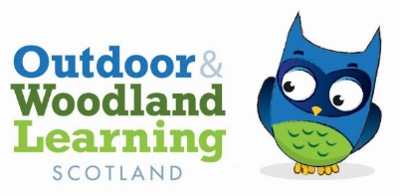

Minutes of the MORAY OWL Group Meeting
Online
12th January 2023

Apologies:
Present: Ruaridh Milne
Alan Smith
Natalie Campbell
Ged Connell
Dan Puplett
Eleanor Foster
Neil Theodoreson

(FYI - action to be taken is in bold type)

- Introductions
- Action points from previous minutes – NC forwarded minutes of last meeting with introduction to Steve Hutcheon, he confirmed he would pleased to attend a Moray OWL meeting. NC to send him details of Networking event in Huntly when available. Using Nature as a Resource to Support Mental Health was very successful workshop, exceeding minimum number of participants and great feedback. Report sent to Eilidh. Procurement policy updated and sent to Eilidh. List of kit to purchase sent to AS.
- New kit still to be ordered – issues with paying by cheque & currently no internet banking available on our account due to legacy signatures.
- It was agreed by all to open a new bank account with internet banking and transfer the funds from the current account to the new one. Then purchase the kit - AS
- Email received from teacher at Forres Academy regarding a conservation project in May with S1-3. NC got back in touch to see if email details could be forwarded to members but she will let us know in due course. Would like to be updated on future kit availability. NC
- Sharing shed with TTF – Ruaridh reported that the ball is in their court regarding next steps. We have agreed to put secure storage in the shed for our kit, so that if shared with TTF tool library it can be kept separate. (*update since meeting – TTF emailed to request code for shed to put some cabinets in there. This was given on the understanding it wouldn’t be given to others until our kit is secure)
- Draft programme for networking has been produced by Julia (NESOLG) and will be forwarded shortly.
- Eleanor nominated to join the committee by Natalie, seconded by Alan.
- Eleanor reported that there is a vacancy at Earthtime for a nursery manager and asked that the information be passed onto anyone that may be interested.
- Neil reported funding has been supporting conservation and biking groups and plans to start a forest school nursery in Huntly.
- From previous minutes - In the spring the group would like to hold a Shed Introduction event – showcasing all the new kit and adding hooks/shelves for better storage.

- Next meeting will be 30th March 5:30pm, at the shed.

N Campbell
Secretary
Moray OWL Group

