OWL Meeting and Skill Share
Dumfries House
Monday 9th September
4.30 – 6 pm

Present: Carolyn McFarlane (EAC LOST) , Lorna Sloan (john Muir Award) , Jo Dempster (Prince’s Foundation) , Aly Conquer (EAC LOST , Lesley Colville, Christine Strong (EA Coutryside Rangers), Simon Sadinsky (Prince’s Foundation)

Apologies: Willie White, Lyndsay Gilbertson, Mark Kerr, Jessica Wharf, David Hill, Gary Yemm, Tim McArthur, Natasha Kater, Jacqueline Farrell

1. Welcome and Introductions
Introductions were made and Dumfries House were thanked for providing the venue for the meeting and Skill Share.

2. Purchase and Sharing of Equipment

At our last meeting it was proposed that we buy equipment to be loaned to Ayrshire OWLs members. Lorna reported that the grant application for funding was denied due to changes in the OWL Scotland budget. No grants are being made for equipment in the Financial Year 2019-20.

The group will consider alternative ways to raise the necessary funds.
Action: WW, CM, LS, All
3. Invitation to Attend O Factor, St Joseph’s Campus, Kilmarnock 21.11.19
The annual O Factor event at St Joseph’s Academy is an opportunity to share good practice in Outdoor Learning in East Ayrshire. Ayrshire OWLs members were invited to attend and to showcase their own work. An Ayrshire OWLs meeting will run after the O Factor (which runs from 2.30 to 5.00) at Outdoor Education.

4. AOCB
Attendees expressed their appreciation that the meeting and Skill Share were being held at Dumfries House i.e. in the Cumnock area. Cumnock was a more convenient location and requests were made to consider other venues that did not entail, for some, a long journey to Kilmarnock. Dumfries House offered to host future Ayrshire OWLs events.
Action: WW, CM

5. Skill Share Sessions
See separate sheet

6. Meeting Closed and Date of Next Meeting
The meeting ended with both Lorna and Jo warmly thanked for their contributions.
Next meeting: 21 November 2019 at Outdoor Learning, St Joseph’s Campus after the ‘O’ Factor event in the main hall at St Joseph’s Academy (see details above and https://blogs.glowscotland.org.uk/ea/learningoutdoorssupportteam/contact-us/
Action CM WW

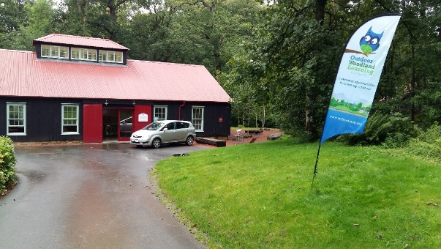
Ayrshire OWLs Skill Share
Morphy Richards Engineering
Education Centre
Dumfries House, KA18 2NJ

9th September, 2019

Making and Using Biological Recording Tools
Jo Dempster, STEM Tutor, Princes Foundation, Dumfries House

Jo and the STEM team lead sessions with Primary and Secondary pupils to make equipment which can be used as biological recording tools. The equipment is made using inexpensive materials, can be made by young people (P5 and above) with minimal support and can then be used to record data on local wildlife populations. All activities were linked to the Curriculum for Excellence Experiences and Outcomes in Science, Technology and Maths and Numeracy. Jo shared three examples.

- Moth Trap – created using a waste paper bin and some simple electronics. Light attracts the moths to the trap and they are trapped safely for identification and counting the next day.

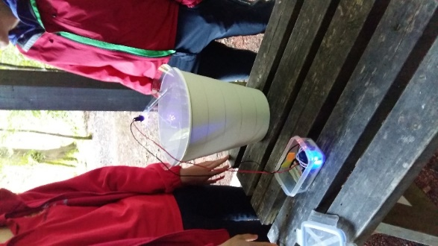
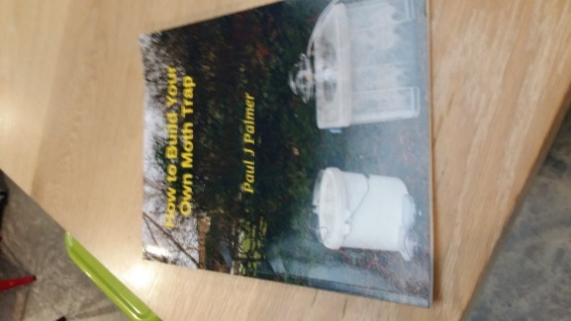

- Beating Tray – made from a hula hoop and a piece of white fabric and a few pegs/clips. the picture is fairly self explanatory! Hold the hoop below a branch or shrub as you gently shake it and collect the falling debris and wildlife!

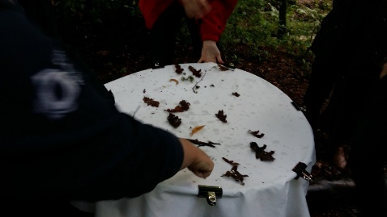

- Mammal Footprint Tracking Tunnel – constructed using corrugated plastic sheets, tape, charcoal dust and water and bait (cat food or peanut butter works well). Small mammals have to walk through the tunnels to get to the bait. The floor at the entrance to the tunnel is covered with charcoal dust so that footprints are made on paper lining the tunnel floor. The prints can then be identified using age and stage appropriate spotter guides (both the RSPB and Field Studies Council produce guides to suit different age groups) to give an indication of the local wildlife population.

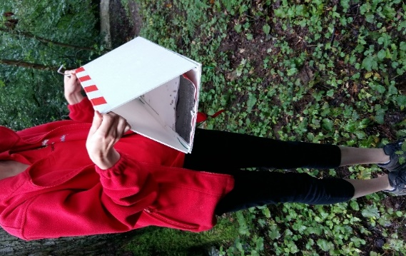
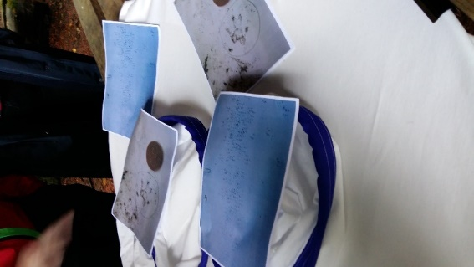

Jo recommended How to build Your Own Moth Trap by Paul J. Palmer. Simple guides and child friendly instructions for mammal footprint traps and other biological recording tools can be found on the Wildlife Watch https://www.wildlifewatch.org.uk/

Painting with Natural Materials
Lorna Sloan, John Muir Award

Lorna demonstrated how to use natural materials (leaves, soil, herbs and spices for example) to extract natural pigments and use them in pieces of art. Lorna brought along mortar and pestle but explained that these are not necessary. Stones (pestle) and a flat tile or any other solid surface (mortar) could be used as substitutes. Writing tools were made sharpening some stems and woody cuttings. Brushes were made using pieces of broom (the plant) and twiggy stems. The OPAL guide to Painting with Soil gives clear instructions and suggest extension activities. https://www.opalexplorenature.org/sites/default/files/7/file/Painting-with-soil.pdf

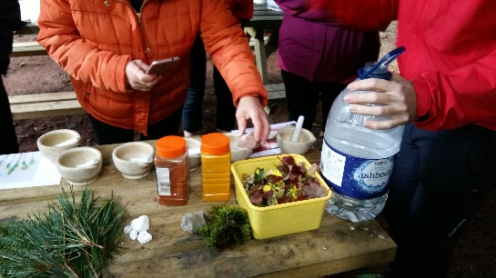
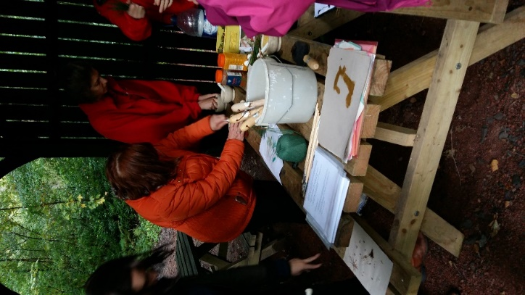

This activity has been tried and tested with many Early Years and Primary pupils. It is always popular and a great stimulus for both scientific and creative investigations.

