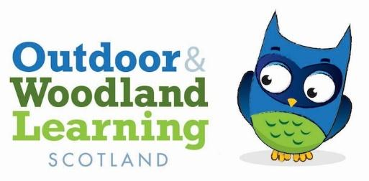

Midlothian OWL Group Meeting Minutes
Monday 5th February 6.00pm - 8.00pm at Newbattle Abbey College, Outdoor Learning Hut
In person, no Zoom attendees.

Present: Jules, John, Judy, Beth, Helen N, Sally, Corinna, Elly, Fran Nelson, Katie Gerrardot, Lynne, Suzie
Apologies: Cathay, Eve, Holly, Helen B
Agenda
- Welcome from the MOWL committee
- Julie has taken over from Judy as Chair of the group.
- The group gave introductions.
- Roles still available
- John proposed Beth as new secretary/admin, Jules seconded and Beth accepted position. Sally commented that the paid hours can be undertaken and invoiced by any committee members with prior agreement of the group.
- It was noted that the group needs a new treasurer. Judy is currently a signatory on the bank account. Susie proposed Fran as new treasurer, Jules seconded and Fran accepted position. Following discussion it was agreed that Judy would remain as signatory and Fran would keep a record of financial transactions made by Judy from the MOWL bank account.
- Incorporation of East Lothian into the group, Tina Mistlebrook, East Lothian.
- All were in agreement that we would like to incorporate East Lothian OWL. Sally will speak to Tina Mistlebrook about this.
- Locations of CPD and Networking/Seasonal workshops:
- John and Jules presented a proposed outline of the 4 seasonal networking/skill sharing events which we plan to host this year. The proposition was for 4 sessions to take place, 2 being at Newbattle Abbey (to reflect on the seasonal changes on site), one at Cliftonhall school and one at Gifford Community Woodland. Katie will seek permission from Gifford Community Woodland to host.
- Following discussion, the group agreed that for simplicity, these are the sites we will seek to use for this year’s 4 events. John suggested that in subsequent years we would seek to host these events in new places to reach a wider audience and to contribute to opening up more woodlands for forest school activities. For the time being the focus will be on delivering content. John suggested the development of a 5 year strategy moving forwards.
- The following schedule was suggested - Spring at Cliftonhall, Summer at Newbattle Abbey, Autumn at Gifford Community Woodland, Winter at Newbattle Abbey. It was agreed that this year we will seek to host one weekend long event, with the possibility of accommodation on Friday and Saturday evenings, and 3 one day events. The group agreed that having an evening session for the first 1 day event would be a good idea, both for the social element and for the opportunity to explore topics like star gazing and wildlife tracking. It is expected that the first networking day will finish around 8pm and involve a dinner.
- Elly commented that it seems that the committee are initially most interested in expanding our own skill sets and that it could be a good idea to start small before branching out. The group agreed that we will plan for the first networking event to be kept to committee and friends/colleagues. It was noted that the committee are particularly interested in campfire cooking and food hygiene.
- The general idea is to replicate similar workshops in all 4 seasons. For 2 day events, the sessions on each day can follow a similar theme depending on the resources available at that site, e.g. at Newbattle Abbey there might be a session each day around river dipping.
- John will form a sub committee for organising the networking events. Anyone interested should e-mail John and he will set up an initial Zoom meeting.
- Regarding payments for attending the events, Judy suggested that committee members would get a subsidised rate.
- Sally commented that it would be good to find out what training Midlothian and East Lothian teachers would benefit from, to inform the workshops we plan for these events. Currently the group has no representation from East Lothian or Midlothian teachers. She added that she knows the STEM lead for Midlothian. It was suggested that the events sub committee which John will form should investigate the training needs across teachers in Mid and East Lothian.

- Flip Chart for Skill Share /Phylum Feast!
- Sally gave an excellent overview of Darwin’s life history and contribution to how we see the natural world. The group had a delicious and biodiverse Phylum Feast!
- Meanwhile, the group were invited to record on a flipchart which skills they could share at a networking event - see image below.

Actions:
- Judy to email Eilidh to inform of Beth’s new role as secretary/admin and to seek clarity on invoicing for hours - which hours can be invoiced, and by which committee members etc.
- Sally to have a discussion with Tina about incorporating East Lothian OWL.
- Katie to seek permission from Gifford Community Woodland committee to host one of the MOWL networking events, most likely in October.
- Jules to set dates for a Spring Cliftonhall networking event.
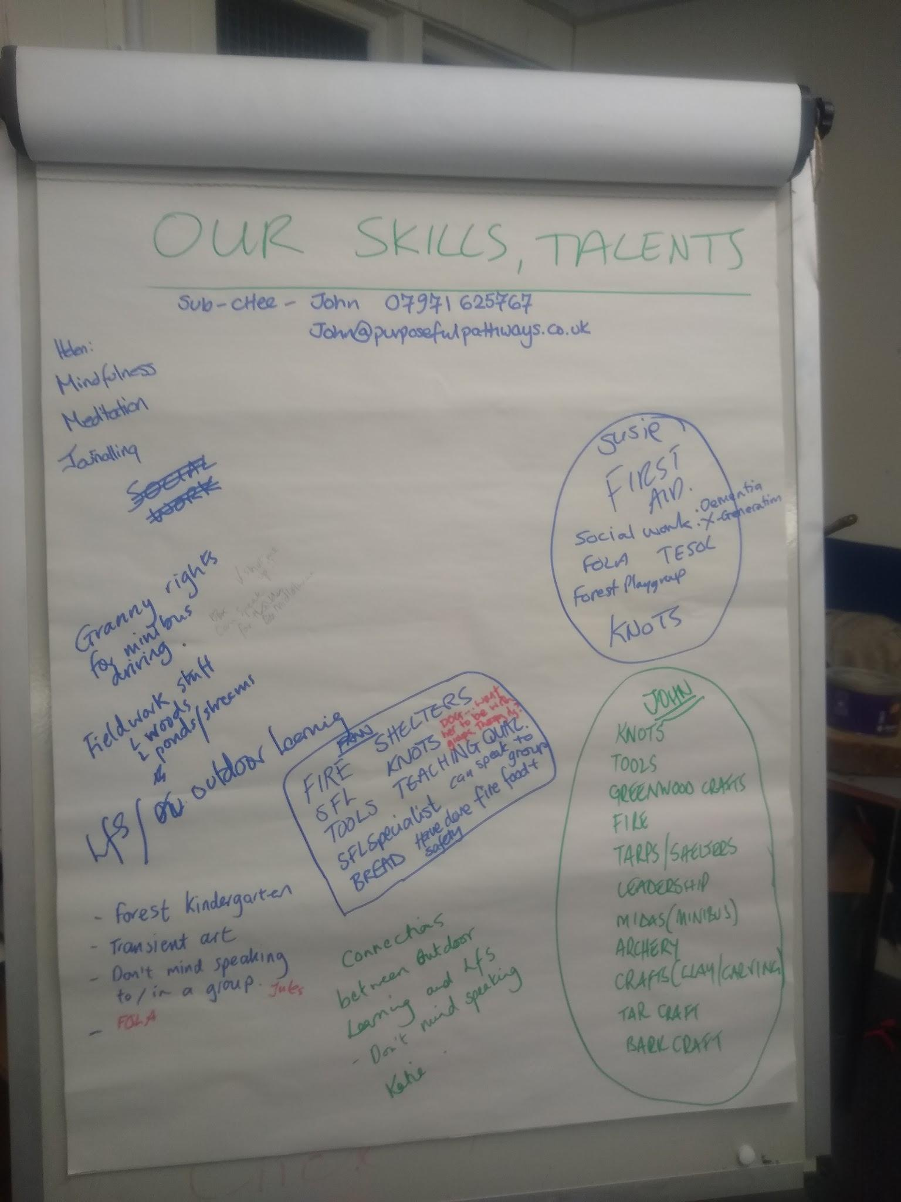
- John to form a sub committee for organising the networking events. Anyone interested should e-mail John and he will set up an initial Zoom meeting.

