Edinburgh OWLs Meeting-on Teams,14th November 2022- 7.30pm
Present: Margon, Susan, Roy, Rosy, Sara, Barbara, Louise, Karolina
Apologies: Jo, Anna, Katrina, Maarya
Agenda:
- Insurance & Bank
- Grants Update
- 2023 Nature Play Conference
- EOWL CPD Planning 2022-2023
- Other OWL Scotland news -February OWL Scotland Network meeting
- A.O.B.

1. Insurance 2022-2023
We have new insurance with Birnbeck from 15th September costing £250. This gives very comprehensive cover and is better for the activities we do.
Bank Account- Update: Recent OWL grant funds have now arrived into the EOWL account
2. Grants:
We were awarded 100% applied for funds for all 5, recent grant applications
A. OWL Group annual admin grant. Barbara, Rosy and Roy claim this at £14 an hour. They Don't claim all the hours they work.
B. CPD grant - events are being planned, see further on in minute
C. Networking grant: Nature Play Conference.
- Lou has booked Cramond Church Hall for the event on 29th April 23. Roy will pay the £50.00 deposit.
- Tracy is keen to arrange meetings with BM & LC soon. CEC funding has been set aside.
- Eilidh and Bonnie will attend from OWL Scotland.
- Henry has confirmed his attendance
- We haven't decided on a key- note speaker as yet. Discussed what theme we wanted to have thinking about-'Resilience, Self-esteem and Confidence', so a mental health theme.
- Ros to send out a WhatsApp invitation for EOWLers to suggest a possible keynote Speaker.
- EOWL to provide people to lead four sessions,
- Edinburgh City to provide four sessions.
- Additionally, ask GROWL if they would like to help at Nature Play.
- Invite other OWL groups to Nature Play for further networking.

D. Kit Grant-
- We hope to make up kit boxes in January and further discuss arrangements to keep these at Bangholm. Boxes will co-ordinate with CPD Themes
- We need to co-ordinate WHEC collection of existing EOWL Kit. Sara offered her minibus.
- Barbara offered indoor space for all for making up kit boxes @Northfield near Meadowbank

E. Junior Forester Award Grant- Jill leading on this project with Leanne at Kaimes. All going well and Jill posting lovely updates on Facebook.
OWL Scotland CPD Training
There is an OWL Scotland Training Day for the Junior Forester Award on 26/11/22. Rosy sent out info to book, in a previous email.
- Barbara and Lou attending and will give feedback.
- Sara was interested in this award for older children/young people in future years.

4. CPD Planning- Aim for 4 CPD sessions , one for each season.
Winter Date and venue to be confirmed a.s.a.p.
- Tracking skills – (1) Dave Crosby (recommended by Rosy) Rosy has been in touch, and he is interested ask him for Dec or Jan23. East Lothian woodland
- Dan Pupplet interested too
Early Spring / Late Spring with OWL booklets Dates and venues to be confirmed a.s.a.p.
- Wolf Brother – (2) Bridgend (t.b.c.) Storytelling- Jane & Barbara - Environmental Arts/ Dens
- Tree Stories – (3) Tree ID, Scots Pine Poster and measuring Morton Hall – t.b.c. Tools (ALL?)
April Nature Play with OWL booklets
- Soil Beneath our Feet – (4) Ros & Sara
- Foraging for medicinal and edible plants, (5) Anna-Roslyn ? Anna’s booklet
- Forest Bathing- (6) Maarya & Diana ?
- Foraging & Fire?/ Woodland Recipes ? – (7) Kat & (OWL Fire Guidelines)
Summer
- Wheely Wild Forest School – (8)T.B.D. Dani and Rowan
Suggested Venues: accessible with woodlands, parking, facilities etc
A Variety of locations have been identified, in addition to our local, Bridgend Farmhouse
- Bonaly -costly (£80.00+ payable to Scout Association) West Edinburgh
- Hermitage of Braid, South -West Edinburgh
- Mortonhall -South West Edinburgh
- Roslyn - Midlothian, suggested by Susan
- The Three Hares Woodland -an 18-acre community woodland near Auchendinny, Midlothian
5. OWL Scotland Networking Event-17th to 19th February 23, Aberfoyle
Cost Approx. £50.00. We could arrange car shares, if EOWL folks are interested. More info out in next OWL Scotland Bulletin
6. A.O.B. / Other news
- OWL Bulletin-We need information by Thursday. Barbara writing up
- Sara has a Senior Youth Development post to advertise. To be put on OWL Edinburgh & OWL Scotland webpages. URL link – Senior Youth Development Worker

- There was discussion about Nature Kindergarten CPD training in Edinburgh, which will take place at Newbattle Abbey grounds.
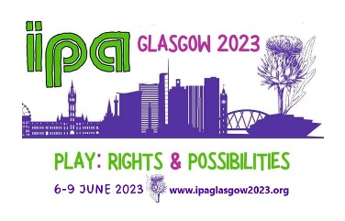
- Also, discussion about The International Play Conference in 2023 - Play: Rights & Possibilities, in Glasgow. We would like to be able to support people to attend. Sara sending some ideas for grant applications. IPAGlasgow2023

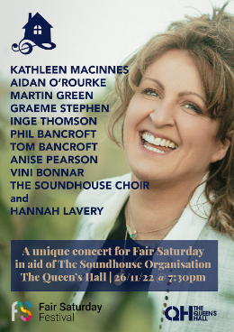
- Barbara's Soundhouse Choir and other musicians are having a fundraising gig for Fair Saturday on Saturday 26th Nov at The Queens Hall

Next Meeting: Monday 12th December 2022. (7.00pm -9.00pm) Book Group & Drinks
No venue decided, as yet. Shall we try Joseph Pearce’s again as it is quiet throughout the week? (The roadworks have eased a bit)
Thanks to Ros for taking the minute. December Volunteer required.

