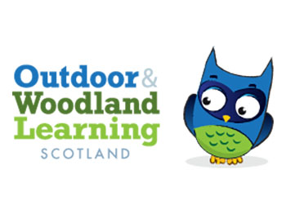
Ayrshire Owls AGM
2 May 2018 3.45 – Outdoor Learning Base St Joseph’s Academy
Are you interested in Outdoor Learning, would you like to have access to free training enabling you to learn and develop pedagogical skills, resources and meeting with likeminded people?
Why not come along and learn more about what is on offer. This new local group is starting out and looks forward to meeting with you.
St Joseph’s Academy in East Ayrshire will host our first AGM and we look forward to welcoming you.
For more information
https://www.owlscotland.org/local-groups/ayrshire-owl
St Joseph's Academy, Grassyards Road, Kilmarnock KA3 7SL

