Ayrshire OWLs
Skill Share and AGM

Monday, 17th June, 2019
4.30 – 6.00 pm

Outdoor Education
St Joseph’s Campus
Grassyards Road
KILMARNOCK
KA3 7SL

The meeting will consist of a skill share with short sessions on Bushcraft, Story Telling and Arts and Crafts.

The AGM is expected to last approximately 30 minutes and will follow on from the skill share.

All are welcome. Come along for a chat and a relaxed, fun session!

Refreshments will be available!

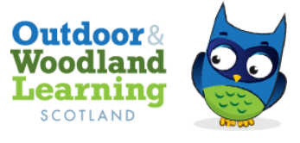

The Ayrshire OWLs group is part of the OWL Scotland network https://www.owlscotland.org/.
Our aims and objectives are to

- increase opportunities to learn outdoors
- provide first hand learning experiences,
- increase knowledge and understanding of outdoor environments
- increase recognition of the positive health benefits of going outdoors
- support Learning for Sustainability.

Our group is a network of outdoor learning enthusiasts sharing practice in greenspace, woodland, hill, mountain
and school/ECC environments.

