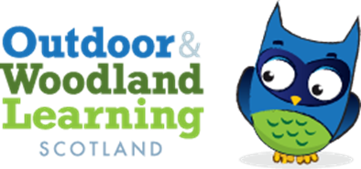
West Fife OWL Group Meeting Agenda
Tuesday 24th^{st} October 19:30 Online WhatsApp Group Call

Present: Karen Valentine (Chair), Chris Leitch (Secretary), Jess Hermann (Secretary), Zoe Mayes (Committee Member)
Apologies: Eric Main (Co-chair), Katie Marie Nash (Treasurer) Jenny Ventham(Committee member)
AGENDA: Networking Event: Tuesday 7th November 3:30-6pm

- Event starting at 3:30 for workshops starting at 3:45.
- Workshops
  - 3 x 30 minute sessions.
  - Little Bugs: Literacy and Numeracy Outdoors
  - Chris Childe: Music
  - About the Trees: Whittling
  - Grant from the Sanctuary Garden: School Gardening
  - Freelancers leading workshops paid by OWLS £150 each for the afternoon.
- Confirmed Information Stalls
  - Natural Connections
  - Kingdom of Fife Orienteering
  - Active Schools
  - Eilidh OWLs
  - Leaves and Learning
  - John Muir Trust
  - Forestry Land Scotland
  - Aline Hill-FOLA and First Aid
  - Little Bugs Nursery
  - The Tree Council
- Action Points
  - Chris Leitch: Bulletin and Facebook group
  - Zoe Mayes: Directions for school arrivals, parking etc
  - Jess to collate workshop data from Eventbrite and emails.
  - Jess to create an email outlining what will happen on the day for workshop leaders and tables.
  - Jess and Karen to arrive after school lunch time to help set up and direct on the day
  - UPDATES TO BE POSTED ON WHATSAPP GROUP
Next meeting: After 7th November to evaluate event (TBC)

