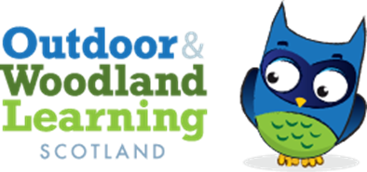
West Fife OWL Group Meeting Agenda
Tuesday 21st September 19:30 Online WhatsApp Group Call

Present: Karen Valentine (Chair), Chris Leitch (Secretary), Jess Hermann (Secretary) Jenny Ventham) , Zoe Mayes (Committee Member)
Apologies: Eric Main (Co-chair), Katie Marie Nash (Treasurer)
AGENDA: Networking Event: Tuesday 7th November 3:30-6pm

- Event starting at 3:30 for workshops starting at 3:45.
- Workshops
  - 3 x 30 minute sessions.
  - Little Bugs: Literacy and Numeracy Outdoors
  - Chris Childe: Music
  - About the Trees: Whittling
  - Grant from the Sanctuary Garden: School Gardening
  - Freelancers leading workshops paid by OWLS £150 each for the afternoon.
- Information Stalls
  - Natural Connections
  - Kingdom of Fife Orienteering
  - Active Schools
  - RSPB
  - Eilidh OWLs
  - SSERC-Fordell Firs
  - Ecology Centre
  - Leaves and Learning
  - John Muir Trust
  - Forestry Land Scotland
  - Aline Hill-FOLA and First Aid
- Action points to contact and confirm
  - Karen Valentine: Ecology Centre
  - Jenny Ventham: SSERC and John Muir Trust
  - Jess Hermann: RPSB
DEADLINE FOR CONFIRMATIONS THURSDAY 28th September

Advertising
- Action Points
  - Chris Leitch: Bulletin
  - Jess Hermann Flyer, Scottish Primary Teachers and Facebook.
  - Zoe Mayes: Teams and Active Schools
  - All to be in place BEFORE THE OCTOBER HOLIDAYS- 2nd October
  - UPDATES TO BE POSTED ON WHATSAPP GROUP
Next meeting: Thursday 24th October 2023 7:30pm WHATSAPP

