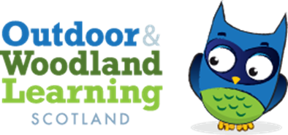
West Fife OWL Group Meeting Agenda
Tuesday 29th Aug 2023 18:30 Little Bugs Nursery, Fordell Firs

Present: Karen Valentine (Chair), Chris Leitch (Secretary), Jess Hermann (Secretary) Katie Nash (Treasurer), Zoe Mayes (Committee Member)
Apologies: Eric Main (Co-chair), Chris Childe, Jenny Ventham
- Treasurers Report:
Bank Account £5385.96
However, £1961.08 unclaimed possibly from freelance work on the Kelty project as Katie received an invoice from Chris Childe from the Madras College project but not the Kelty one.
Any unclaimed money from this grant will be taken back by the Forestry.
Action Point: Katie to contact Chris to see if he hasn’t claimed this freelance payment. Also to contact Jenny to see what resources she still needs to invoice.
It was highlighted that there was no need to apply for OWLs grant this year due to the remaining £3424.88 to work with for the networking event and to run CPD and workshops.

- Admin Grant
Karen raised that we could apply for an admin grant to pay for the time put into tasks involving advertising and setting up these events.
Action Point: Karen and Chris to work on application to be submitted by the end of the week.

Networking Event: Tuesday 7th November 3:30-6pm
Venue: Chris suggested contacting the scout halls to hold the events and Zoe suggested the community centres, Townhill bowling club and Belleyeoman PS.
Action Point:
- Zoe and Chris to contact these venues and get pricing and report back to the committee by 5th September. After this, the rest of the committee will contact the following groups for the event.
- Karen: RHET, Owen (Storytelling), Aline (Forest School and First Aid), Phil (Ardroy).
- Zoe: Grant (The sanctuary garden), Blair (Active Schools), Kingdom of Fife Orienteering, Little Bugs, RSPB
- Jenny: Gavin of the woods
- Jess: Scouts, Natural connections, Leaves and Learning, Eilidh OWLS
- Chris: Look in to how to update Fife bulletin for advertising.

Next meeting: TBC (Before October Holidays)

