West Coast OWL “Nest Meeting” 02/02/2021 Minutes

Attendees: Susan, Rosamonde, Judith, Isabel and Heather
Apologies: Lynne

AGENDA:
1. Welcome - Susan
2. Check Ins
3. Previous Minutes – Everyone agreed.
4. Previous Actions – All Completed:
- Roz added WCOWL email to OWL Scotland Bulletin
- Newsletter sign ups?
- Roz – shared Early Years OWL workshops. Susan forwarded to local school contacts and communications with Headteacher.
- Roz – share draft constitution and minutes
- E-signatures completed on Constitution and emailed to Bonnie with minutes
- Roz – Dropbox access for everyone
- Isabel and Roz – OWL Website content and uploaded
- Isabel and Roz – OWL Bulletin notice content and shared with Bonnie

5. Constitution and confirmation with Bonnie – We are CONSTITUTED!!!!

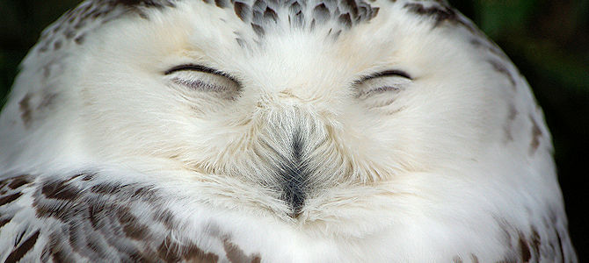

6. OWL Scotland Website - Update from Isabel – not on the map yet but will be on there soon.

7. WCOWL Bank Account - discussion and decision - Updates from Heather around Community Banking and what options are available:
- Royal Bank of Scotland Community Account – 4 week lead time, 4 signatories allowed. Don’t like ethics but it will get us set up in time to access OWL Scotland funding.
- Coop Bank Community Banking but not allowed if only constituted. 3 month lead time – too long. Ethical. But couldn’t get through on the phone to check about set up for OWL.
- Most banks closed for transferring accounts at the moment but might be an option in the future.
- Discussion – need to be aware of time allowances. Go with RBS at this time and consider transferring at a later date.
- Signatories – Minimum 2 for OWL requirements.
- Proposal suggested by Susan – three OWL Group signatories will be used for the bank account. Treasurer as main signatory and Susan and Roz as secondary signatories.
All agreed – set up RBS Community bank account
All agreed – 3 signatories are Treasurer, Chair, Secretary. Main signatory is Treasurer.

8. Ways of Working for the team
- Meeting frequency
  - Minimum of 3 meetings per year – Membership Meetings including AGM.
  - Fortnightly for steering group for the time being (review start of march)
- Setting deadlines
  - Fortnightly feedback process as a routine for actions/tasks and to save on lots of email streams. Task, Finish and Review process – fortnightly routine again. Updates and reviews can be at each meeting rather than through lots of emails.
- Communication
  - Ensure replies are associated to topic content of email to save time in replies
  - Emails sent anytime to the group
  - Checking weekly on OWL emails just in case there are any urgent items.
  - Do we have any interest in WhatsApp Group or Signal Group? Not at the moment – happy to continue with email feeds.
  - Main contact details consented to be collected – Contact sheet for the group held on Dropbox? For any urgent communications we can text.

9. Communications and sharing news of WCOWL being established
- Task and finish approach - articles, press release, announcements, comms with existing contacts.
  - Use OWL Bulletin content for article about being constituted. Put this into CommUnity News end of February and decide a future date for our engagement event.
  - Option to feature announcement across the Wester Ross and Skye area.

10. Engagement Event and building membership
- Explore options of how to launch over the next two weeks
- Judith – offer from North Highland OWL to help. Inviting Kerry Dolan to join one of our next meetings.
- Isabel can check out GDPR requirements for gathering contacts – specifically to do with email contacts. Good contact is Jo Anne Ford (Skye and Lochalsh Council for Voluntary Organisations). https://www.slcvo.org.uk/copy-of-starting-a-new-group-or-pro-4
- Susan happy to contact SLCVO to register ourselves as a community group and find out what support/learning we can access to help our group.
- Moved to next meeting - GDPR and Storing contact information (decide process/policy) - Guidance from Lynne

11. Using pronouns
- Isabel opened the discussion – focusing on the importance of pronouns for inclusion and diversity especially when working across different groups and within public domains. Important dialogue to continue and explore.
- Opportunity to access more guidance from SLCVO about pronoun use.
- Be good to have feedback from Lynne at a future date.

12. Facebook
- Agree process/roles for managing page and posting
  - Susan – can explore how to time posts on the page.
  - Isabel – deciding what to post and how we want to go about it.
  - Susan – Over the coming weeks we can organically re-post articles, events, groups and content that we feel is suitable for the page.
  - Isabel – will ensure the OWL Scotland website link is updated on our FB page.
- Everyone an admin except Heather – Heather being added but due to The Plock role and FB posts for her and Judith they will not be able to give time to WCOWL specific posts, but can be shar The Plock ones where relevant.

13. AOB – no

14. Next Meeting
- Thursday 18th February 19:30 - 20:30 (check times with Lynne)
- Thursday 4th March 19:30 – 20:30

Moved to Next Meeting
- GDPR and Storing contact information (decide process/policy) - Guidance from Lynne

Actions
- Everyone – Think about what we would like to have happen over the next year, including the launch event and plans that we visioned in the Balmacara Woods.
- Roz – set up contact sheet for all steering group members and save in Dropbox.
- Roz – Check next meeting dates/times are okay for Lynne
- Judith – contacting Kerry at the North Highland OWL to invite to one of our next meetings and give some ideas on engagement event and activities for our first year.
- Susan – Contacting SLCVO to find out if they have guidance/learning on GDPR and use of pronouns, and check if we can be registered as a community group on their database.
- Isabel – updating Facebook page and making Heather an admin.
- Isabel – research any GDPR guidance for database of contacts
- Everyone – Facebook – sharing organically any articles, posts, links and local group news they feel is relevant. Re-sharing posts from any of our other managed pages. No expectation to fill the WCOWL Facebook page daily, but just when we notice something relevant to reshare. Use this a prototyping process.
- Heather – Bank account application

